# Compute on AWS

When you consider what compute service to use for a specific use case, you should ensure that you are up to date on any new AWS service or feature releases. To review a high-level overview of the different AWS compute services AWS, see [Compute on AWS - Compute for any workload](https://aws.amazon.com/products/compute/).

## AWS Lambda

For this weeks architecture, we have chosen AWS Lambda as the compute service due to it’s serverless nature and ability to support a web backend. Lambda is a compute service that provides serverless compute functions that run in response to events or triggers. When an event or trigger is detected, a Lambda function is spun up in its own secure and isolated runtime environment, which is called an execution environment. Lambda functions can run for up to 15 minutes. Any processes that need longer than 15 minutes to run should use other compute services on AWS for hosting. Each execution environment stays active for a period of time, and then it shuts down on its own.

When you use Lambda, you are responsible only for your code, which can make it easier to optimize for operational efficiency and low operational overhead. Lambda manages the compute fleet, which offers a balance of memory, CPU, network, and other resources to run your code. Because Lambda manages these resources, you can’t log in to compute instances or customize the operating system on the provided runtimes. Lambda performs operational and administrative activities on your behalf, including managing capacity, monitoring, and logging your Lambda functions.If you need to manage your own compute resources, AWS has other compute services that can meet your needs. For example:

* Amazon Elastic Compute Cloud (Amazon EC2) offers a wide range of EC2 instance types to choose from. With Amazon EC2, you can customize operating systems, settings for network and security, and the entire software stack. You are responsible for provisioning capacity, monitoring fleet health and performance, and using Availability Zones for fault tolerance.
* AWS Elastic Beanstalk is a service that you can use to deploy and scale applications on Amazon EC2. You retain ownership and full control over the underlying EC2 instances.

Lambda can be used for virtually any application or backend that requires compute and that runs in under 15 minutes. Common use cases are web backends, Internet of Things (IoT) backends, mobile backends, file or data processing, stream or message processing, and more. Lambda is a good choice for use cases where the requirements include reducing operational overhead, optimizing for cost, or optimizing for performance efficiency. Lambda works well for these use cases because it’s a managed service and you only pay for what you use. There are no idling resources when working with AWS Lambda, which means that each Lambda function is highly performant and cost efficient.

* To gain a deeper understanding of Lambda, see [AWS Lambda FAQs](https://aws.amazon.com/lambda/faqs/).
* To learn more about Lambda, see the [AWS Lambda Developer Guide](https://docs.aws.amazon.com/lambda/latest/dg/welcome.html) or the [AWS Lambda Operator Guide](https://docs.aws.amazon.com/lambda/latest/operatorguide/intro.html).
* To learn more about architecting and best practices for Lambda, see [Architecture and Best Practices](https://docs.aws.amazon.com/lambda/latest/operatorguide/architecture-best-practice.html).
* For a list of technical talks that cover Lambda, see [AWS Lambda - Technical Talks](https://aws.amazon.com/lambda/resources/webinars-and-talks/).
* For a list of technical tutorials that use Lambda, see [AWS Lambda - Workshops & Tutorials](https://aws.amazon.com/lambda/resources/workshops-and-tutorials/).

## Amazon API Gateway

After Morgan selected Lambda for the compute backend, she needed to find a way to expose the backend Lambda function. Amazon API Gateway integrates with Lambda, thus providing a way to expose the backend service without exposing to the open internet. This week’s customer might decide to add authentication to API Gateway to secure it further.

API Gateway is a fully managed service that makes it easier for developers to create, publish, maintain, monitor, and secure APIs at any scale. APIs act as the front door for applications, so that the applications can access data, business logic, or functionality from your backend services. By using API Gateway, you can create RESTful APIs and WebSocket APIs that enable real-time two-way communication applications. API Gateway supports containerized and serverless workloads, as well as web applications.

API Gateway handles all the tasks involved in accepting and processing up to hundreds of thousands of concurrent API calls, including traffic management, CORS support, authorization and access control, throttling, monitoring, and API version management. API Gateway has no minimum fees or startup costs. You pay for the API calls you receive and the amount of data transferred out and, with the API Gateway tiered pricing model, you can reduce your cost as your API usage scales.

* For more information about Amazon API Gateway, see [Amazon API Gateway](https://aws.amazon.com/api-gateway/) or [Amazon API Gateway FAQs](https://aws.amazon.com/api-gateway/faqs/).

## Amazon EC2

Amazon EC2 is a service that provides resizable compute capacity in the cloud, which means that it provides virtual machines in the cloud. Amazon EC2 is a flexible service that offers multiple instance types, sizes, and pricing models to meet specific requirements. Because you can choose your operating system and configurations for your instance, you can configure Amazon EC2 to work with virtually any workload.

You can use Amazon EC2 when you want to run applications on AWS, but still want to retain control over the underlying infrastructure. Morgan didn’t choose Amazon EC2 as the compute service for this customer’s use case because of the operational overhead that Amazon EC2 requires. You have a lot of control over Amazon EC2, but that control also means that you will have overhead for managing the service. The customer had a straightforward use case and was willing to rewrite the code to use Lambda. The customer also had a spiky demand for their workload. Thus, choosing a service such as Lambda minimizes idling resources during low volume times, which can be more difficult to achieve with Amazon EC2.

* For a beginner tutorial about Amazon EC2, see [Get started with Amazon EC2 Linux instances](https://docs.aws.amazon.com/AWSEC2/latest/UserGuide/EC2_GetStarted.html).
* To gain a deeper understanding of Amazon EC2, see [What is Amazon EC2?](https://docs.aws.amazon.com/AWSEC2/latest/UserGuide/concepts.html) or [Amazon EC2 FAQs](https://aws.amazon.com/ec2/faqs/).

## AWS container services

Container management tools can be divided into three categories: registry, orchestration, and compute. AWS offers services that give you a secure place to store and manage your container images, orchestration that manages when and where your containers run, and flexible compute engines to power your containers. AWS can help manage your containers and their deployments for you, so you don't have to worry about the underlying infrastructure. No matter what you're building, AWS makes it easy and efficient to build with containers.

Container services were not chosen for this architecture because the customer did not want to integrate this technology into their stack. So, even though running a container on Amazon ECS using AWS Fargate as the compute platform would technically work it was not chosen because of other customer preferences.

### Amazon ECS

Amazon Elastic Container Service (Amazon ECS) is a fully managed container orchestration service that you can use to deploy, manage, and scale containerized applications. It integrates with the rest of the AWS Cloud to provide a secure and easy-to-use solution for running container workloads in the cloud or on premises. Key features of Amazon ECS:

* Serverless by default with AWS Fargate: Fargate is built into Amazon ECS, and it reduces the time you need to spend on managing servers, handling capacity planning, or figuring out how to isolate container workloads for security. With Fargate, you define your application’s requirements and select Fargate as your launch type in the console or AWS Command Line Interface (AWS CLI). Then, Fargate takes care of all the scaling and infrastructure management that’s needed to run your containers.
* Security and isolation by design: Amazon ECS natively integrates with the tools you already trust for security, identity, and management and governance. This can help you get to production quickly and successfully. You can assign granular permissions for each of your containers, giving you a high level of isolation when you build your applications. You can launch your containers with the security and compliance levels that you have come to expect from AWS.
* Autonomous control plane operations: Amazon ECS is a fully-managed container orchestration service, with AWS configuration and operational best practices built-in—with no control plane, nodes, or add-ons for you to manage. It natively integrates with both AWS and third-party tools to make it easier for teams to focus on building the applications, not the environment.

### Amazon EKS

Amazon Elastic Kubernetes Service (Amazon EKS) is a managed service that you can use to run Kubernetes on AWS without needing to install, operate, and maintain your own Kubernetes control plane or nodes. Kubernetes is an open-source system for automating the deployment, scaling, and management of containerized applications. Amazon EKS offers the following features:

* It runs and scales the Kubernetes control plane across multiple AWS Availability Zones to ensure high availability.
* It also automatically scales control plane instances based on load, detects and replaces unhealthy control plane instances, and provides automated version updates and patching for them.
* It is integrated with many AWS services to provide scalability and security for your applications, including the following capabilities:
* Amazon Elastic Container Registry (Amazon ECR for container images).
* Elastic Load Balancing for load distribution.
* AWS Identity and Access Management (IAM) for authentication.
* Amazon Virtual Private Cloud (VPC) for isolation.
* It runs up-to-date versions of Kubernetes, so you can use all of the existing plugins and tooling from the Kubernetes community.

Applications that run on Amazon EKS are fully compatible with applications that run on any standard Kubernetes environment—it doesn’t matter whether they run in on-premises data centers or public clouds. This means that you can migrate any standard Kubernetes application to Amazon EKS with virtually no code modification.

### AWS Fargate

AWS Fargate is a technology that you can use with Amazon ECS to run containers without managing servers or clusters of EC2 instances. AWS Fargate reduces your need to provision, configure, or scale clusters of virtual machines to run containers. Thus, it also minimizes your need to choose server types, decide when to scale your clusters, or optimize cluster packing.

When you run your tasks and services with the Fargate launch type, you package your application in containers, specify the CPU and memory requirements, define networking and IAM policies, and launch the application. Each Fargate task has its own isolation boundary and doesn’t share the underlying kernel, CPU resources, memory resources, or elastic network interface with another task.

With Amazon ECS on AWS Fargate capacity providers, you can use both Fargate and Fargate Spot capacity with your Amazon ECS tasks. With Fargate Spot, you can run interruption-tolerant Amazon ECS tasks at a discounted rate, compared to the Fargate price. Fargate Spot runs tasks on spare compute capacity. When AWS needs the capacity back, your tasks will be interrupted with a 2-minute warning notice.

* To learn more about Amazon EKS, see the [Amazon EKS User Guide](https://docs.aws.amazon.com/eks/latest/userguide/what-is-eks.html).
* To learn more about AWS container services, see [Containers on AWS.](https://aws.amazon.com/containers/services/)
* To learn more about AWS Fargate, see [Amazon ECS on AWS Fargate.](https://docs.aws.amazon.com/AmazonECS/latest/developerguide/AWS_Fargate.html)
* For hands-on tutorials using Amazon ECS, see [Amazon ECS Workshop.](https://ecsworkshop.com/)

# Databases on AWS

Databases are purpose-built on AWS, which means that each AWS database service is built for a specific use case or set of use cases. Using a database that is a best fit for the use case can save a lot of time in development hours. In the past, it was common to use relational databases for everything because they were the most commonly operated database on premises. With AWS, you can run different types of databases more easily without managing the infrastructure yourself. This can lead to making decisions that are more aligned with the use case and aren’t limited to in-house skill for database administration.

For this weeks customer, Morgan chose Amazon DynamoDB as the database choice because the customer is using it as a simple lookup table, there is no need for complex SQL queries or joins across tables, and the serverless nature of the table makes it easy to operate over time.

For a high-level overview of the AWS database services, see [AWS Cloud Databases.](https://aws.amazon.com/products/databases/)

## Amazon Aurora

Amazon Aurora is a fully managed relational database engine that's compatible with MySQL and PostgreSQL. You can use the code, tools, and applications for your existing MySQL and PostgreSQL databases with Aurora.

Aurora wasn’t chosen for this architecture because the customer doesn’t need the complex, enterprise-database features that Aurora offers.

As an enterprise-level database, Aurora can—with some workloads—deliver up to five times the throughput of MySQL and up to three times the throughput of PostgreSQL without requiring changes to most of your existing applications.

Aurora includes a high-performance storage subsystem. Its MySQL-compatible and PostgreSQL-compatible database engines are customized to take advantage of that fast, distributed storage. The underlying storage grows automatically as needed. An Aurora cluster volume can grow to a maximum size of 128 tebibytes (TiB). Aurora also automates and standardizes database clustering and replication, which are typically among the most challenging aspects of database configuration and administration.

Aurora is part of the managed database service Amazon Relational Database Service (Amazon RDS). Amazon RDS is a web service that makes it easier to set up, operate, and scale a relational database in the cloud. Aurora Serverless v2is an on-demand, automatic scaling configuration for Aurora.

Aurora Serverless v2 helps automate the processes of monitoring the workload and adjusting the capacity for your databases. Capacity is adjusted automatically based on application demand. You're charged only for the resources that your database clusters consume. Thus, Aurora Serverless v2 can help you to stay within budget and reduce the need to pay for computer resources that you don't use.

This type of automation is especially valuable for multitenant databases, distributed databases, development and test systems, and other environments with highly variable and unpredictable workloads.

* For more information on Amazon Aurora Serverless, see [Using Aurora Serverless v2](https://docs.aws.amazon.com/AmazonRDS/latest/AuroraUserGuide/aurora-serverless-v2.html).
* For links to tutorials for Amazon Aurora, see [Getting started with Amazon Aurora](https://aws.amazon.com/rds/aurora/getting-started/).

## Amazon RDS Proxy

By using Amazon RDS Proxy, your applications can pool and share database connections to improve their ability to scale. RDS Proxy makes applications more resilient to database failures by automatically connecting to a standby DB instance, while preserving application connections. By using RDS Proxy, you can also enforce AWS Identity and Access Management (IAM) authentication for databases, and securely store credentials in AWS Secrets Manager.

With RDS Proxy, you can handle unpredictable surges in database traffic that otherwise might cause issues because of oversubscribing connections or creating new connections at a fast rate. RDS Proxy establishes a database connection pool and reuses connections in this pool without the memory and CPU overhead of opening a new database connection each time. To protect the database against oversubscription, you can control the number of database connections that are created.

RDS Proxy queues or throttles application connections that can't be served immediately from the pool of connections. Although latencies might increase, your application can continue to scale without abruptly failing or overwhelming the database.

* For more information about Amazon RDS Proxy, see [Using Amazon RDS Proxy.](https://docs.aws.amazon.com/AmazonRDS/latest/AuroraUserGuide/rds-proxy.html)

## Amazon DynamoDB

Amazon DynamoDB is a fully managed NoSQL database service that provides fast and predictable performance with seamless scalability. By using DynamoDB, you can offload the administrative burdens of operating and scaling a distributed database so that you can reduce your need to handle hardware provisioning, setup and configuration, replication, software patching, or cluster scaling. DynamoDB also offers encryption at rest, which reduces your operational burden and the complexity involved in protecting sensitive data.

With DynamoDB, you can create database tables that can store and retrieve virtually any amount of data and serve virtually any level of request traffic. You can scale up or scale down your tables' throughput capacity with minimal downtime or performance degradation.

If you are an application developer, you might have some experience using a relational database management system (RDBMS) and Structured Query Language (SQL). As you begin working with Amazon DynamoDB, you will encounter many similarities, but also many things that are different.

NoSQL is a term used to describe nonrelational database systems that are highly available, scalable, and optimized for high performance. Instead of the relational model, NoSQL databases (such as DynamoDB) use alternate models for data management, such as key-value pairs or document storage.

In DynamoDB, tables, items, and attributes are the core components that you work with. A table is a collection of items, and each item is a collection of attributes. DynamoDB uses primary keys to uniquely identify each item in a table, and secondary indexes to provide more querying flexibility. You can use DynamoDB Streams to capture data modification events in DynamoDB tables.

* For more information about Amazon DynamoDB, see [What is Amazon DynamoDB?](https://docs.aws.amazon.com/amazondynamodb/latest/developerguide/Introduction.html) or [Amazon DynamoDB FAQs](https://aws.amazon.com/dynamodb/faqs/).
* For more information about Amazon DynamoDB data modeling, see [Example of modeling relational data in DynamoDB](https://docs.aws.amazon.com/amazondynamodb/latest/developerguide/bp-modeling-nosql-B.html).
* For hands-on learning with Amazon DynamoDB, see [Hands-on labs for DynamoDB](https://amazon-dynamodb-labs.com/hands-on-labs.html).

Event-Driven Architectures on AWS

This week’s customer currently uses a synchronous web application to host the orders service, which is causing various issues—for example, the code is too tightly coupled with downstream API calls. Morgan suggested that they move to an event-driven architecture to solve this problem.

An event-driven architecture uses events to invoke and communicate between decoupled services. It’s a common architecture in modern applications that are built with microservices. An event is a change in state, or an update, such as placing an item in a shopping cart on an ecommerce website. Events can either carry the state (the item purchased, its price, and a delivery address) or events can be identifiers (a notification that an order was shipped).

Event-driven architectures have three key components: event producers, event routers, and event consumers. A producer publishes an event to the router, which filters and pushes the events to consumers. Producer services and consumer services are decoupled, which means that they can be scaled, updated, and deployed independently.

The following diagram shows an example of an event-driven architecture for an ecommerce site. By using this architecture, the site can react to changes from various sources during times of peak demand, without crashing the application or overprovisioning resources.

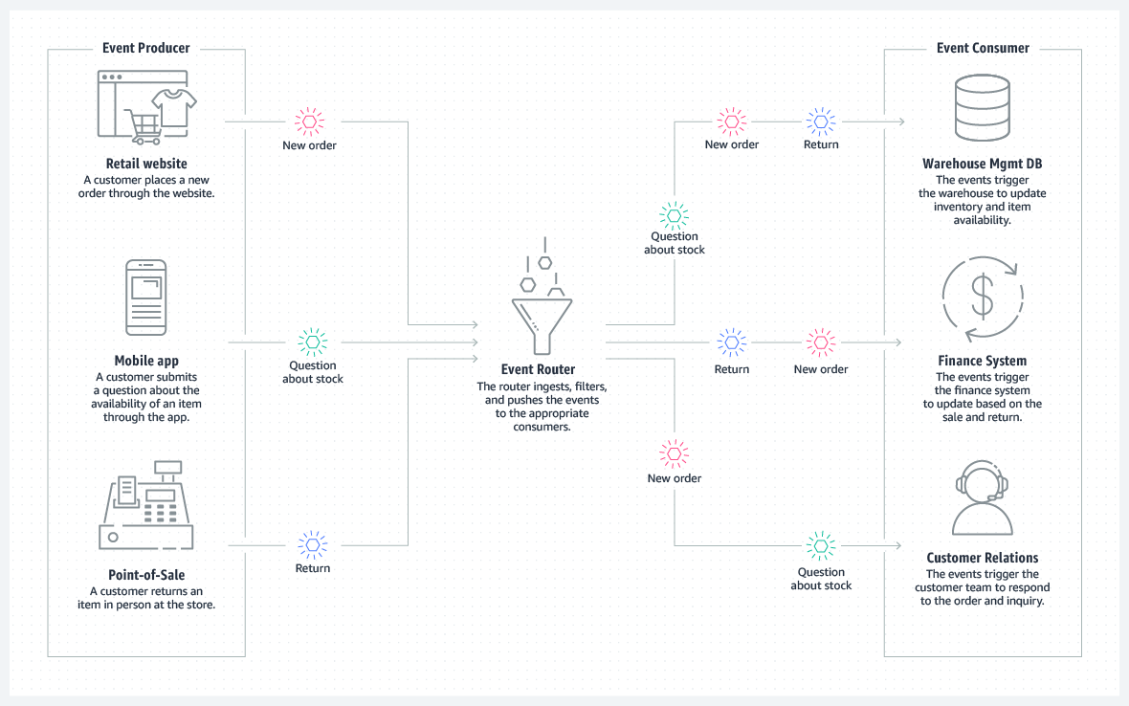

For more information about event-driven architectures, see [What is an Event-Driven Architecture?](https://aws.amazon.com/event-driven-architecture/)

**Amazon EventBridge compared to Amazon SNS**

You can use both Amazon EventBridge and Amazon Simple Notification Service (Amazon SNS) to develop event-driven applications. Your choice will depend on your specific needs.

We recommend EventBridge when you want to build an application that reacts to events from software as a service (SaaS) applications or AWS services. EventBridge is the only event-based service that integrates directly with third-party SaaS AWS Partners. EventBridge also automatically ingests events from over 90 AWS services without requiring developers to create any resources in their account. In addition, EventBridge uses a defined, JSON-based structure for events, and you can also select events to forward to a target by creating rules that are applied across the entire event body. EventBridge currently supports over 15 AWS services as targets, including AWS Lambda, Amazon Simple Queue Service (Amazon SQS), Amazon SNS, Amazon Kinesis Data Streams, and Amazon Kinesis Data Firehose, and more. At launch, EventBridge has limited throughput (see the service limits), which can be increased on request. It also has a typical latency of about half a second.

We recommend Amazon SNS when you want to build an application that reacts to high throughput or low-latency messages that are published by other applications or microservices. Amazon SNS provides nearly unlimited throughput. You can also use it for applications that need very high fan-out (thousands or millions of endpoints). Messages are unstructured and can be in any format. Amazon SNS supports forwarding messages to six different types of targets, including AWS Lambda, Amazon SQS, HTTP/S endpoints, Short Message Service (SMS), mobile push, and email. The typical latency of Amazon SNS typical is under 30 milliseconds. A range of AWS services—more than 30, including Amazon Elastic Compute Cloud (Amazon EC2), Amazon Simple Storage Service (Amazon S3), and Amazon Relational Database Service (Amazon RDS)—send SNS messages by configuring the service to send them.

**Amazon EventBridge**

EventBridge is a serverless event bus service that you can use to connect your applications with data from various sources. EventBridge delivers a stream of real-time data from your applications, software as a service (SaaS) applications, and AWS services to targets such as AWS Lambda functions, HTTP invocation endpoints using API destinations, or event buses in other AWS accounts.

EventBridge receives an event, which is an indicator of a change in environment. EventBridge then applies a rule to route the event to a [target](https://docs.aws.amazon.com/eventbridge/latest/userguide/eb-targets.html). Rules match events to targets based on either the structure of the event (which is called an *e*vent pattern), or on a schedule. For example, when an EC2 instance changes from pending to running, you can have a rule that sends the event to a Lambda function. For more information about events, see [Amazon EventBridge events](https://docs.aws.amazon.com/eventbridge/latest/userguide/eb-events.html). For more information about rules, see [Amazon EventBridge rules](https://docs.aws.amazon.com/eventbridge/latest/userguide/eb-rules.html). Finally, for more information about event patterns, see [Amazon EventBridge event patterns](https://docs.aws.amazon.com/eventbridge/latest/userguide/eb-event-patterns.html).

All events that come to EventBridge are associated with an event bus. Rules are tied to a single event bus, so they can only be applied to events on that event bus. Your account has a default event bus, which receives events from AWS services. You can also create custom event buses to send or receive events from a different account or Region. For more information about event buses, see [Amazon EventBridge event buses](https://docs.aws.amazon.com/eventbridge/latest/userguide/eb-event-bus.html).

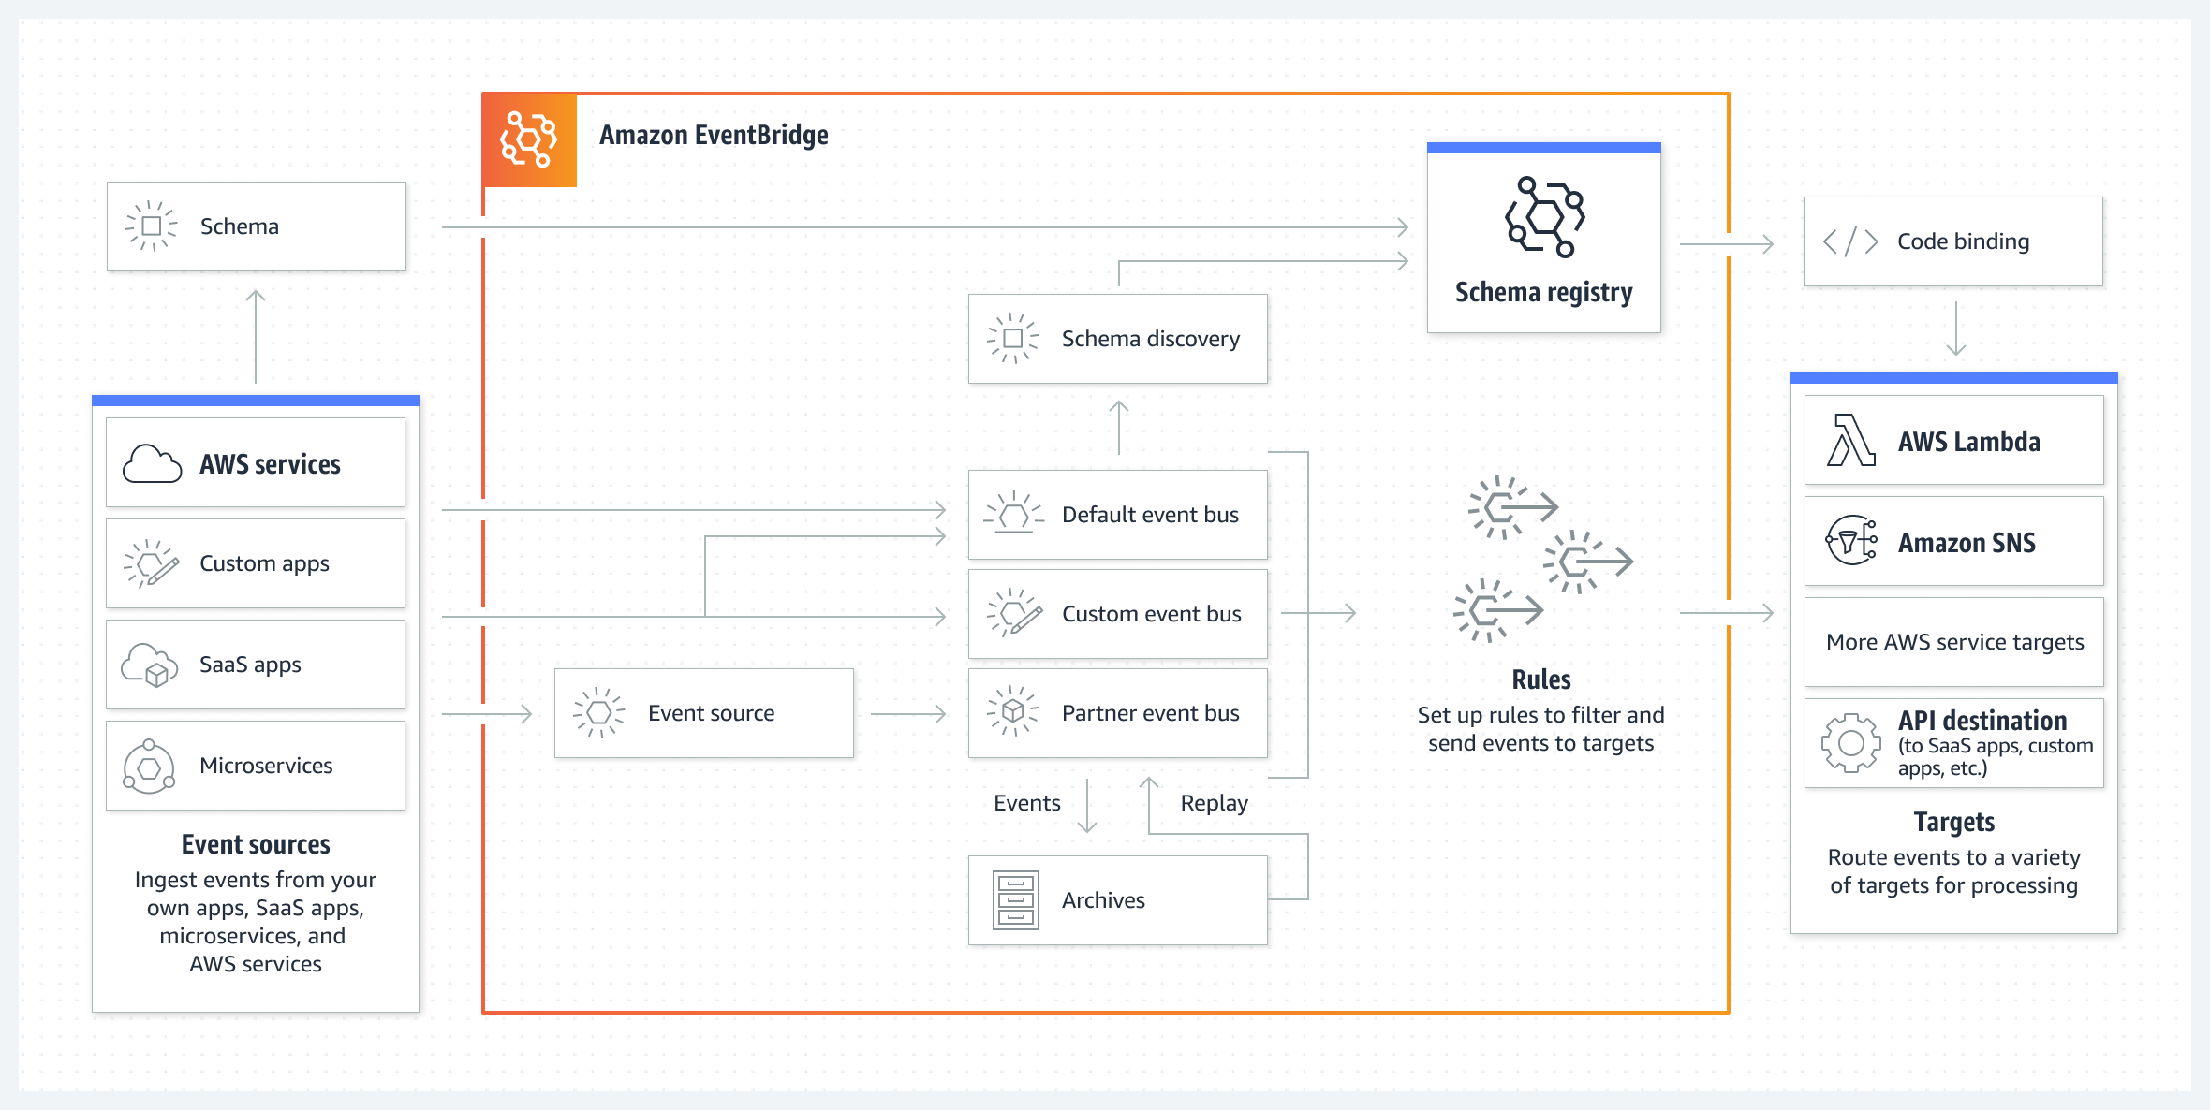

For more information about Amazon EventBridge, see the [Amazon EventBridge FAQs](https://aws.amazon.com/eventbridge/faqs/) or [What is Amazon EventBridge?](https://docs.aws.amazon.com/eventbridge/latest/userguide/eb-what-is.html)

**Amazon SNS**

Amazon SNS is a managed service that provides message delivery from publishers to subscribers (which are also known as producers and consumers). Publishers communicate asynchronously with subscribers by sending messages to a topic, which is a logical access point and communication channel. Clients can subscribe to the SNS topic and receive published messages by using a supported endpoint type, such as Amazon Kinesis Data Firehose, Amazon SQS, AWS Lambda, HTTP, email, mobile push notifications, and mobile text messages through Short Message Service (SMS).

Morgan chose Amazon SNS the customer’s architecture because it’s simple to use and supports a straightforward way to send messages between application components.

**Service Update:** Amazon SNS now supports payload-based message filtering [click here](https://aws.amazon.com/blogs/compute/introducing-payload-based-message-filtering-for-amazon-sns/) for more information.

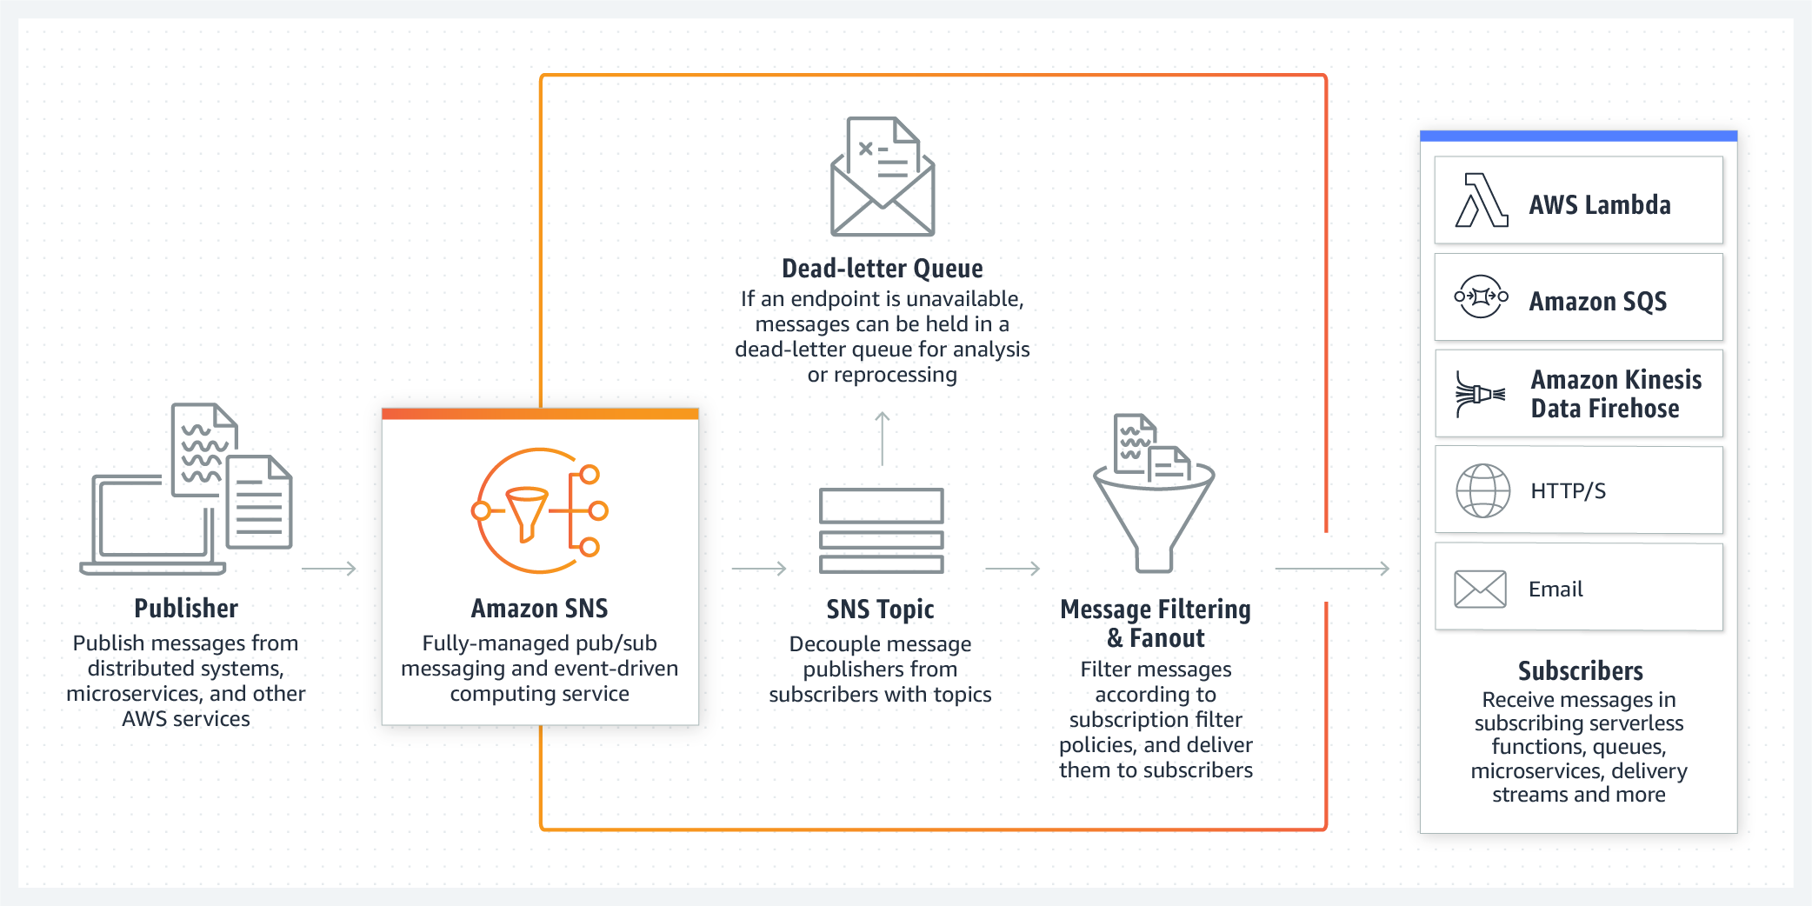

* For more information about Amazon SNS, see the [Amazon SNS FAQs](https://aws.amazon.com/sns/faqs/) or [What is Amazon SNS?](https://docs.aws.amazon.com/sns/latest/dg/welcome.html)
* For a tutorial on how to set up an Amazon SNS topic, see [Getting started with Amazon SNS.](https://docs.aws.amazon.com/sns/latest/dg/sns-getting-started.html#step-create-queue)

**Amazon DynamoDB Streams**

DynamoDB Streams captures a time-ordered sequence of item-level modifications in any DynamoDB table, and stores this information in a log for up to 24 hours. Applications can access this log and view the data items as they appeared, before and after they were modified, in near-real time.Encryption at rest encrypts the data in DynamoDB streams.DynamoDB Streams helps ensure the following:

* Each stream record appears exactly one time in the stream.
* For each item that is modified in a DynamoDB table, the stream records appear in the same sequence as the actual modifications to the item.

DynamoDB Streams writes stream records in near-real time so that you can build applications that consume these streams and take action based on the contents.You can enable a stream on a new table when you create it by using the AWS Command Line Interface (AWS CLI) or one of the AWS SDKs. You can also enable or disable a stream on an existing table, or change the settings of a stream. DynamoDB Streams operates asynchronously, so table performance isn’t affected if you enable a stream.All data in DynamoDB Streams is subject to a 24-hour lifetime. You can retrieve and analyze the last 24 hours of activity for any given table. However, data that is older than 24 hours is susceptible to trimming (removal) at any moment.

* For more information about Amazon DynamoDB Streams, see [Change data capture for DynamoDB Streams.](https://docs.aws.amazon.com/amazondynamodb/latest/developerguide/Streams.html)
* For a tutorial about how to process DynamoDB streams with an AWS Lambda function, see [Tutorial: Process new items with DynamoDB Streams and Lambda](https://docs.aws.amazon.com/amazondynamodb/latest/developerguide/Streams.Lambda.Tutorial.html)

# Decoupling Solutions on AWS

This week’s customer had issues with latency for their end users because they were using a synchronous model for their web backend. Morgan suggested that they migrate to an asynchronous model, where the order is first stored, and then processed shortly after. With this model, end user can receive a response more quickly from the backend. When the backend system receives an order, it can immediately respond and then process the request asynchronously.

A loosely coupled architecture minimizes the bottlenecks that are caused by synchronous communication, latency, and I/O operations. Amazon Simple Queue Service (Amazon SQS) and AWS Lambda are often used to implement asynchronous communication between different services.You should consider using this pattern if you have the following requirements:

* You want to create loosely coupled architecture.
* All operations don’t need to be completed in a single transaction, and some operations can be asynchronous.
* The downstream system can’t handle the incoming transactions per second (TPS) rate. The messages can be written to the queue and processed based on the availability of resources.

A disadvantage of this pattern is that the actions of business transaction are synchronous. Even though the calling system receives a response, some part of the transaction might still continue to be processed by downstream systems.

For more information, see [Patterns for integrating microservices](https://docs.aws.amazon.com/prescriptive-guidance/latest/modernization-integrating-microservices/integrating-patterns.html).

## Building storage-first applications

Building a storage-first application can help an application be more reliable when working with events. You can read more about this topic in the blog post [Building storage-first serverless applications with HTTP APIs service integrations](https://aws.amazon.com/blogs/compute/building-storage-first-applications-with-http-apis-service-integrations/).

## Amazon SQS

Amazon SQS is a fully managed, message queuing service that you can use to decouple and scale microservices, distributed systems, and serverless applications. Amazon SQS reduces the complexity and overhead associated with managing and operating message-oriented middleware, which means that developers can focus on differentiating work. By using Amazon SQS, you can send, store, and receive messages between software components at virtually any volume, without losing messages or requiring other services to be available.

When you [create](https://docs.aws.amazon.com/AWSSimpleQueueService/latest/SQSDeveloperGuide/sqs-configure-create-queue.html) or [edit](https://docs.aws.amazon.com/AWSSimpleQueueService/latest/SQSDeveloperGuide/sqs-configure-edit-queue.html) a queue, you can configure the following parameters:

* Visibility timeout: The length of time that a message received from a queue (by one consumer) won't be visible to the other message consumers.
* Message retention period: The amount of time that Amazon SQS retains messages that remain in the queue. By default, the queue retains messages for 4 days. You can configure a queue to retain messages for up to 14 days.
* Delivery delay: The amount of time that Amazon SQS will delay before it delivers a message that is added to the queue. For more information, see [Amazon SQS delay queues](https://docs.aws.amazon.com/AWSSimpleQueueService/latest/SQSDeveloperGuide/sqs-delay-queues.html).
* Maximum message size: The maximum message size for the queue.
* Receive message wait time: The maximum amount of time that Amazon SQS waits for messages to become available after the queue gets a receive request.
* Enable content-based deduplication: Amazon SQS can automatically create deduplication IDs based on the body of the message.
* Enable high throughput FIFO: This feature enables high throughput for messages in the queue. Choosing this option changes the related options (deduplication scope and FIFO throughput limit) to the required settings for enabling high throughput for FIFO queues.
* Redrive allow policy: This policy defines which source queues can use this queue as the dead-letter queue.

### Short polling compared to long polling

When you consume messages from a queue by using short polling, Amazon SQS samples a subset of its servers (based on a weighted random distribution) and returns messages from only those servers. Thus, a particular ReceiveMessage request might not return all of your messages. However, if you have fewer than 1,000 messages in your queue, a subsequent request will return your messages. If you keep consuming from your queues, Amazon SQS samples all of its servers, and you receive all of your messages.

The following diagram shows the short-polling behavior of messages returned from a standard queue after one of your system components makes a receive request. Amazon SQS samples several of its servers (in gray) and returns messages A, C, D, and B from these servers. Message E isn't returned for this request, but it's returned for a subsequent request.

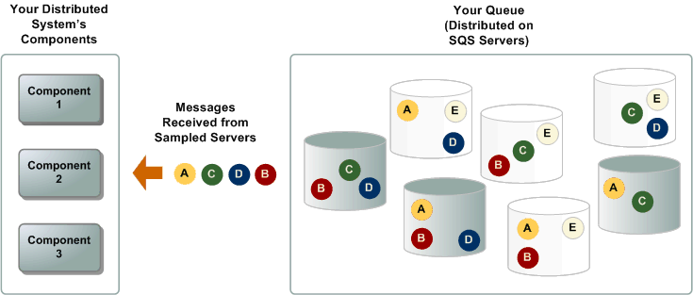

When the wait time for the ReceiveMessage API action is greater than 0, long polling is in effect. The maximum long polling wait time is 20 seconds. Long polling helps reduce the cost of using Amazon SQS by reducing the number of empty responses (when there are no messages available for a ReceiveMessage request) and false empty responses (when messages are available, but aren't included in a response). For information about enabling long polling for a new or existing queue using the Amazon SQS console, see [Configuring queue parameters (console)](https://docs.aws.amazon.com/AWSSimpleQueueService/latest/SQSDeveloperGuide/sqs-configure-queue-parameters.html). For best practices, see [Setting up long polling](https://docs.aws.amazon.com/AWSSimpleQueueService/latest/SQSDeveloperGuide/working-with-messages.html#setting-up-long-polling).

Long polling offers the following benefits:

* Reduces empty responses by letting Amazon SQS wait until a message is available in a queue before it sends a response. Unless the connection times out, the response to the ReceiveMessage request contains at least one of the available messages, up to the maximum number of messages specified in the ReceiveMessage action. In rare cases, you might receive empty responses even when a queue still contains messages, especially if you specify a low value for the ReceiveMessageWaitTimeSeconds parameter.
* Reduces false empty responses by querying all—instead of a subset of—Amazon SQS servers.
* Returns messages as soon as they become available.

### Resources

* For more information about Amazon SQS, see [What is Amazon Simple Queue Service?](https://docs.aws.amazon.com/AWSSimpleQueueService/latest/SQSDeveloperGuide/welcome.html) or [Amazon SQS FAQs](https://aws.amazon.com/sqs/faqs/).
* For a tutorial about setting up Amazon SQS to invoke Lambda functions, see [Using AWS Lambda with Amazon SQS](https://docs.aws.amazon.com/lambda/latest/dg/with-sqs.html).

# Architecture Optimizations for Week 1

In this reading, you will find further information about the topics that Morgan and Raf talked about in the video where they both played Solutions Architects.

## Caching for Amazon DynamoDB by using Amazon DynamoDB Accelerator

Raf mentioned that if you need to improve Amazon DynamoDB performance to microsecond latency, to look into using Amazon DynamoDB Accelerator (DAX).

DAX is a fully managed, highly available, in-memory [cache](https://aws.amazon.com/caching/) for DynamoDB that’s designed to deliver up to a 100-times performance improvement—from milliseconds to microseconds—even at millions of requests per second.

DAX does the heavy lifting that’s required to add in-memory acceleration to your DynamoDB tables—and developers don’t need to manage cache invalidation, data population, or cluster management.

A benefit of using DAX is that you don’t need to modify the application logic because DAX is compatible with existing DynamoDB API calls.

DAX is designed to run within an Amazon Virtual Private Cloud (Amazon VPC) environment. Amazon VPC defines a virtual network that closely resembles a traditional data center. With a VPC, you have control over its IP address range, subnets, routing tables, network gateways, and security settings. You can launch a DAX cluster in your virtual network, and control access to the cluster by using Amazon VPC security groups.

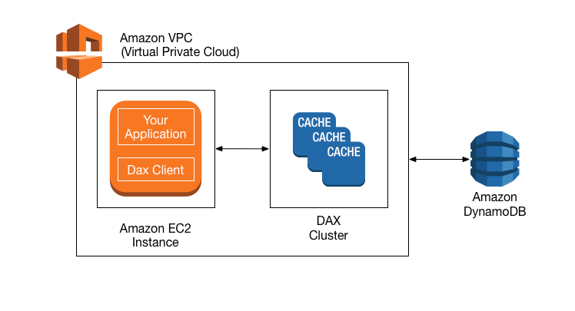

For more information about DAX, see [Amazon DynamoDB Accelerator.](https://aws.amazon.com/dynamodb/dax/)

## Optimizing AWS Lambda

### AWS Lambda Power Tuning

Morgan mentioned that you can fine-tune the memory or power configuration for your AWS Lambda functions to potentially increase performance and lower costs.

[AWS Lambda Power Tuning](https://github.com/alexcasalboni/aws-lambda-power-tuning) is an open-source tool that helps you visualize and fine-tune the memory or power configuration of Lambda functions. It runs in your own AWS account, and it supports three optimization strategies: cost, speed, and balanced.

AWS Lambda Power Tuning is a state machine that’s powered by AWS Step Functions. It helps you optimize your Lambda functions for cost or performance in a data-driven way.The state machine is designed to be easy to deploy and fast to execute. Also, it's language agnostic, so you can optimize any Lambda functions in your account.

To work with AWS Lambda Power Turning, you provide a Lambda function Amazon Resource Name (ARN) as input. The state machine then invokes that function with multiple power configurations (from 128 MB to 10 GB—you decide which values). Then, it analyzes all the execution logs and suggests the best power configuration to minimize cost or maximize performance.

Note that the input function will run in your AWS account, which means that it will perform HTTP requests, SDK calls, cold starts, and so on. The state machine also supports cross-Region invocations, and you can enable parallel execution to generate results in a few seconds.

The state machine generates a visualization of average cost and speed for each power configuration.

For example, the following diagram shows results for two CPU-intensive functions, which become both cheaper and faster with more power.

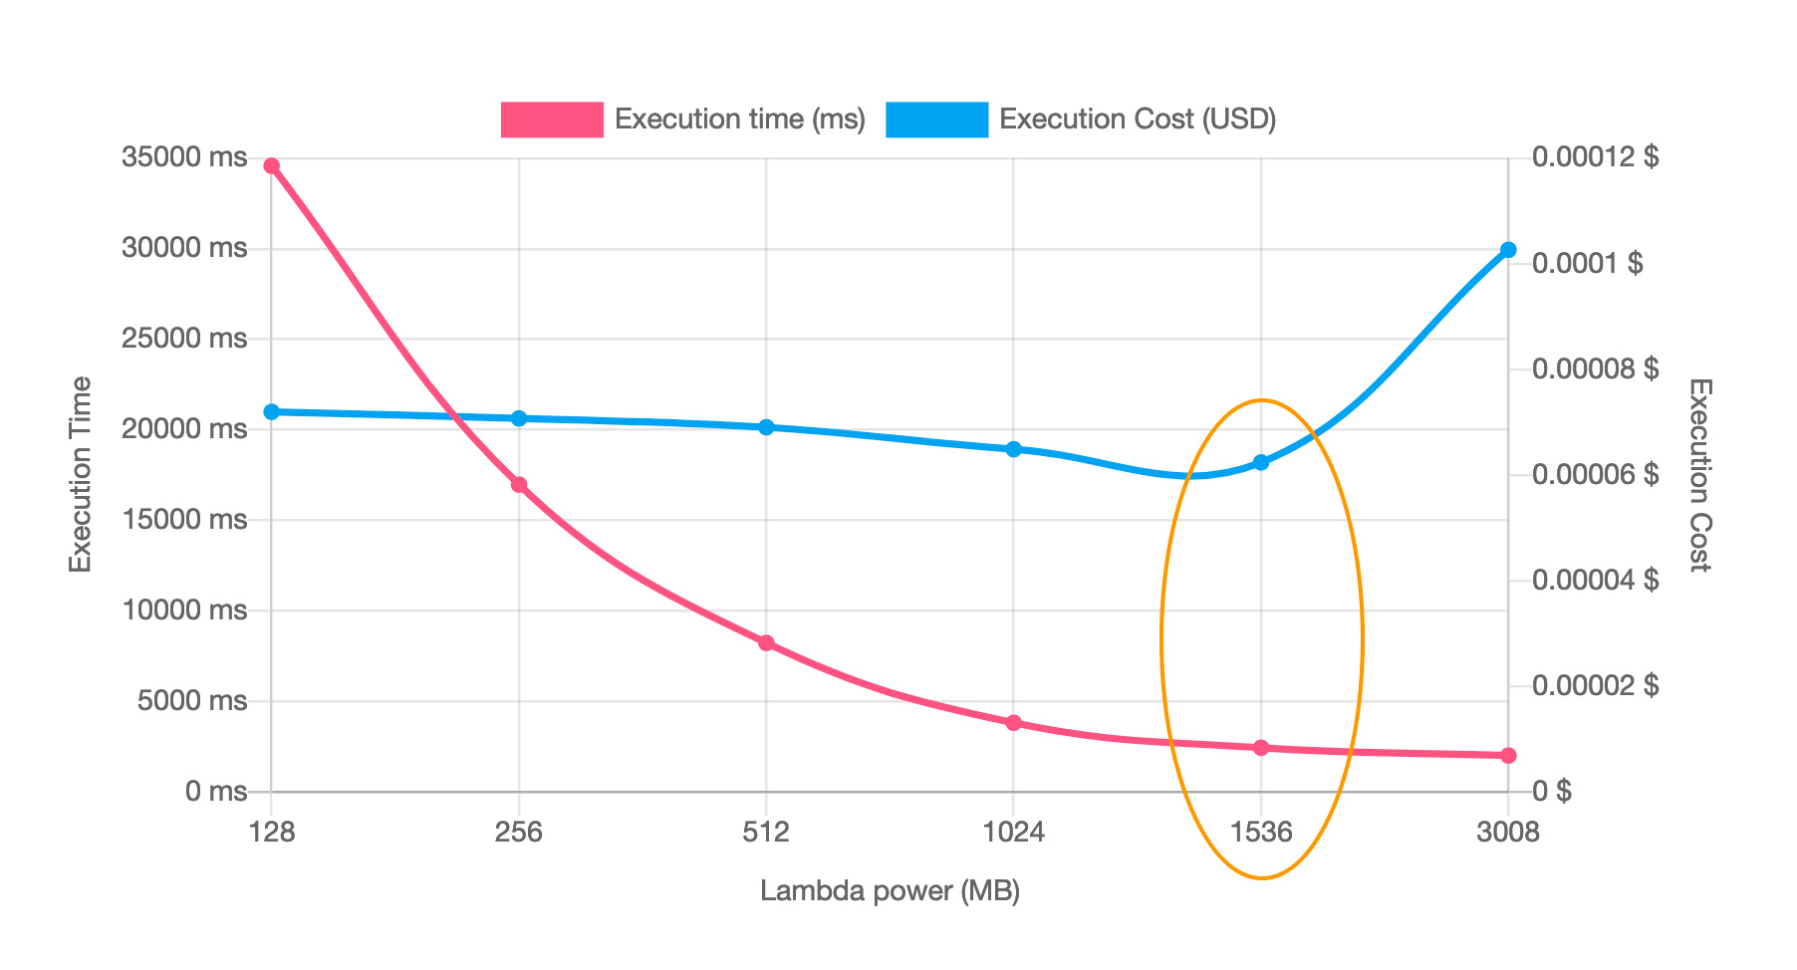

For more information, see [AWS Lambda Power Tuning](https://github.com/alexcasalboni/aws-lambda-power-tuning).

### AWS Lambda Powertools

Morgan also mentioned that you can use another suite of tools called AWS Lambda Powertools to optimize your Lambda functions and use best practices. AWS Lambda Powertools is a suite of utilities for AWS Lambda functions that is designed to make it easier to adopt best practices such as tracing, structured logging, custom metrics, idempotency, batching, and more.

For more information, see [AWS Lambda Powertools](https://awslabs.github.io/aws-lambda-powertools-python/latest/).

### AWS Lambda execution environment reuse

Another optimization technique that Morgan mentioned for Lambda is to move certain initialization tasks in your code so they are outside the handler. These tasks can then be reused across invocations (which is also known as execution environment reuse).

You can take advantage of execution environment reuse to improve the performance of your function. To do this, initialize SDK clients and database connections outside of the function handler, and cache static assets locally in the /tmp directory. Subsequent invocations that are processed by the same instance of your function can reuse these resources. This reuse saves cost by reducing function run time.

To avoid potential data leaks across invocations, don’t use the execution environment to store user data, events, or other information with security implications. If your function relies on a mutable state that can’t be stored in memory within the handler, consider creating a separate function or separate versions of a function for each user.

To learn more, see [Best practices for working with AWS Lambda.](https://docs.aws.amazon.com/lambda/latest/dg/best-practices.html)

### Resources

* For more information about how to optimize serverless applications for cost, see [Building well-architected serverless applications: Optimizing application costs](https://aws.amazon.com/blogs/compute/building-well-architected-serverless-applications-optimizing-application-costs/) in the AWS Compute Blog.
* For more information about well-architected serverless applications, visit [Serverless Applications Lens - AWS Well-Architected Framework](https://docs.aws.amazon.com/wellarchitected/latest/serverless-applications-lens/welcome.html?did=wp_card&trk=wp_card).

# A Look into AWS Data Services

In this course, the Morgan and Raf cover some of the AWS data services that can be used for a solution that ingests clickstream data. Clickstream is the term for small events that contain pieces of data that are generated continuously with high speed and volume. Remember, clickstream data is usually data that’s collected by systems (mostly frontends) regarding user interactions with that system. In this week’s scenario, clickstream data will be used to collect information about users’ behaviors when they interact with a restaurant menu. Regardless of whether you are architecting for clickstream data, AWS provides various analytics services that meet your needs for data analytics. Organizations of all sizes and industries can use these services to reinvent their business with data.

## AWS data services

From data movement, data storage, data lakes, big data analytics, log analytics, streaming analytics, business intelligence, and machine learning (ML) to many things in between, AWS offers purpose-built services that provide price performance, scalability, and low costs. [Data Lakes and Analytics on AWS](https://aws.amazon.com/big-data/datalakes-and-analytics/) lists all the AWS services that can be used for data analytics, and places the services into four distinct categories. This reading summarizes the most popular services in each category.

## Data lakes and data storage

#### Amazon S3

Amazon Simple Storage Service (Amazon S3) is an object storage service that offers scalability, data availability, security, and performance. Customers of all sizes and industries can store and protect virtually any amount of data for virtually any use case, such as data lakes, cloud-native applications, and mobile apps. With cost-effective storage classes and easy-to-use management features, you can optimize costs, organize data, and configure fine-tuned access controls to meet specific business, organizational, and compliance requirements.

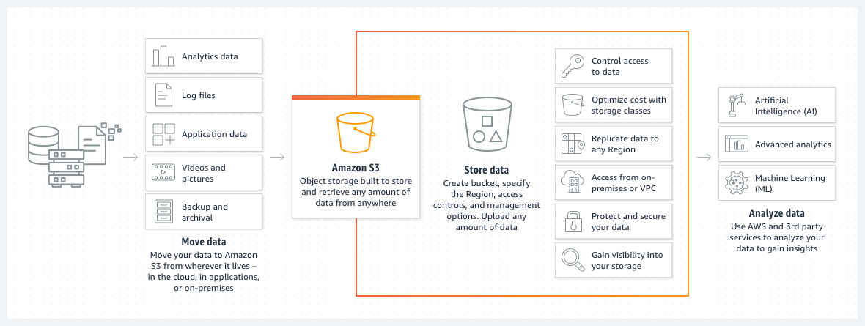

The following list details some use cases for Amazon S3:

* Archive data at the lowest cost: Move data archives to the Amazon Simple Storage Service Glacier (Amazon S3 Glacier storage classes to lower costs, reduce operational complexities, and gain new insights.
* Run cloud-native applications: Build fast, powerful, mobile and web-based cloud-native applications that scale automatically in a highly available configuration, such as static websites that use the client side for coding.
* Build a data lake: Run big data analytics, artificial intelligence (AI), machine learning (ML), and high performance computing (HPC) applications to unlock data insights.
* Back up and restore critical data: Meet Recovery Time Objectives (RTO), Recovery Point Objectives (RPO), and compliance requirements with the robust replication features of Amazon S3.

For more information, see [Amazon S3](https://aws.amazon.com/s3/).

#### Amazon S3 Glacier

**Note:** Amazon S3 storage classes will have their own dedicated reading later in this week.The Amazon S3 Glacier storage classes are purpose-built for data archiving. They are designed to provide you with high performance, retrieval flexibility, and low-cost archive storage in the cloud. All S3 Glacier storage classes provide virtually unlimited scalability and are designed for 99.999999999 percent (11 nines) of data durability. In addition to low-cost storage, the S3 Glacier storage classes also deliver options for fast access to your archival data.

For more information, see [Amazon S3 Glacier storage classes](https://aws.amazon.com/s3/storage-classes/glacier/).

#### AWS Lake Formation

AWS Lake Formation is a service that you can use to set up a secure data lake in days. A data lake is a centralized, curated, and secured repository that stores all your data, both in its original form and prepared for analysis. You can use a data lake to break down data silos and combine different types of analytics to gain insights and guide better business decisions.

For more information, see [AWS Lake Formation](https://aws.amazon.com/lake-formation/?whats-new-cards.sort-by=item.additionalFields.postDateTime&whats-new-cards.sort-order=desc).

## Data analytics

#### Amazon Athena

Amazon Athena is an interactive query service that you can use to analyze data in Amazon S3 by using standard Structured Query Language (SQL). Athena is serverless, so you don’t need to manage infrastructure, and you pay only for the queries that you run.

Using Athena is straightforward. You point to your data in Amazon S3, define the schema, and start querying by using standard SQL. Most results are delivered within seconds. With Athena, you don’t need complex extract, transform, and load (ETL) jobs to prepare your data for analysis. Anyone with SQL skills can use Athena to quickly analyze large-scale datasets.

For more information, see [Amazon Athena](https://aws.amazon.com/athena/).

#### Amazon EMR

Amazon EMR is a big data solution for petabyte-scale data processing, interactive analytics, and machine learning that use open-source frameworks, such as Apache Spark, Apache Hive, and Presto.

In this course, we didn’t use or explore Amazon EMR for this week’s scenario because the customer was short-staffed, and Amazon EMR requires a learning curve to operate the open-source frameworks that it uses. In fact, Amazon EMR has so many features that we could make an entire 4-week course about it! The following list details some of the use cases for Amazon EMR. (Notice that the third item aligns well with the week’s scenario—Amazon EMR would a good candidate for the task if the customer already had big data knowledge.)

* Run large-scale data processing and what-if analysis by using statistical algorithms and predictive models to uncover hidden patterns, correlations, market trends, and customer preferences.
* Extract data from various sources, process it at scale, and make the data available for applications and users.
* Analyze events from streaming data sources in real time to create long-running, highly available, and fault-tolerant streaming data pipelines.
* Analyze data using open-source ML frameworks, such as Apache Spark MLlib, TensorFlow, and Apache MXNet.
* Connect to Amazon SageMaker Studio for large-scale model training, analysis, and reporting.

For more information, see [Amazon EMR](https://aws.amazon.com/emr/?c=a&sec=srv).

#### Amazon OpenSearch Service

You can use Amazon OpenSearch Service to perform interactive log analytics, real-time application monitoring, website search, and more. OpenSearch is an open source, distributed search and analytics suite that is derived from Elasticsearch. Amazon OpenSearch Service is the successor to Amazon Elasticsearch Service. It offers the latest versions of OpenSearch, support for 19 versions of Elasticsearch, and visualization capabilities that are powered by OpenSearch Dashboards and Kibana. Amazon OpenSearch Service currently has tens of thousands of active customers, with hundreds of thousands of clusters under management, processing hundreds of trillions of requests per month.

For more information, see [Amazon OpenSearch Service](https://aws.amazon.com/opensearch-service/?c=a&sec=srv).

## Data movement

#### Amazon Kinesis

**Note:** Later this week, Amazon Kinesis will have its own dedicated reading that further explains each of the Kinesis services (such as Amazon Kinesis Data Streams, Amazon Kinesis Data Firehose, and Amazon Kinesis Data Analytics).

With Amazon Kinesis, you can collect, process, and analyze real-time, streaming data so that you can get timely insights and react quickly to new information. Amazon Kinesis offers key capabilities to cost-effectively process streaming data at virtually any scale, along with the flexibility to choose the tools that best suit the requirements of your application. With Amazon Kinesis, you can ingest real-time data such as video, audio, application logs, website clickstreams, and Internet of Things (IoT) telemetry data for machine learning, analytics, and other applications. You can use Amazon Kinesis to process and analyze data as it arrives, which means that you can respond quickly—you don’t need to wait for all your data to be collected before processing can begin.

For more information, see [Amazon Kinesis](https://aws.amazon.com/kinesis/).

#### AWS Glue

AWS Glue is a serverless data integration service that you can use to discover, prepare, and combine data for analytics, machine learning, and application development. AWS Glue provides capabilities that are needed for data integration so that you can start analyzing your data and using your data in minutes instead of months. Data integration is the process of preparing and combining data for analytics, machine learning, and application development. It involves multiple tasks, such as discovering and extracting data from various sources; enriching, cleaning, normalizing, and combining data; and loading and organizing data in databases, data warehouses, and data lakes. These tasks are often handled by different types of users who each use different products.

For more information, see [AWS Glue](https://aws.amazon.com/glue/?whats-new-cards.sort-by=item.additionalFields.postDateTime&whats-new-cards.sort-order=desc).

#### AWS DMS

AWS Database Migration Service (AWS DMS) helps you migrate databases to AWS quickly and securely. The source database remains fully operational during the migration, which minimizes downtime to applications that rely on the database. AWS DMS can migrate your data to and from the most widely used commercial and open-source databases.

For more information, see [AWS Database Migration Service](https://aws.amazon.com/dms/).

## Predictive analytics and machine learning

You won’t explore this area much in this course, but—as was mentioned earlier in this reading—regardless of the kind of architecture you want to create, AWS offers services that can help. (That is, use the right tool for the job!) Though you might not see the following AWS services typically listed with AWS data services, you can use them to handle or process data for predictive analytics and machine learning (ML).

#### Amazon SageMaker

SageMaker can be used for any generic ML solution. You can use it to build, train, and deploy ML models for virtually any use case with fully managed infrastructure, tools, and workflows. SageMaker requires a learning curve to use, but it’s a managed serverless service that many people can use to innovate with ML through a choice of tools—such as integrated development environments (IDEs) for data scientists and no-code interfaces for business analysts.

For more information, see [Amazon SageMaker](https://aws.amazon.com/sagemaker/).

#### Amazon Rekognition

Amazon Rekognition is one of Raf’s favorite ML services from the entire list of AWS services! It is easy to use, serverless, and abstracted, in the sense that you interact with it by doing API calls. With Amazon Rekognition, you can automate image and video analysis by adding pretrained or customizable computer vision API operations to your applications without building ML models and infrastructure from scratch.

On its own, Amazon Rekognition is not a data analytics service. However, it’s listed here because you can use it as part of a data analytics solution. It is designed to analyze millions of images, streaming, and stored videos within 3 seconds.

Check out some examples:



In this image, Amazon Rekognition is detecting objects (such as packages, pets, or people) in real time from live video streams.



In this image, Amazon Rekognition is detecting faces that appear in images and videos, and recognizing attributes (such as open eyes, glasses, and facial hair) for each face.

For more information, see [Amazon Rekognition](https://aws.amazon.com/rekognition/).

#### Amazon Comprehend

Amazon Comprehend is a natural-language processing (NLP) service that uses ML to uncover valuable insights and connections in text, which is instrumental for a data analytics solution. For example, you could mine business and call center analytics or process financial documents. For medical use cases, you can use Amazon Comprehend Medical, which focuses on extracting information accurately and quickly from unstructured medical text.For more information, see [Amazon Comprehend](https://aws.amazon.com/comprehend/) and [Amazon Comprehend Medical](https://aws.amazon.com/comprehend/medical/).

# Amazon S3 Cross-Region Replication and Object Lifecycle

## S3 CRR

With S3 Cross-Region Replication (CRR), you can replicate objects—and their respective metadata and object tags—into other AWS Regions for reduced latency, compliance, security, disaster recovery, and other use cases. CRR can be configured from a single, source Amazon Simple Storage Service (Amazon S3) bucket to replicate objects into one or more destination buckets in another AWS Region.

CRR automatically replicates data between buckets across different AWS Regions. With CRR, you can set up replication at a bucket level, a shared prefix level, or an object level (by using Amazon S3 object tags).

You can use CRR to provide lower-latency data access in different geographic regions. CRR can also help if you have a compliance requirement to store copies of data hundreds of miles apart. You can use CRR to change account ownership for the replicated objects to protect data from accidental deletion. For more information about CRR, see [Replicating objects](https://docs.aws.amazon.com/AmazonS3/latest/userguide/replication.html) in the Amazon S3 User Guide.

Example use cases include the following:

* Compliance: Amazon S3 stores your data across multiple geographically distant Availability Zones by default. However, compliance requirements might require you to store data at even greater distances. You can use CRR to replicate data between distant AWS Regions to satisfy these requirements.
* Latency performance: If your customers or end users are distributed across one or more geographic locations, you can minimize latency for data access by maintaining multiple object copies in AWS Regions that are geographically closer to your customers.
* Regional efficiency: If you have compute clusters in two or more AWS Regions that analyze the same set of objects, you might choose to maintain object copies in all of those AWS Regions.

## S3 Lifecycle

You can add rules in an S3 Lifecycle configuration to tell Amazon S3 to transition objects to another Amazon S3 storage class. For more information about storage classes, see. Some examples of when you might use S3 Lifecycle configurations in this way include the following:

* When you know that objects are infrequently accessed, you might transition them to the S3 Standard-IA storage class.
* You might want to archive objects that you don't need to access in real time to the S3 Glacier Flexible Retrieval storage class.

However, what if you’re not sure about the data access patterns?

### Amazon S3 Intelligent-Tiering storage class

S3 Intelligent-Tiering is a good storage class for data with unknown, changing, or unpredictable access patterns—independent of object size or retention period. You can use S3 Intelligent-Tiering as the default storage class for virtually any workload, especially data lakes, data analytics, new applications, and user-generated content.

S3 Intelligent-Tiering is the only cloud storage class that’s designed to deliver automatic storage cost savings when data access patterns change, without performance impact or operational overhead. S3 Intelligent-Tiering is designed to optimize storage costs by automatically moving data to the most cost-effective access tier when access patterns change. For a small monthly object monitoring and automation charge, S3 Intelligent-Tiering monitors access patterns and automatically moves objects that haven’t been accessed to lower-cost access tiers.

There are no retrieval charges in S3 Intelligent-Tiering. S3 Intelligent-Tiering has no minimum eligible object size, but objects smaller than 128 KB are not eligible for automatic tiering. These smaller objects can be stored, but they will always be charged at the Frequent Access tier rates and don’t incur the monitoring and automation charge.

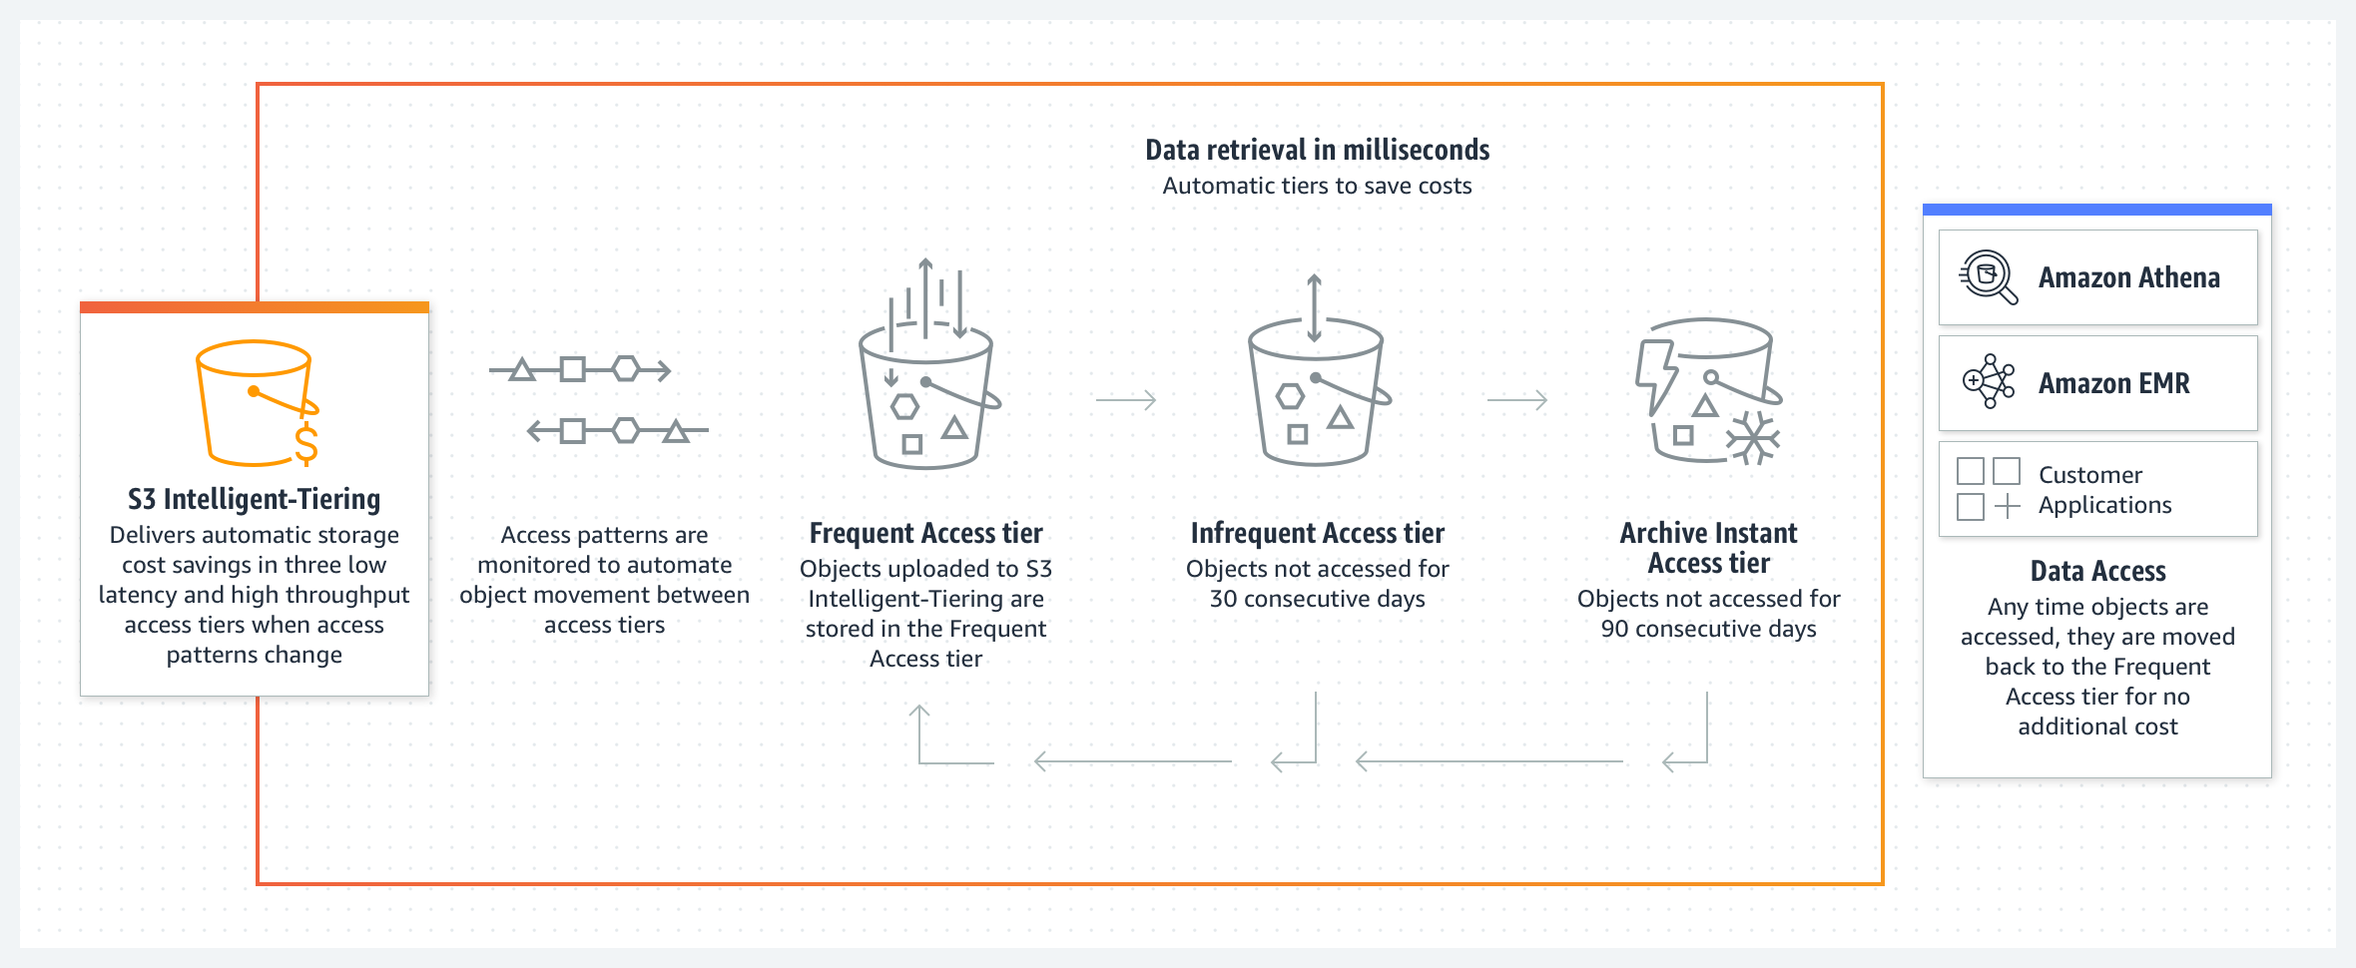

For more information, see [Amazon S3 Intelligent-Tiering storage class](https://aws.amazon.com/s3/storage-classes/intelligent-tiering/).

### Amazon S3 Glacier storage classes

You can use Amazon S3 Lifecycle policies to transition objects from one storage class to another. These storage classes include Amazon Simple Storage Service Glacier (Amazon S3 Glacier) storage classes, which are purpose-built for data archiving. S3 Glacier storage classes provide you with low-cost archive storage in the cloud. All S3 Glacier storage classes provide virtually unlimited scalability and are designed for 99.999999999 percent (11 nines) of data durability. The S3 Glacier storage classes deliver options for fast access to your archive data and low-cost archive storage in the cloud.

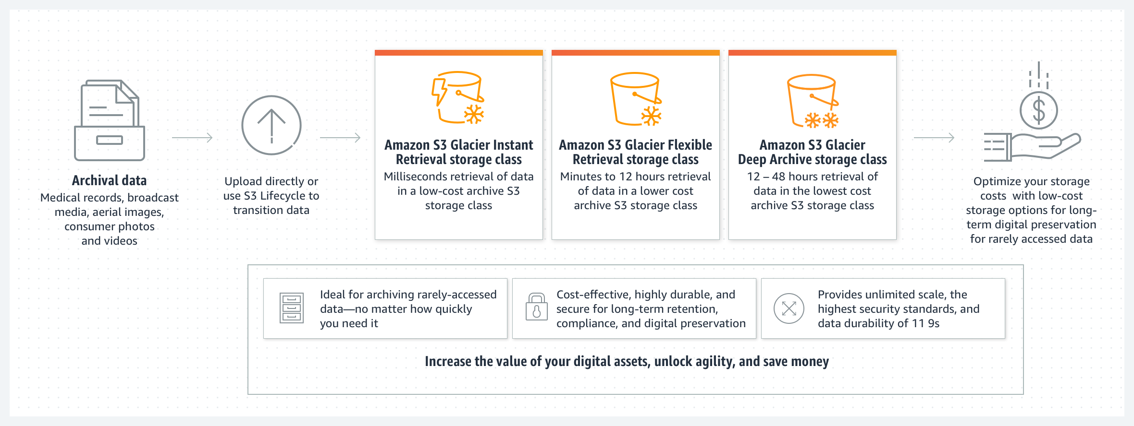

For more information, see [Amazon S3 Glacier storage classes](https://aws.amazon.com/s3/storage-classes/glacier/).

# Differences Between Amazon Kinesis Services

**Amazon Kinesis Family** The Amazon Kinesis Family makes it easier to collect, process, and analyze real-time, streaming data so that you can get timely insights and react quickly to new information. Amazon Kinesis offers key capabilities to cost-effectively process streaming data at virtually any scale, along with the flexibility to choose the tools that best suit the requirements of your application. With Amazon Kinesis, you can ingest real-time data such as video, audio, application logs, website clickstreams, and Internet of Things (IoT) telemetry data for machine learning, analytics, and other applications. You can use Amazon Kinesis to process and analyze data as it arrives, which means that you can respond quickly instead of waiting until all your data is collected before it’s processed. For more information, see [Amazon Kinesis](https://aws.amazon.com/kinesis/). **Amazon Kinesis Data Streams** Amazon Kinesis Data Streams is a massively scalable and durable real-time data streaming service. Kinesis Data Streams is designed to continuously capture gigabytes of data per second from hundreds of thousands of sources, such as website clickstreams, database event streams, financial transactions, social media feeds, IT logs, and location-tracking events. The data that’s collected is typically available in milliseconds, which means that you can use Kinesis Data Streams with use cases for real-time analytics, such as real-time dashboards, real-time anomaly detection, dynamic pricing, and more. For more information, see [Amazon Kinesis Data Streams](https://aws.amazon.com/kinesis/data-streams/). **Amazon Kinesis Data Firehose** Amazon Kinesis Data Firehose is designed to reliably load streaming data into data lakes, data stores, and analytics services. It can capture, transform, and deliver streaming data to Amazon Simple Storage Service (Amazon S3), Amazon Redshift, Amazon Elasticsearch Service, generic HTTP endpoints, and service providers like Datadog, New Relic, MongoDB, and Splunk. It is a fully managed service that automatically scales to match the throughput of your data and requires virtually no ongoing administration. It can also batch, compress, transform, and encrypt your data streams before loading, which minimizes the amount of storage that you use and increases security. Although it’s easier to operate when compared with Amazon Kinesis Data Streams, Kinesis Data Firehose delivery streams have a higher latency from the moment that data is ingested. For example, you can set the batch interval to 60 seconds if you want to receive new data within 60 seconds of sending it to your delivery stream. However, you could have latencies that are lower than 1 second when you use Amazon Kinesis Data Streams. For more information, see [Amazon Kinesis Data Firehose](https://aws.amazon.com/kinesis/data-firehose/?kinesis-blogs.sort-by=item.additionalFields.createdDate&kinesis-blogs.sort-order=desc). **Amazon Kinesis Data Analytics** Amazon Kinesis Data Analytics is designed to transform and analyze streaming data in real time with Apache Flink. Apache Flink is an open-source framework and engine for processing data streams. Amazon Kinesis Data Analytics reduces the complexity of building, managing, and integrating Apache Flink applications with other AWS services. Amazon Kinesis Data Analytics is designed to take care of everything that’s required to run streaming applications continuously. It also scales automatically to match the volume and throughput of your incoming data. With Amazon Kinesis Data Analytics, there are no servers to manage, no minimum fee or setup cost, and you only pay for the resources that your streaming applications consume. For more information, see [Amazon Kinesis Data Analytics](https://aws.amazon.com/kinesis/data-analytics/). **Amazon Kinesis Video Streams** Amazon Kinesis Video Streams is designed to securely stream video from connected devices to AWS for analytics, machine learning (ML), playback, and other forms of processing. Kinesis Video Streams automatically provisions and elastically scales the infrastructure that’s needed to ingest streaming video data from millions of devices. It’s designed to durably store, encrypt, and index video data in your streams, and you can access your data through the Kinesis Video Streams APIs. You can use Kinesis Video Streams to play back video for live and on-demand viewing. You can also use it to quickly build applications that take advantage of computer vision and video analytics through integration with Amazon Rekognition Video and libraries for ML frameworks (such as Apache MXNet, TensorFlow, and OpenCV). Kinesis Video Streams also supports WebRTC, an open-source project that uses APIs to facilitate real-time media streaming and interaction between web browsers, mobile applications, and connected devices. Typical uses for WebRTC include video chat and peer-to-peer media streaming. For more information, see [Amazon Kinesis Video Streams](https://aws.amazon.com/kinesis/video-streams/).

Amazon QuickSight Features

With Amazon QuickSight, everyone in your organization can better understand your data by asking questions in natural language and exploring interactive dashboards. QuickSight can also automatically look for patterns and outliers (a feature that’s powered by machine learning).

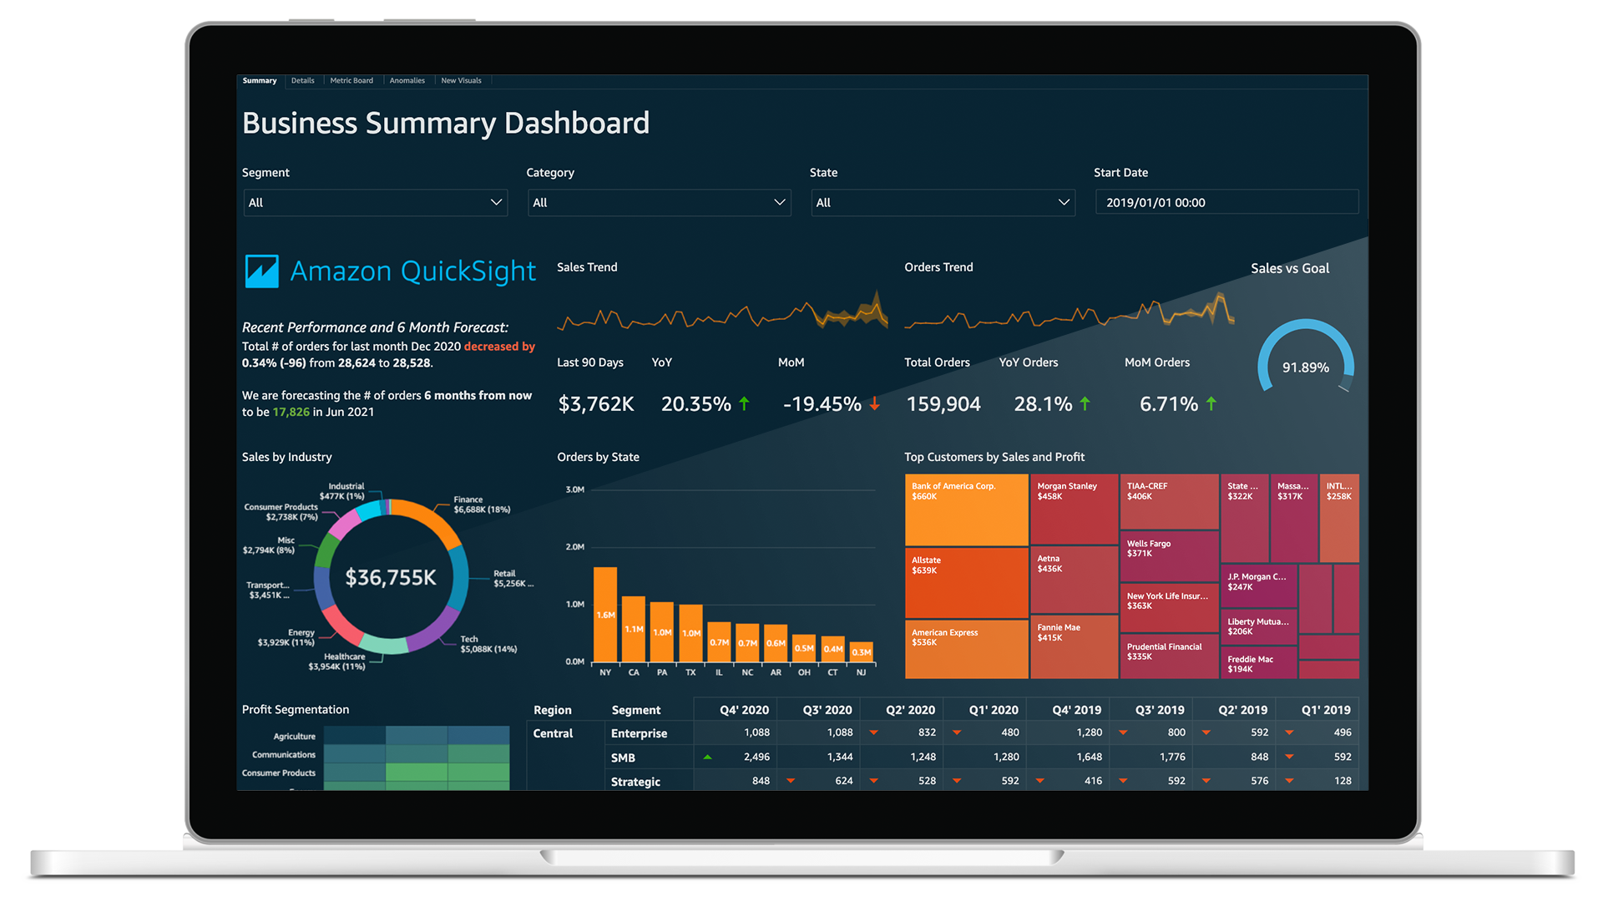

QuickSight powers millions of dashboard views weekly for customers, which means that their end users can make better, data-driven decisions. Here are some key features and benefits of QuickSight:

* Connect and scale all your data
  + Connect to all your data in AWS, in third-party cloud service providers, or on premises
  + Use SPICE in-memory storage to scale data exploration to thousands of users
  + Combine data from multiple sources and create complex data models for governed data sharing
* Build customizable dashboards
  + Use dashboard design to create customized, use-case-specific dashboards
  + Deliver personalized email reports and alerts to end users
  + Access information from virtually anywhere by using QuickSight access for iOS, Android, or mobile web applications
* Use machine learning (ML) integrations for insights
  + Use Anomaly Detection to continuously analyze all your data for anomalies and variations
  + Forecast business metrics and perform interactive what-if analyses
  + Customize Auto-Narratives and weave them into dashboards to provide deeper context for users
* Enable self-service business intelligence (BI) for everyone
  + Dive deep into data through simple questions, without BI training
  + Create visual analyses of data by using a web-based authoring interface
  + Embed QuickSight capabilities in applications for data-driven user experiences
* Use native integration with AWS
  + Use private virtual private cloud (VPC) connectivity for secure AWS access to Amazon Redshift, Snowflake, Exasol, Amazon Relational Database Service (Amazon RDS), and more
  + Use native AWS Identity and Access Management (IAM) permissions for Amazon Simple Storage Service (Amazon S3) and Amazon Athena, with fine-grained access control for serverless data exploration
  + Use Amazon SageMaker integration to incorporate sophisticated ML models without complex data pipelines
* Take advantage of no servers to manage, and paying by usage
  + Automatically scale serverless architecture to hundreds of thousands of users with high availability, with no need to overprovision for peak usage
  + Provide consistent, fast response times for end users and analysts through the auto-scaling capabilities of the SPICE in-memory engine, with no need to scale databases for high workloads
  + Optimize costs through the pay-per-session model by paying only for actual usage, with no need to buy thousands of end-user licenses for large-scale BI or embedded analytics
* Take advantage of built-in security, governance, and compliance
  + Use end-to-end data encryption for data, and use encryption at rest for data in SPICE
  + Use row-level and column-level security with API support for control at the user or group level.
  + Take advantage of rapid deployment for regulated workloads with compliance support for the Health Insurance Portability and Accountability Act (HIPAA), HITRUST CSF, General Data Protection Regulation (GDPR), System and Organizational Controls (SOC), Payment Card Industry (PCI), International Organization for Standardization (ISO) 27001, Federal Risk and Authorization Management Program (FedRAMP) High, and more

Architecture Optimizations for Week 2

In this reading, you will find further information about the topics that Morgan and Raf talked in the video where they both played solutions architects.

**Serverless on AWS**

Morgan commented about changing the system that generates QR codes into something serverless, or a container. AWS offers technologies for running code, managing data, and integrating applications—all without managing servers. Serverless technologies feature automatic scaling, built-in high availability, and a pay-for-use billing model to increase agility and optimize costs. These technologies also reduce infrastructure management tasks, such as capacity provisioning and patching, so that you can focus on writing code that serves your customers. Serverless applications start with AWS Lambda, an event-driven compute service that natively integrates with over 200 AWS services and software as a service (SaaS) applications.

For more information, see [Serverless on AWS](https://aws.amazon.com/serverless/).

**Amazon CloudFront**

Then, Raf commented that Amazon CloudFront could be used with the Amazon Simple Storage Service (Amazon S3) bucket that is used to display the restaurant menus. Amazon CloudFront is a web service that speeds up the distribution of your static and dynamic web content (such as .html, .css, .js, and image files) to your users. CloudFront delivers your content through a worldwide network of data centers that are called edge locations. When a user requests content that you're serving with CloudFront, the request is routed to the edge location that provides the lowest latency (time delay), so that content is delivered with the best possible performance. In addition, Amazon CloudFront allows custom SSL certificates (issued by AWS Certificate Manager, or ACM), custom domain names, and further distributed denial of service (DDoS) protection that is powered by AWS WAF and AWS Shield.

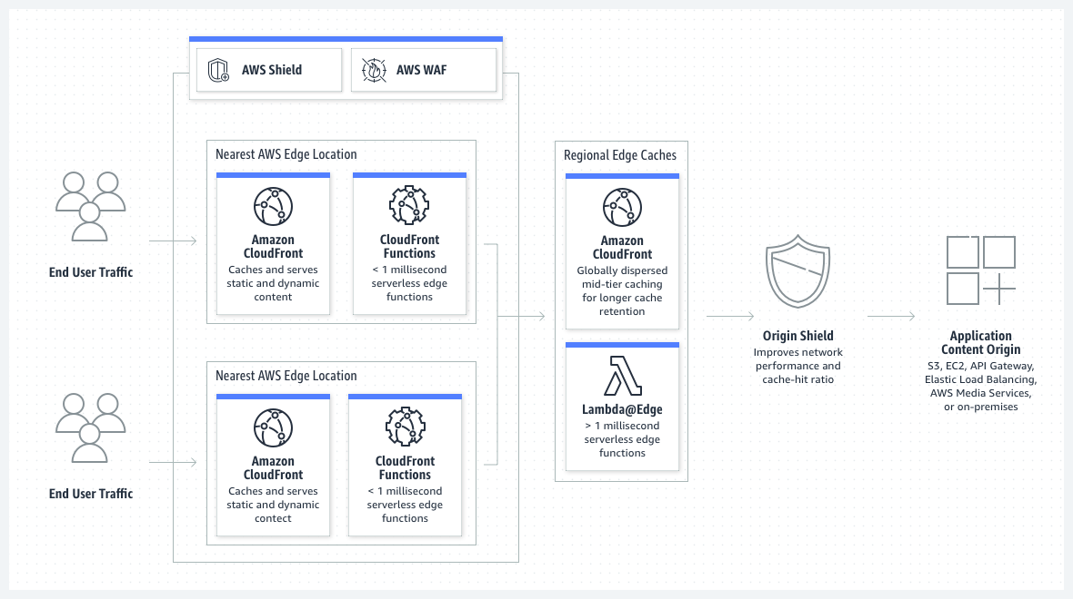

For more information, see [Amazon CloudFront](https://aws.amazon.com/cloudfront/).

**Amazon Cognito**

Morgan commented about using Amazon Cognito instead of Amazon API Gateway to send data to Amazon Kinesis. This solution would require refactoring code in the JavaScript library that sends the clickstream data. However, it would also bypass API Gateway, and therefore reduce cost. You can use Amazon Cognito to add user sign-up, sign-in, and access control to your web applications and mobile apps. Amazon Cognito scales to millions of users and supports sign-in with social identity providers, such as Apple, Facebook, Google, and Amazon, and enterprise identity providers through SAML 2.0 and OpenID Connect. For more information, see [Amazon Cognito](https://aws.amazon.com/cognito/). With Amazon Cognito, you can have a mobile JavaScript library that assumes a role with a web identity. That role must have a strict policy associated with it—for example, the policy could allow only the PutRecord API operation on a specific Kinesis data stream. For more information, see [AssumeRoleWithWebIdentity](https://docs.aws.amazon.com/STS/latest/APIReference/API_AssumeRoleWithWebIdentity.html) in the *AWS Security Token Service API Reference*.

**Amazon CloudFormation and IaC**

Later in the conversation, Raf talked about transforming the entire environment into a template that could be further replicated for each of the customer’s clients. This can be achieved by treating infrastructure as code (IaC) with a managed AWS service called AWS CloudFormation. CloudFormation helps you model and set up your AWS resources so that you can spend less time managing those resources, and more time focusing on your applications that run in AWS. You create a template that describes all the AWS resources that you want—for example, Amazon Elastic Compute Cloud (Amazon EC2) instances or Amazon Relational Database Service (Amazon RDS) DB instances—and CloudFormation provisions and configures those resources for you. You don't need to individually create and configure AWS resources and figure out which resource is dependent on another resource. For example, this YAML template snippet creates an S3 bucket with the following configurations:

* Static website hosting that uses index.html as the index document and error.html as the error document
* Bucket policy that allows everyone to GET objects (otherwise, the bucket is private)
* Deletion policy that asks CloudFormation to retain the bucket if the CloudFormation stack is deleted (this is a good practice when you use data services, such as buckets and databases)

The snippet also outputs the https:// URL that’s used by static website hosting, which you can send to someone else, or copy and paste into a web browser after the bucket is created.

1

2

3

4

5

6

7

8

9

10

11

12

13

14

15

16

17

18

19

20

21

22

23

24

25

26

27

28

29

30

31

32

33

34

35

36

37

38

39

40

AWSTemplateFormatVersion: 2010-09-09

Resources:

  S3Bucket:

    Type: 'AWS::S3::Bucket'

    Properties:

      AccessControl: PublicRead

      WebsiteConfiguration:

        IndexDocument: index.html

        ErrorDocument: error.html

    DeletionPolicy: Retain

  BucketPolicy:

    Type: 'AWS::S3::BucketPolicy'

    Properties:

      PolicyDocument:

        Id: MyPolicy

        Version: 2012-10-17

        Statement:

          - Sid: PublicReadForGetBucketObjects

            Effect: Allow

            Principal: '*'

            Action: 's3:GetObject'

            Resource: !Join

              - ''

              - - 'arn:aws:s3:::'

                - !Ref S3Bucket

                - /*

      Bucket: !Ref S3Bucket

Outputs:

  WebsiteURL:

    Value: !GetAtt

      - S3Bucket

      - WebsiteURL

    Description: URL for website hosted on S3

  S3BucketSecureURL:

    Value: !Join

      - ''

      - - 'https://'

        - !GetAtt

          - S3Bucket

          - DomainName





For more examples of how to use CloudFormation templates, see [Template snippets](https://docs.aws.amazon.com/AWSCloudFormation/latest/UserGuide/CHAP_TemplateQuickRef.html) in the *AWS CloudFormation User Guide*. Creating infrastructure templates is important because you can replicate customer workloads across multiple AWS accounts or Regions. You will learn more about how relevant and important this is in week 4 of this course. For more information, see [AWS CloudFormation](https://aws.amazon.com/cloudformation/).

**Error retries and exponential backoff in AWS**

Morgan also talked about error retries and exponential backoffs. Although this topic seems complicated, here are some best practices and observations about error retries and exponential backoffs. Numerous components on a network—such as DNS servers, switches, load balancers, and others—can generate errors anywhere in the life of a given request. The usual technique for dealing with these error responses in a networked environment is to implement retries in the client application. This technique increases the reliability of the application and reduces operational costs for the developer. If you are using one of the AWS SDKs, they already practice exponential backoffs by default. This default behavior would be one benefit of using Amazon Cognito on the client side to send data to Kinesis, instead of using a custom routine that sends data to API Gateway. You should implement a maximum delay interval and a maximum number of retries. The maximum delay interval and maximum number of retries are not necessarily fixed values. These values should be set based on the operation that’s being performed and other local factors, such as network latency. For more information, see [Error retries and exponential backoff in AWS](https://docs.aws.amazon.com/general/latest/gr/api-retries.html) in the *AWS General Reference*.

**Data optimizations for Amazon Athena**

Last, but not least—in the conversation, Raf talked about data optimization for Amazon Athena. This topic is broad, and it even has dedicated AWS Blog posts about the [Top 10 Performance Tuning Tips for Amazon Athena](https://aws.amazon.com/blogs/big-data/top-10-performance-tuning-tips-for-amazon-athena/). The top three data best practices for Athena are compressing, partitioning, and converting your data into columnar formats. In brief, Athena is a service that charges per amount of data scanned. By data scanned, AWS means the amount of data that Athena fetches to perform a query. As you know, data compression can reduce file sizes, which means that Athena scans less data per query. Because Athena scans less data, the queries also run faster. You can save from 30 percent to 90 percent on your per-query costs, and get better performance by applying data best practices. Data partitioning is another technique to restrict the amount of data that’s scanned by each query. You can partition your data by any key. A common practice is to partition the data based on time, which often leads to a multi-level partitioning scheme. For example, a customer who has data coming in every hour might decide to partition by year, month, date, and hour. Say that you have a 5-TB file containing monthly information in it, and this file pertains to a whole year. If you constantly query things by adding statements such as **WHERE Month = "February"**, the system will scan the entire 5-TB file for each query. The system will probably ignore data that doesn’t belong to the month of February. This process is slower and more expensive than partitioning the data so that you have files that belong to each individual month. If you partitioned the data by month, a query that contains a clause like **WHERE Month = "February"** would only scan data that pertains to the month of February, thus making the query faster and cheaper. For more information, see [Partitioning data in Athena](https://docs.aws.amazon.com/athena/latest/ug/partitions.html). Another strategy is to use an AWS service to convert bucket data into columnar data formats. Apache Parquet and ORC are columnar storage formats that are optimized for the fast retrieval of data and they are also used in AWS analytical applications. Columnar storage formats have the following characteristics that make them suitable for use with Athena:

* Compression by column, with the compression algorithm selected for the column data type to save storage space in Amazon S3, and reduce disk space and I/O during query processing.
* Predicate pushdown in Parquet and ORC enables Athena queries to fetch only the blocks that it needs, thus improving query performance. When an Athena query obtains specific column values from your data, it uses statistics from data block predicates, such as max or min values, to determine whether to read or skip the block.
* Splitting data in Parquet and ORC enables Athena to split the reading of data to multiple readers and increase parallelism when it processes queries.

For more information, see [Converting to columnar formats](https://docs.aws.amazon.com/athena/latest/ug/convert-to-columnar.html).

# Hybrid Networking and Connectivity

This week, the customer has a hybrid deployment, and they require a consistent connection between their data center and AWS. You should consider multiple architecture choices for this solution. However, Morgan ultimately chose AWS Direct Connect because the customer needed consistent, dedicated throughput for the high volume of data that flows between the data center and AWS.

For more information about common networking setups with AWS, see [Network-to-Amazon VPC connectivity options](https://docs.aws.amazon.com/whitepapers/latest/aws-vpc-connectivity-options/network-to-amazon-vpc-connectivity-options.html).

## AWS Direct Connect

The AWS Direct Connect cloud service is the shortest path to your AWS resources. While your network traffic is in transit, it remains on the AWS global network and never touches the public internet. This isolation reduces the chance of encountering bottlenecks or unexpected increases in latency.

When you create a new connection, you can choose a hosted connection that’s provided by an AWS Direct Connect Delivery Partner, or choose a dedicated connection from AWS—and deploy at over 100 AWS Direct Connect locations around the globe. With AWS Direct Connect SiteLink, you can send data between AWS Direct Connect locations to create private network connections between the offices and data centers in your global network.

Each dedicated AWS Direct Connect connection consists of a single dedicated connection between ports on your router and an AWS Direct Connect device. We recommend establishing a second connection for redundancy.

When you request multiple ports at the same AWS Direct Connect location, they will be provisioned on redundant AWS equipment.

If you have configured a backup Internet Protocol security (IPsec) virtual private network (VPN) connection instead, all virtual private cloud (VPC) traffic will fail over to the VPN connection automatically. Traffic to or from public resources, such as Amazon Simple Storage Service (Amazon S3), will be routed over the internet. If you don’t have a backup AWS Direct Connect link or an IPsec VPN link, then Amazon VPC traffic will be dropped if a failure occurs. Traffic to or from public resources will be routed over the internet.

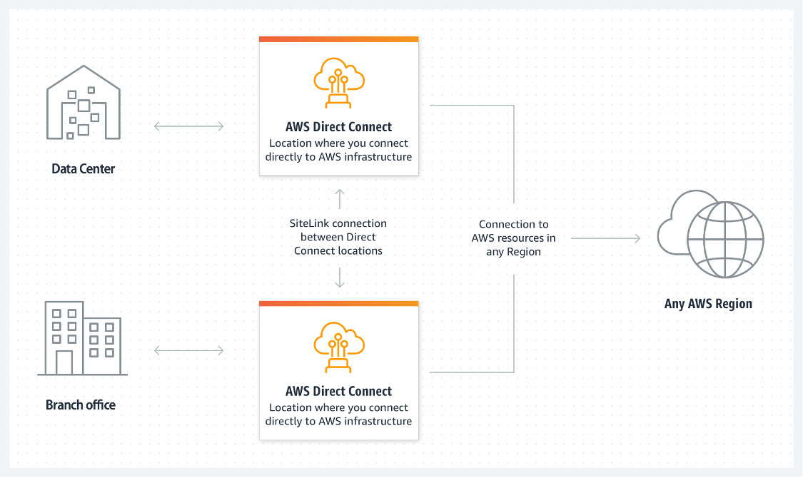

For more general information about AWS Direct Connect, see [What is AWS Direct Connect?](https://docs.aws.amazon.com/directconnect/latest/UserGuide/Welcome.html) and [AWS Direct Connect FAQs.](https://aws.amazon.com/directconnect/faqs/?nc=sn&loc=6)

## AWS Managed VPN

### AWS Site-to-Site VPN

By default, instances that you launch into a VPC can't communicate with your own (remote) network. You can enable access to your remote network from your VPC by creating an AWS Site-to-Site VPN connection, and configuring routing to pass traffic through the connection.VPN connection is a general term, but in AWS, a VPN connection refers to the connection between your VPC and your own on-premises network. Site-to-Site VPN supports IPsec VPN connections.

### Virtual private gateway

A virtual private gateway is the VPN concentrator on the Amazon side of the Site-to-Site VPN connection. You create a virtual private gateway and attach it to the VPC where you want to create the Site-to-Site VPN connection.

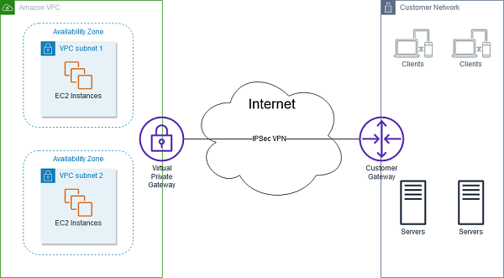

Consider taking this approach when you want to take advantage of an AWS managed VPN endpoint that includes automated redundancy and failover built into the AWS side of the VPN connection.

The virtual private gateway also supports and encourages multiple user gateway connections so that you can implement redundancy and failover on your side of the VPN connection, as shown in the following figure.

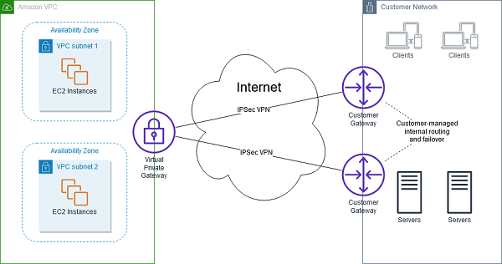

The previous diagram also shows a customer gateway on the customer-network side. A customer gateway device is a physical or software appliance that you own or manage in your on-premises network (that is, on your side of a Site-to-Site VPN connection). You or your network administrator must configure the device to work with the Site-to-Site VPN connection.

### AWS Client VPN

AWS Client VPN is a fully managed, remote-access VPN solution that your remote workforce can use to securely access resources within both AWS and your on-premises network. It’s fully elastic, so it automatically scales up or down, based on demand. When you migrate applications to AWS, your users access the applications in the same way before, during, and after the move. AWS Client VPN, including the software client, supports the OpenVPN protocol.The following scenarios are examples of how you could use AWS Client VPN.

#### Scenario 1

The configuration for this scenario includes a single target VPC. We recommend this configuration if you need to give clients access to the resources inside only a single VPC.

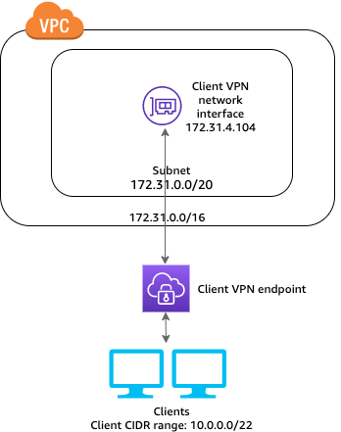

#### Scenario 2

The configuration for this scenario includes access to only an on-premises network. We recommend this configuration if you need to give clients access to the resources inside only an on-premises network.

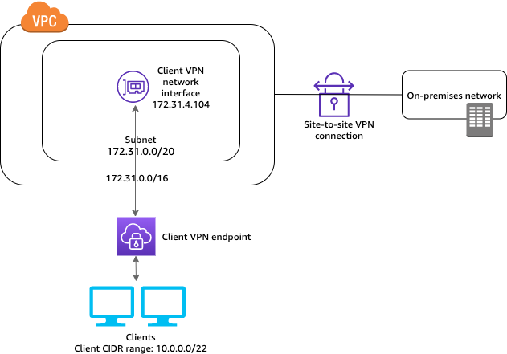

#### Scenario 3

In the configuration for the scenario shown in the following diagram, clients can access a single VPC, and clients can also route traffic to each other. We recommend this configuration if the clients that connect to the same client VPN endpoint also need to communicate with each other. Clients can communicate with each other by using the unique IP address that's assigned to them from the client Classless Inter-Domain Routing (CIDR) range when they connect to the client VPN endpoint.

* For more information about AWS Site-to-Site VPN, see [What is Amazon Site-to-Site VPN?](https://docs.aws.amazon.com/vpn/latest/s2svpn/VPC_VPN.html)

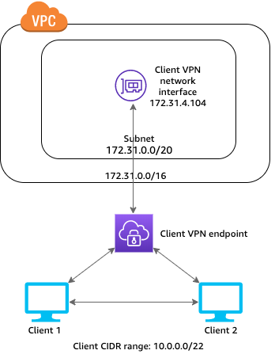

For more resources about AWS VPN services, see the following:

* For more information about AWS Client VPN, see [What is AWS Client VPN?](https://docs.aws.amazon.com/vpn/latest/clientvpn-admin/what-is.html)

## AWS Transit Gateway

Morgan mentioned that if multiple Regions or AWS accounts were all connected to a remote data center by using AWS Direct Connect, then she might recommend using AWS Transit Gateway.

AWS Transit Gateway connects your VPCs and on-premises networks through a central hub. This arrangement simplifies your network and minimizes complex peering relationships. Transit Gateway acts as a cloud router—each new connection is made only once.

As you expand globally, inter-Region peering connects transit gateways together through the AWS global network. Your data is automatically encrypted and never travels over the public internet.

### Without AWS Transit Gateway

The following diagram shows what a network solution might look like without the use of AWS Transit Gateway. Notice that there are many different connection points between the different components. This network configuration is complex, and it can be difficult to manage.

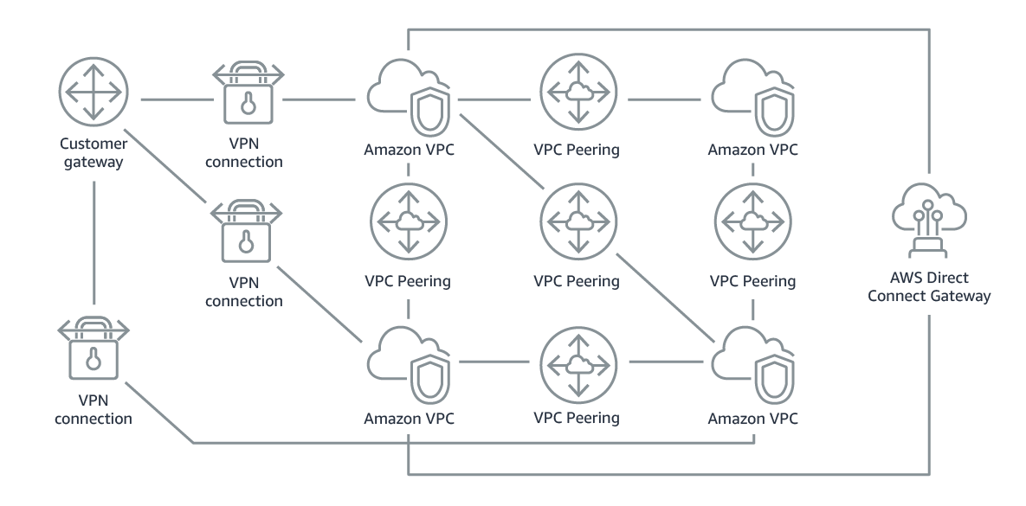

### With AWS Transit Gateway

In contrast, the following diagram shows what a network solution might look like with the use of AWS Transit Gateway. Transit Gateway is the hub for the connections between the different networks. Using a transit gateway can make the network easier to manage. You can apply route tables so that the transit gateway can connect networks to each other in a more centralized manner.

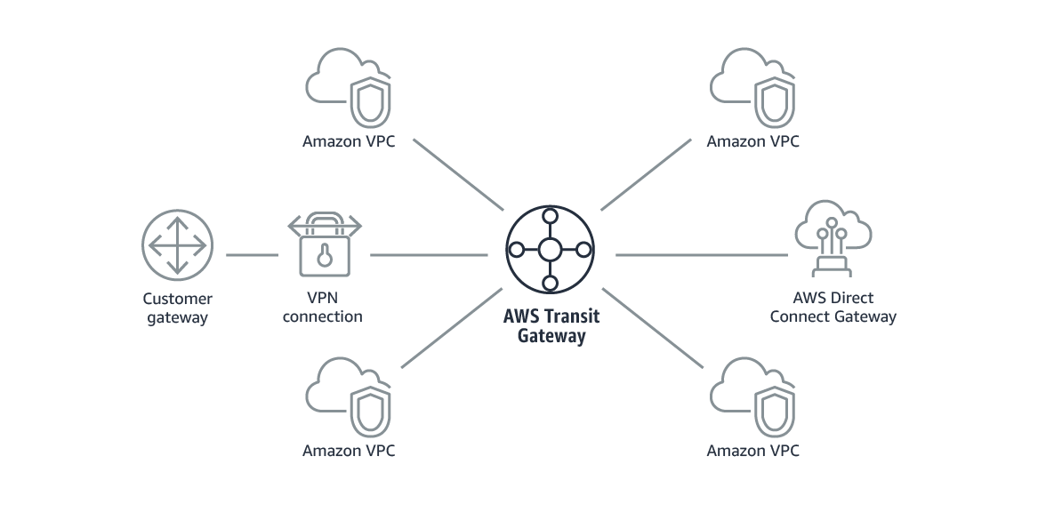

The following example shows what using AWS Transit Gateway with AWS Direct Connect could look like for a solution that has a remote network and three AWS Regions. Each Region has multiple VPCs.

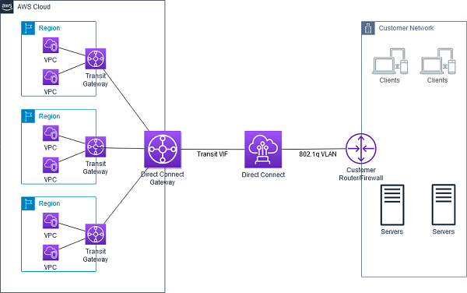

# Running Containers on AWS and NAT Gateways

This week’s customer needed a solution to host containers on AWS. These containers will be running internal applications that don’t require inbound communication from the internet. However, the applications might require outbound communication to the internet so they can do tasks such as download updates from internet sources. The customer must use their own custom Amazon Machine Image (AMI) for the cluster that hosts the containers, and they must also have SSH access to underlying instances. For these reasons, Morgan chose Amazon Elastic Container Service (Amazon ECS) as the container orchestration tool and Amazon Elastic Compute Clear (Amazon EC2) as the launch type. Morgan also chose to include a NAT gateway in the architecture so that private instances could download information from the internet.

## Amazon ECS launch types

After you choose which container orchestration tool you want to use—either Amazon ECS or Amazon Elastic Kubernetes Services (Amazon EKS)—there are two launch types to pick from:

* EC2: Deploy and manage your own cluster of EC2 instances for running the containers
* AWS Fargate: Run containers directly, without any EC2 instances

Both launch types are good compute options for hosting your containers in a scalable and reliable way. Which launch type you choose will depend on which factors you want to optimize for.

In the video, Morgan chose the EC2 launch type for containers that were being run by Amazon ECS. She chose the EC2 launch type because the customer wants to use a custom AMI. The customer also wants to maintain SSH access to underlying instances so they could try to have similar management operations across workloads. AWS Fargate doesn’t support either of these options. Therefore, EC2 was the correct choice for this use case.

### EC2 launch type

You can use the EC2 launch type to run your containerized applications on EC2 instances, which you register to your Amazon ECS cluster and manage yourself.

The following diagram shows the general architecture.

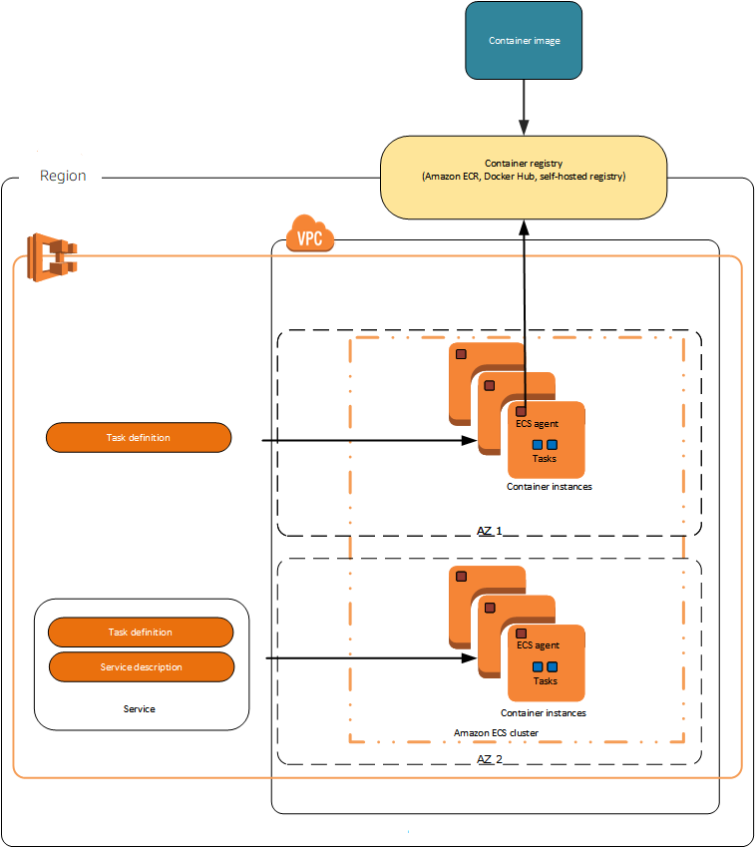

The diagram shows that the ECS agent is installed on each EC2 instance in the cluster. The ECS agent enables the orchestration tool that Amazon ECS uses to manage nodes.

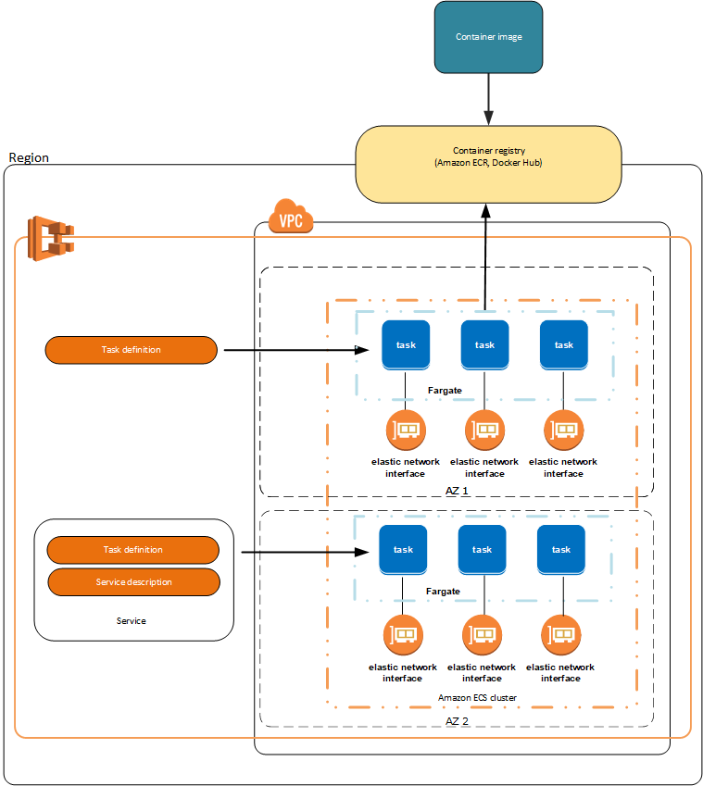

## Fargate launch type

You can use the Fargate launch type to run your containerized applications without the need to provision and manage the underlying infrastructure. AWS Fargate is the serverless way to host your Amazon ECS workloads.

The following diagram shows the general architecture.



For more resources about containers on AWS, see the following:

* For general information about AWS container services, see [Containers at AWS](https://aws.amazon.com/containers/) or the [Customers FAQs](https://aws.amazon.com/containers/faqs/) on the AWS Containers site.
* For more information about ECS launch types, see [Amazon ECS launch types](https://docs.aws.amazon.com/AmazonECS/latest/developerguide/launch_types.html).

## NAT devices

You can use a NAT device to allow resources in private subnets to connect to the internet, other VPCs, or on-premises networks. These instances can communicate with services outside the VPC, but they can’t receive unsolicited connection requests.

The NAT device replaces the source IPv4 address of the instances with the address of the NAT device. When the NAT device sends response traffic to the instances, the device translates the addresses back to the original source IPv4 addresses.

You can use a managed NAT device that’s offered by AWS, which is called a NAT gateway. You can also create your own NAT device on an EC2 instance, which is called a NAT instance. We recommend that you use NAT gateways because they provide better availability and bandwidth, and administering NAT gateways requires less effort on your part. You can manage how the traffic flows from the private resources to the NAT device by using route tables.

### NAT instances

You can create your own AMI that provides network address translation, and use your AMI to launch an EC2 instance as a NAT instance. You can launch a NAT instance in a public subnet so that instances in a private subnet can initiate outbound IPv4 traffic to the internet or other AWS services without receiving inbound traffic that was initiated on the internet.

### NAT gateways

A NAT gateway is a NAT service. You can use a NAT gateway so that instances in a private subnet can connect to services that are outside your VPC, but external services can’t initiate a connection with those instances.

When you create a NAT gateway, you specify one of the following connectivity types:

* Public (default): Instances in private subnets can connect to the internet through a public NAT gateway, but can’t receive unsolicited inbound connections from the internet. You create a public NAT gateway in a public subnet, and you must associate an elastic IP address with the NAT gateway at creation. You route traffic from the NAT gateway to the internet gateway for the VPC. Alternatively, you can use a public NAT gateway to connect to other VPCs or your on-premises network. In this case, you route traffic from the NAT gateway through a transit gateway or a virtual private gateway.
* Private: Instances in private subnets can connect to other VPCs or your on-premises network through a private NAT gateway. You can route traffic from the NAT gateway through a transit gateway or a virtual private gateway. You can’t associate an elastic IP address with a private NAT gateway. You can attach an internet gateway to a VPC with a private NAT gateway, but if you route traffic from the private NAT gateway to the internet gateway, the internet gateway drops the traffic.

The NAT gateway replaces the source IP address of the instances with the IP address of the NAT gateway. For a public NAT gateway, this is the elastic IP address of the NAT gateway. For a private NAT gateway, this is the private IP address of the NAT gateway. When the NAT device sends response traffic to the instances, it translates the addresses back to the original source IP address.For more resources about NAT devices, see the following:

* For more information, see [Connect to the internet or other networks using NAT devices](https://docs.aws.amazon.com/vpc/latest/userguide/vpc-nat.html).
* For information comparing NAT devices, see [Compare NAT gateways and NAT instances](https://docs.aws.amazon.com/vpc/latest/userguide/vpc-nat-comparison.html).

# Amazon RDS

## Multi-AZ deployments

For this week’s customer, Morgan recommends that they migrate their on-premises database to Amazon Relational Database Service (Amazon RDS), and to use a Multi-AZ deployment for high availability.

In a Multi-AZ deployment, Amazon RDS automatically creates a primary database (DB) instance and synchronously replicates the data to an instance in a different Availability Zone. When it detects a failure, Amazon RDS automatically fails over to a standby instance without manual intervention. This failover mechanism meets the customer’s need to have a highly available database.

The following diagram shows a Multi-AZ deployment with one standby DB instance, and how it works.

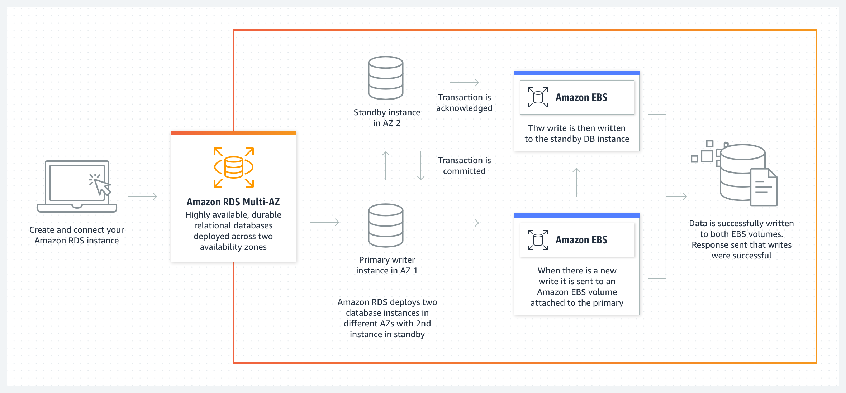

For even higher availability, the customer could explore deploying two standby DB instances, and use three Availability Zones instead of two.

Say that you deploy MySQL or PostgreSQL databases in three Availability Zones by using Amazon RDS Multi-AZ with two readable standbys. With this configuration, you can see automatic failovers typically happen in under 35 seconds, and with a transaction-commit latency that can be up to two times faster when compared to an Amazon RDS Multi-AZ deployment with one standby. You can also gain additional read capacity, and a choice of AWS Graviton2–based or Intel–based instances for compute.

The following diagram shows a Multi-AZ deployment with two standby DB instances, and how it works.

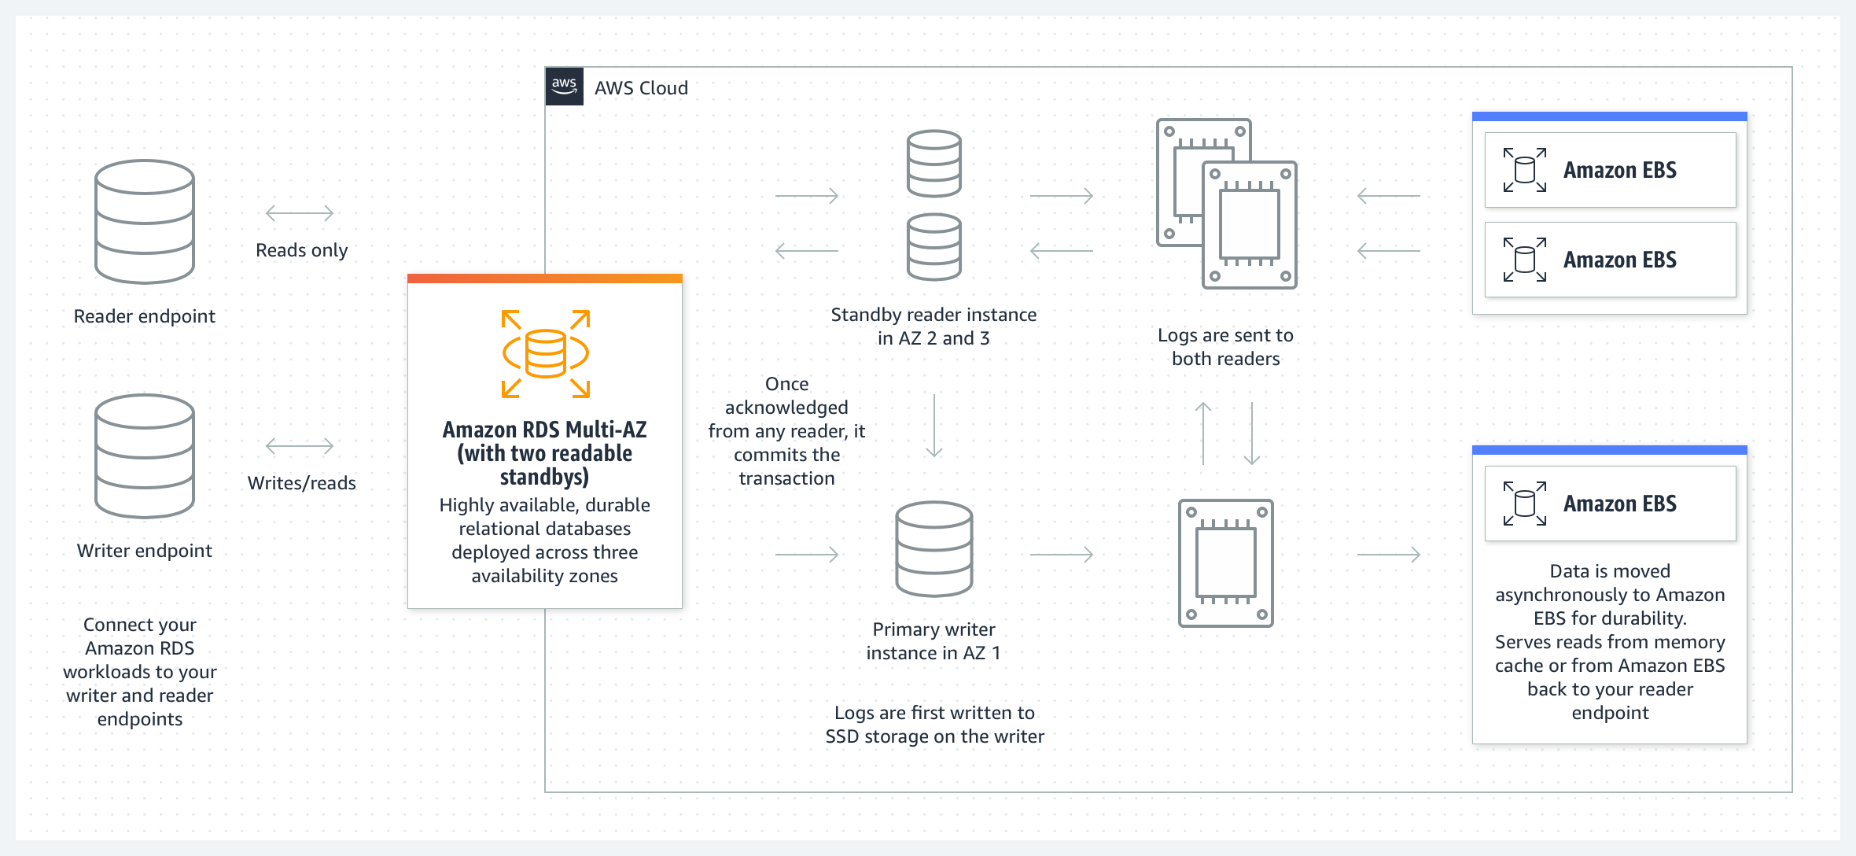

## Read replicas

Customers can also make RDS more highly available by using read replicas.

Amazon RDS read replicas provide enhanced performance and durability for Amazon RDS DB instances. For read-heavy database workloads, read replicas make it easier to elastically scale out beyond the capacity constraints of a single DB instance.

You can create one or more replicas of a given source DB instance and serve high-volume application read traffic from multiple copies of your data, which increases aggregate read throughput. Read replicas can also be promoted to become standalone DB instances, when needed.

Read replicas are available in Amazon RDS for MySQL, MariaDB, PostgreSQL, Oracle, Microsoft SQL Server, and Amazon Aurora.

For the MySQL, MariaDB, PostgreSQL, Oracle, and SQL Server database engines, Amazon RDS creates a second DB instance by using a snapshot of the source DB instance. Amazon RDS then uses the engine’s native asynchronous replication to update the read replica when there’s a change to the source DB instance.

The read replica operates as a DB instance that allows only read-only connections. Applications can connect to a read replica like they would connect to any DB instance. Amazon RDS replicates all databases in the source DB instance.

Here’s an example of when to use a read replica. Say that you’re running reports on your database, which is causing performance issues with CPU-intensive reads. You can use a read replica and direct all the reporting queries to that replica instead of to the primary instance. Offloading some of the intense queries to the replica should result in enhanced performance on the primary instance.

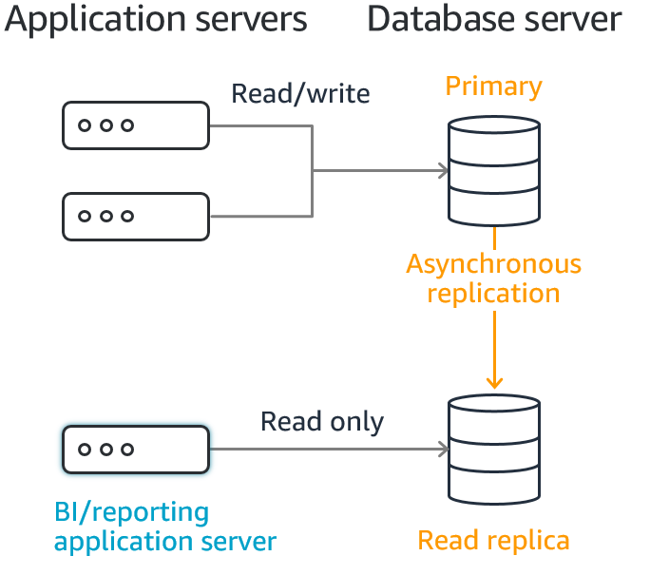

## Scaling Amazon RDS instances

### Scale your instance up vertically

When you create an RDS DB instance, you choose a database instance type and size.

Amazon RDS provides a selection of instance types that are optimized to fit different use cases for relational databases. Instance types comprise varying combinations of CPU, memory, storage, and networking capacity. You have the flexibility to choose the appropriate mix of resources for your database. Each instance type includes several instance sizes, which means that you can scale your database to your target workload’s requirements.

Not every instance type is supported for every database engine, version, edition or Region.

When you want to scale your DB instance, you can vertically scale the instance and choose a larger instance size. This might be the route you choose to take when you need more CPU and storage ability for an instance.

### Use read replicas

If you need more CPU capabilities but don’t need more storage, you might choose to create read replicas to offload some of the workload to a secondary instance.

### Enable RDS Storage Auto Scaling

If you need more storage, but don’t need more CPU, then you could scale the storage horizontally. You can scale storage horizontally by allocating more storage volumes for your instance manually, or by enabling RDS Storage Auto Scaling. RDS Storage Auto Scaling automatically scales storage capacity in response to growing database workloads, with virtually zero downtime.

Previously, you needed to manually provision storage capacity based on anticipated application demands. Underprovisioning could result in application downtime, and overprovisioning could result in underutilized resources and higher costs. With RDS Storage Auto Scaling, you set your desired maximum storage limit and Auto Scaling takes care of the rest.

RDS Storage Auto Scaling continuously monitors actual storage consumption, and scales capacity up automatically when actual utilization approaches provisioned storage capacity.

Auto Scaling works with new and existing database instances. You can enable Auto Scaling with a few clicks in the AWS Management Console.

### Change the storage type for increased performance

Finally, here’s one last thing to consider. If you’re looking for better performance, consider using a different storage type. For example, using Provisioned IOPS instead of General Purpose could give you some of the performance enhancements that you want.

The following list briefly describes the three storage types:

* General Purpose SSD: General Purpose SSD volumes offer cost-effective storage that works well for a broad range of workloads. These volumes deliver single-digit millisecond latencies and the ability to burst to 3,000 IOPS for extended periods of time. Baseline performance for these volumes is determined by the volume's size.
* Provisioned IOPS: Provisioned IOPS storage is designed to meet the needs of I/O-intensive workloads—particularly database workloads—that require low I/O latency and consistent I/O throughput.
* Magnetic: Amazon RDS also supports magnetic storage for backward compatibility. We recommend that you use General Purpose SSD or Provisioned IOPS for any new storage needs. The maximum amount of storage that’s allowed for DB instances on magnetic storage is less than that of the other storage types.

For more resources about Amazon RDS, see the following:

* For more information about Amazon RDS Multi-AZ Deployments, see [Amazon RDS Multi-AZ](https://aws.amazon.com/rds/features/multi-az/).
* For more information about Amazon RDS read replicas, see [Amazon RDS Read Replicas](https://aws.amazon.com/rds/features/read-replicas/).
* For more information about Amazon RDS DB instances, see [Amazon RDS DB instances](https://docs.aws.amazon.com/AmazonRDS/latest/UserGuide/Overview.DBInstance.html).

## AWS DMS

Morgan suggested that this week’s customer use AWS Database Migration Service (Amazon DMS) to migrate data from their on-premises database to Amazon RDS.

AWS DMS helps you migrate databases to AWS quickly and securely. The source database remains fully operational during the migration, which minimizes the downtime to applications that rely on the database. The AWS DMS can migrate your data to and from widely used commercial and open-source databases.

At a basic level, AWS DMS is a server in the AWS Cloud that runs replication software. You create a source and target connection to tell AWS DMS where to extract from and load to. Then, you schedule a task that runs on this server to move your data. AWS DMS creates the tables and associated primary keys if they don't exist on the target. You can precreate the target tables yourself, if you prefer. You can also use AWS Schema Conversion Tool (AWS SCT) to create some or all of the target tables, indexes, views, triggers, and so on.

The following diagram shows the AWS DMS replication process.

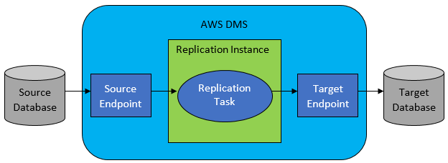

This week’s customer would use AWS DMS to perform a homogenous database migration.

In homogeneous database migrations, the source and target database engines are the same, or are compatible—such as Oracle to Amazon RDS for Oracle, MySQL to Amazon Aurora, MySQL to Amazon RDS for MySQL, or Microsoft SQL Server to Amazon RDS for SQL Server. Because the schema structure, data types, and database code are compatible between the source and target databases, this kind of migration is typically a one-step process. You create a migration task with connections to the source and target databases, and then start the migration. AWS DMS takes care of the rest. The source database can be located in your own premises outside of AWS, on an Amazon Elastic Compute Cloud (Amazon EC2) instance, or in an Amazon RDS DB instance. The target can be a database in Amazon EC2 or Amazon RDS.

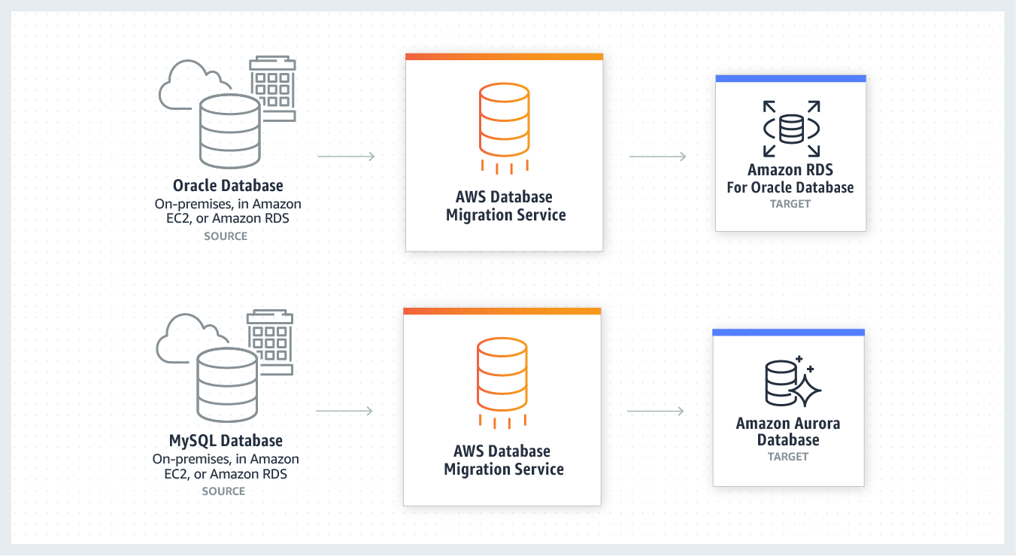

For more general information about AWS DMS, see [What is AWS Database Migration Service?](https://docs.aws.amazon.com/dms/latest/userguide/Welcome.html)

# AWS Storage Services

When you consider which storage service to choose for a specific use case, it’s important to be familiar with the different storage services that AWS has to offer. For this week’s customer, Morgan chose AWS Storage Gateway and Amazon Simple Storage Service (Amazon S3) as the services to support the solution. Morgan chose these services because the customer requires the Network File System (NFS) protocol to remain in place for all on-premises applications. However, the customer also wants to store the files (that they will access) in AWS. Storage Gateway supports this use case.

## AWS Storage Gateway

AWS Storage Gateway connects an on-premises software appliance with cloud-based storage to provide near-seamless integration with data security features between your on-premises IT environment and the AWS storage infrastructure. You can use the service to store data in the AWS Cloud for scalable and cost-effective storage that helps maintain data security. AWS Storage Gateway offers file-based, volume-based, and tape-based storage solutions.

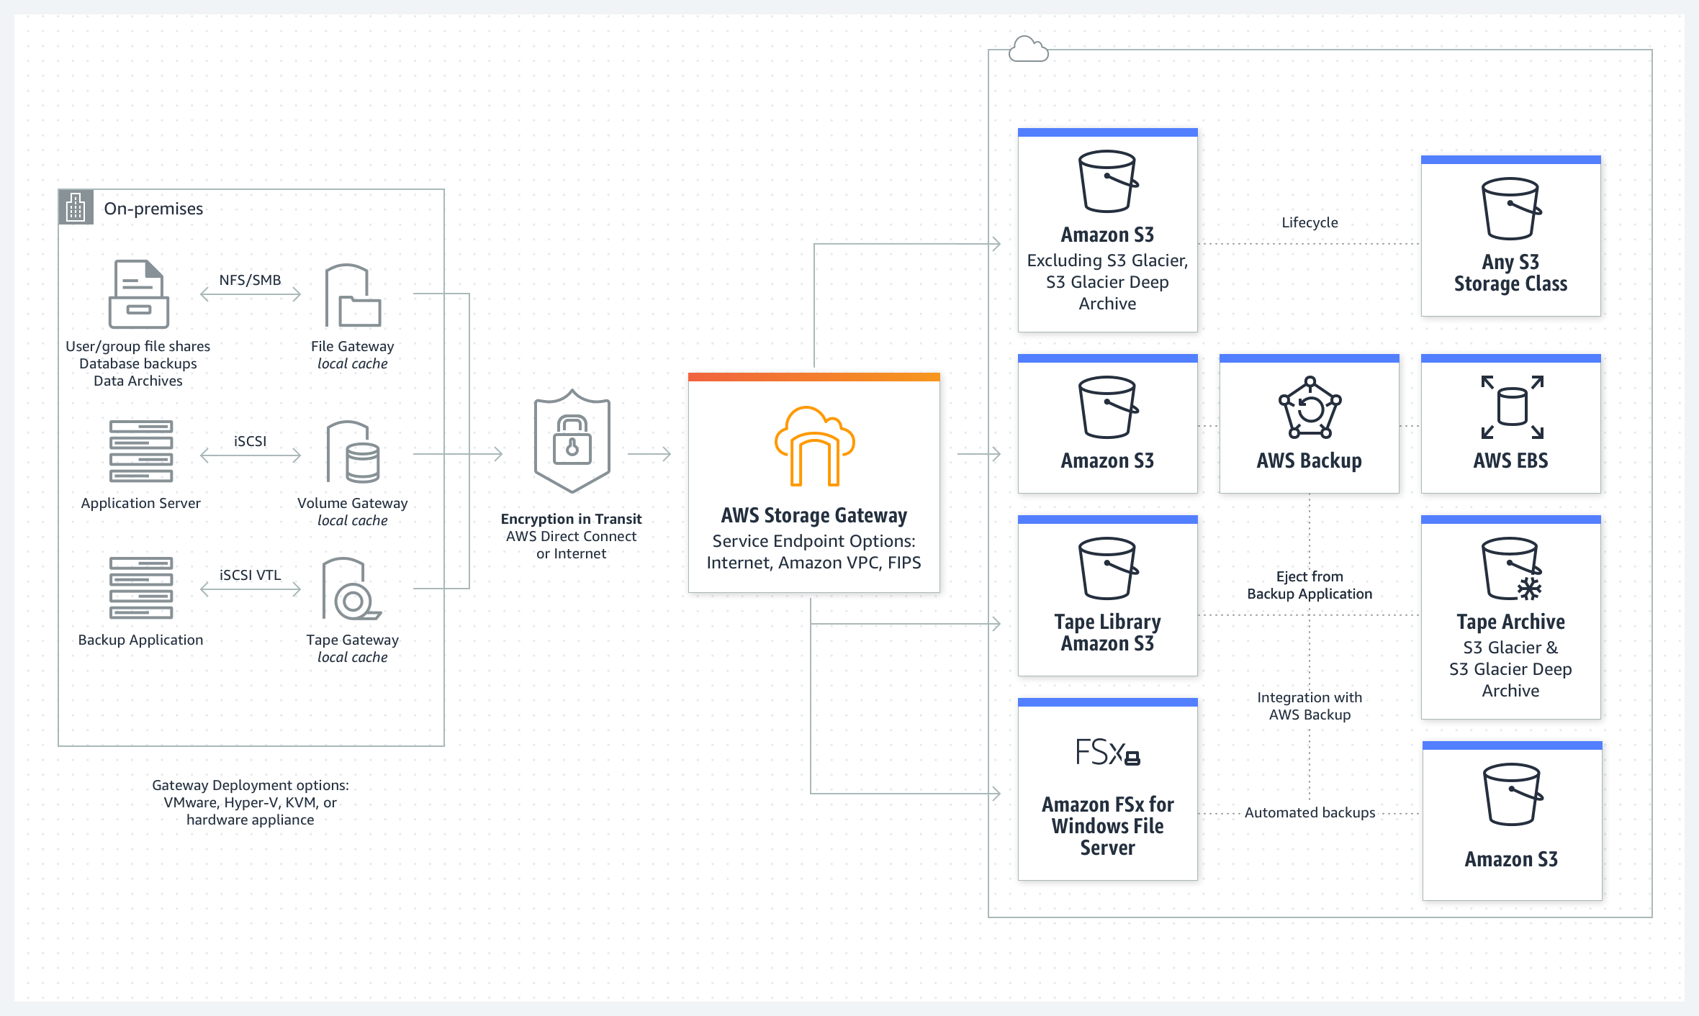

Morgan recommended Amazon S3 File Gateway for the customer’s solution.

## Amazon S3 File Gateway

Amazon S3 File Gateway supports a file interface into Amazon S3, and it combines a service and a virtual software appliance. By using this combination, you can store and retrieve objects in Amazon S3 by using industry-standard file protocols, such as NFS and Server Message Block (SMB). The software appliance (or gateway) is deployed into your on-premises environment as a virtual machine (VM) that runs on VMware ESXi, Microsoft Hyper-V, or Linux Kernel-based Virtual Machine (KVM) hypervisor. The gateway provides access to objects in Amazon S3 as files or file-share mount points. With S3 File Gateway, you can do the following:

* Store and retrieve files directly by using NFS version 3 or version 4.1.
* Store and retrieve files directly by using SMB file system version 2 or version 3.
* Access data directly in Amazon S3 from any AWS Cloud application or service.
* Manage your Amazon S3 data by using lifecycle policies, S3 Cross-Region Replication (CRR), and versioning. You can think of a S3 File Gateway as a file system mount on Amazon S3.

Amazon S3 File Gateway is designed to simplify file storage in Amazon S3. It integrates to existing applications through industry-standard file system protocols, and it provides a cost-effective alternative to on-premises storage. Amazon S3 File Gateway also provides low-latency access to data through transparent local caching. It manages data transfer to and from AWS, and it optimizes and streams data in parallel. Amazon S3 File Gateway also buffers applications from network congestion, and manages bandwidth consumption.For more resources about Amazon S3 File Gateway, see the following:

* For more information about Amazon S3 File Gateway, see [What is Amazon S3 File Gateway?](https://docs.aws.amazon.com/filegateway/latest/files3/what-is-file-s3.html)
* For more information about AWS Storage Gateway, see [AWS Storage Gateway Features](https://aws.amazon.com/storagegateway/features/).

## Amazon EBS

An Amazon Elastic Block Store (Amazon EBS) volume is a durable, block-level storage device that you can attach to your Amazon Elastic Compute Cloud (Amazon EC2) instances. After you attach a volume to an instance, you can use it as you would use a physical hard drive. EBS volumes are flexible. For current-generation volumes attached to current-generation instance types, you can dynamically increase size, modify the provisioned IOPS capacity, and change volume type on live production volumes.

It’s important that you know about the different types of EBS volume types and sizes, and how IOPS are correlated with volume size and type.

Amazon EBS provides the following volume types, which differ in performance characteristics and price, so that you can tailor your storage performance and cost to the needs of your applications.

* Solid-state drives (SSD): Optimized for transactional workloads involving frequent read/write operations with small I/O size, where the dominant performance attribute is IOPS. SSD-backed volume types include General Purpose SSD volumes and Provisioned IOPS SSD volumes
* Hard disk drives (HDD): Optimized for large, streaming workloads where the dominant performance attribute is throughput. HDD-backed volume types include Throughput Optimized HDD and Cold HDD volumes.
* Previous generation: Hard disk drives that you can use for workloads with small datasets, where data is accessed infrequently and performance is not a priority. We recommend that you consider a current-generation volume type instead.

Note that the number of available IOPs increases with the size of the volume. Thus, if you need more IOPs, you must vertically scale the volume.For more information, see [Amazon EBS volume types](https://docs.aws.amazon.com/AWSEC2/latest/UserGuide/ebs-volume-types.html).

## Amazon EFS

Amazon Elastic File System (Amazon EFS) provides a simple, serverless elastic file system that you can use with AWS Cloud services and on-premises resources. It is built to scale on demand to petabytes without disrupting applications. Amazon EFS can grow and shrink automatically as you add and remove files, so it minimizes the need to provision and manage capacity to accommodate growth. Amazon EFS has a web services interface that you can use to create and configure file systems quickly and easily. The service manages all the file storage infrastructure for you, meaning that you can reduce the complexity of deploying, patching, and maintaining complex file system configurations.

Amazon EFS supports NFS version 4 (NFSv4.1 and NFSv4.0), so the applications and tools that you use today work with Amazon EFS. Multiple compute instances—including Amazon EC2, Amazon Elastic Container Service (Amazon ECS), and AWS Lambda—can access an Amazon EFS file system at the same time. Amazon EFS can thus provide a common data source for workloads and applications that run on more than one compute instance or server.

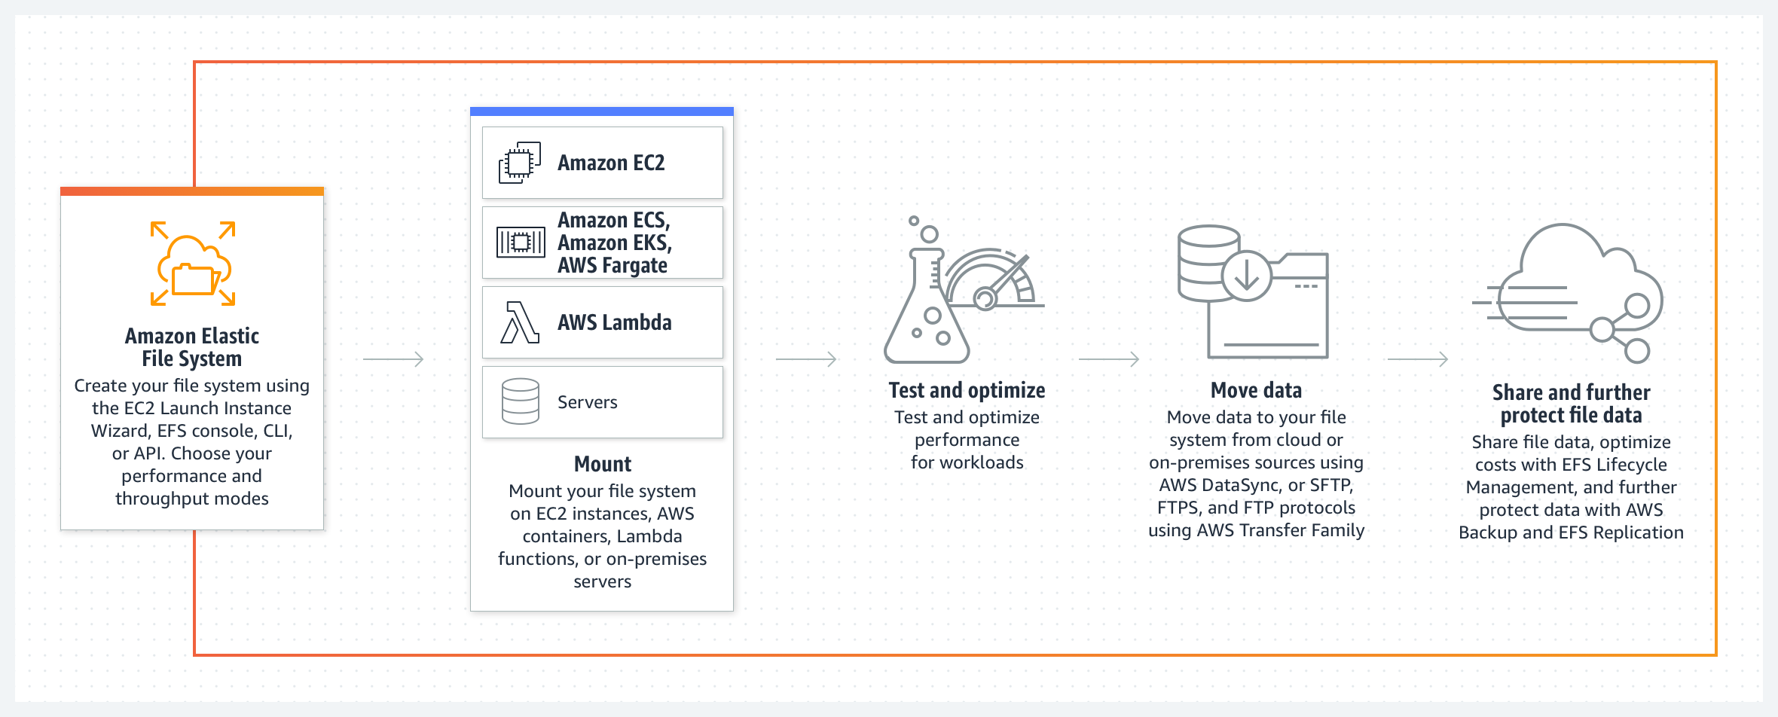

For more information, see [What is Amazon EFS?](https://docs.aws.amazon.com/efs/latest/ug/whatisefs.html)

## Amazon S3

Amazon S3 is an object storage service that stores data as objects within buckets. An object is a file and any metadata that describes the file. A bucket is a container for objects.

To store your data in Amazon S3, you first create a bucket and specify a bucket name and AWS Region. Then, you upload your data to that bucket as objects in Amazon S3. Each object has a key (or key name), which is the unique identifier for the object within the bucket.

S3 provides features that you can configure to support your specific use case. For example, you can use S3 Versioning to keep multiple versions of an object in the same bucket, which means that you can restore objects that are accidentally deleted or overwritten.

### Storage classes

Amazon S3 offers a range of storage classes that are designed for different use cases. For example, you could store mission-critical production data in S3 Standard for frequent access. You could also save on costs by storing infrequently accessed data in S3 Standard-IA or S3 One Zone-IA. Finally, you could archive data at a low costs in S3 Glacier Instant Retrieval, S3 Glacier Flexible Retrieval, and S3 Glacier Deep Archive.

You can store data with changing or unknown access patterns in S3 Intelligent-Tiering, which optimizes storage costs by automatically moving your data between four access tiers when your access patterns change. These four access tiers include two low-latency access tiers, which are optimized for frequent and infrequent access. The four access tiers also include two opt-in archive access tiers that are designed for asynchronous access to rarely accessed data.

For more resources about Amazon S3, see the following:

* For more information, see [What is Amazon S3?](https://docs.aws.amazon.com/AmazonS3/latest/userguide/Welcome.html)
* For more information, including links out to hands-on tutorials, see [Getting Started with Amazon S3](https://aws.amazon.com/s3/getting-started/?nc=sn&loc=6&dn=1).
* For more information about Amazon S3 storage classes, see [Amazon S3 Storage Classes](https://aws.amazon.com/s3/storage-classes/).

AWS Services for Hybrid Deployments

This week’s customer explained that they want to use the same management tools in both their data center and AWS when possible. To support this requirement, Morgan suggested that the customer migrate their on-premises containers to use Amazon Elastic Container Service (Amazon ECS) Anywhere so that they can use common tooling for running containers. Morgan also suggested that the customer use the following tools to manage resources across environments: AWS Systems Manager for operational support and tasks, and AWS Backup for managing backups in one centralized place.

**Amazon ECS Anywhere**

Amazon ECS Anywhere is a feature of Amazon ECS that you can use to run and manage container workloads on customer-managed infrastructure.

Amazon ECS Anywhere builds on the ease and simplicity of Amazon ECS to provide a consistent experience across your container-based applications for working with tooling and APIs. Whether on premises or in the cloud, cluster management, workload scheduling, and monitoring will be similar to what you already know from Amazon ECS. You can reduce costs and mitigate complex local container orchestration by taking advantage of the completely managed solution that Amazon ECS Anywhere provides. Amazon ECS Anywhere can help you meet compliance requirements and scale your business while retaining your on-premises investments.

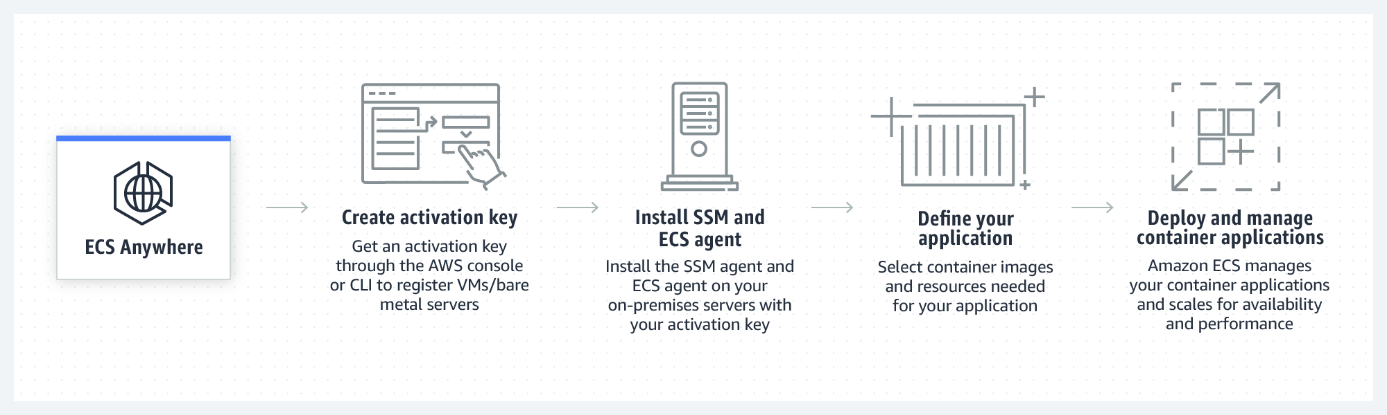

For a hands-on workshop about Amazon ECS Anywhere, see [Amazon ECS Workshop: ECS Anywhere](https://www.ecsworkshop.com/ecsanywhere/).

**AWS Systems Manager**

By using AWS Systems Manager, you have visibility and control of your infrastructure on AWS. Systems Manager provides a unified user interface that you can use to view operational data from multiple AWS services and automate operational tasks across your AWS resources.

With Systems Manager, you can group resources—such as Amazon Elastic Compute Cloud (Amazon EC2) instances, Amazon Simple Storage Service (Amazon S3) buckets, or Amazon Relational Database Service (Amazon RDS) instances—by application. You can also view operational data for monitoring and troubleshooting, and take action on your groups of resources.

Systems Manager is design to simplify resource and application management, reduce the time needed to detect and resolve operational problems, and make it easier to operate and manage your infrastructure securely at scale.

The following diagram shows how some Systems Manager capabilities perform actions on your resources. The diagram doesn't cover all capabilities. Each numbered interaction is described after the diagram.

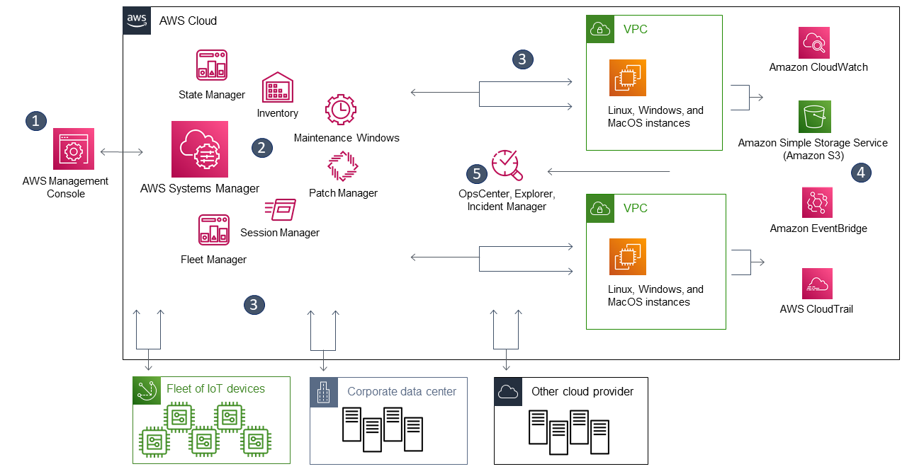

1. Access Systems Manager: Use one of the available options foraccessing Systems Manager, such as the AWS Management Console or the AWS Command Line Interface (AWS CLI).
2. Choose a Systems Manager capability: Determine which capability can help you with the action you want to perform on your resources. The diagram shows only a few of the capabilities that IT administrators and DevOps personnel use to manage their applications and resources.
3. Verification and processing: Systems Manager verifies that your AWS Identity and Access Management (IAM) user, group, or role has the needed permissions to perform the action that you specified. If the target of your action is a managed node, the Systems Manager Agent (SSM Agent) that runs on the node performs the action. For other types of resources, Systems Manager performs the specified action or communicates with other AWS services to perform the action on behalf of Systems Manager.
4. Reporting: Systems Manager, the SSM Agent, and other AWS services that performed an action on behalf of Systems Manager report their status. Systems Manager can send status details to other AWS services, if configured.
5. Systems Manager operations management capabilities: If you enable Systems Manager operations management capabilities—such as Explorer, OpsCenter, and Incident Manager—they can aggregate operations data or create artifacts in response to events or errors with your resources. These artifacts include operational work items (OpsItems) and incidents. The operations management capabilities from Systems Manager provide both operational insight into your applications and resources, and automated remediation solutions to help troubleshoot problems.

For more resources about Systems Manager, see the following:

* For a tutorial about how to use Systems Manager Run Command, see [Remotely Run Commands on an EC2 Instance with AWS Systems Manager](https://aws.amazon.com/getting-started/hands-on/remotely-run-commands-ec2-instance-systems-manager/).
* For a hands-on workshop about using Systems Manager, see [AWS Management and Governance Tools Workshop: AWS Systems Manager.](https://mng.workshop.aws/ssm.html)
* For more general information about Systems Manager, see [What is AWS Systems Manager?](https://docs.aws.amazon.com/systems-manager/latest/userguide/what-is-systems-manager.html)

**AWS Backup**

You can use AWS Backup to centralize and automate data protection across AWS services and hybrid workloads. AWS Backup offers a cost-effective, fully managed, policy-based service that is designed to simplify data protection at scale.

AWS Backup also helps you support your regulatory compliance or business policies for data protection. Together with AWS Organizations, you can use AWS Backup to centrally deploy data protection policies to configure, manage, and govern your backup activity across your company’s AWS accounts and resources. Supported resources include the following:

* EC2 instances
* Applications that are supported by Windows Volume Shadow Copy Service (VSS)—including Windows Server, Microsoft SQL Server, and Microsoft Exchange Server—on Amazon EC2
* Amazon Elastic Block Store (Amazon EBS) volumes
* S3 buckets
* Amazon RDS databases, including Amazon Aurora clusters
* Amazon DynamoDB tables
* Amazon Neptune databases
* Amazon DocumentDB (with MongoDB compatibility) databases
* Amazon Elastic File System (Amazon EFS) file systems
* Amazon FSx for NetApp ONTAP file systems
* Amazon FSx for Lustre file systems
* Amazon FSx for Windows File Server file systems
* Amazon FSx for OpenZFS file systems
* AWS Storage Gateway volumes
* VMware workloads on premises, on Amazon Outposts, and in VMware Cloudon AWS

For more information, see [What is AWS Backup?](https://docs.aws.amazon.com/aws-backup/latest/devguide/whatisbackup.html)

# Architecture Optimizations for Week 3

In this reading, you will find further information about the topics that Morgan and Raf talked in the video where they both played solutions architects.

The following diagram is a more detailed view of the solution that was covered this week.

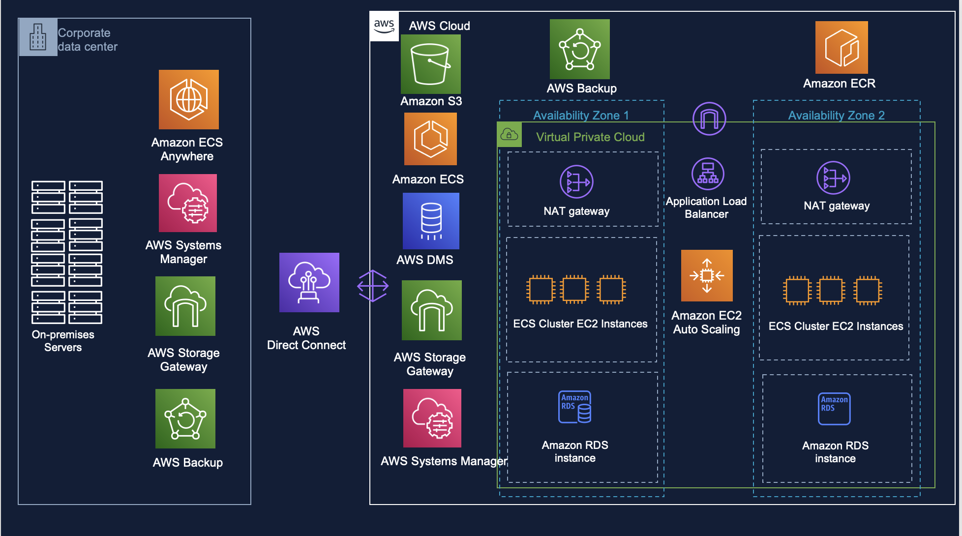

## Disaster recovery

Morgan mentioned that because this week’s customer is an enterprise company, they could consider designing a disaster recovery (DR) plan for this workload.

The DR strategies that are available to you within AWS can be broadly categorized into four approaches, which range from the low cost and low complexity of making backups to more complex strategies that use multiple active Regions. Active/passive strategies use an active site (such as an AWS Region) to host the workload and serve traffic. The passive site (such as a different AWS Region) is used for recovery. The passive site doesn’t actively serve traffic until a failover event is triggered.

The following diagram outlines the different approaches to disaster recovery on AWS.

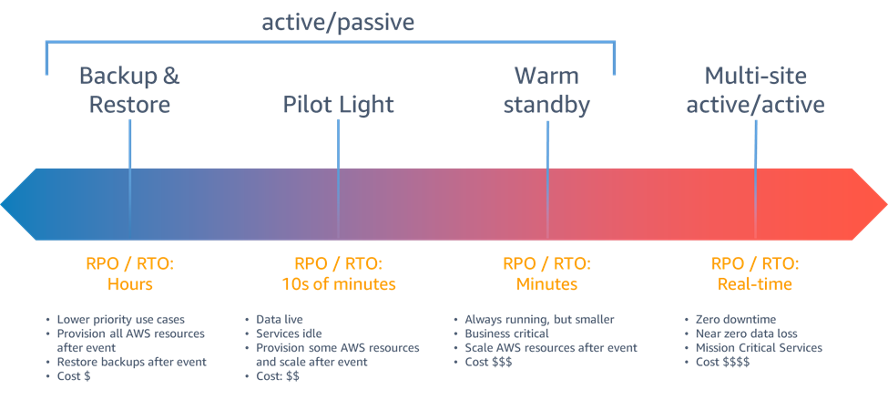

## Backup and restore

Backup and restore is a suitable approach for mitigating against data loss or corruption. This approach can also be used to mitigate against a regional disaster by replicating data to other AWS Regions, or to mitigate a lack of redundancy for workloads that are deployed to a single Availability Zone. In addition to data, you must redeploy the infrastructure, configuration, and application code in the recovery Region. To enable infrastructure to be redeployed quickly without errors, you should always deploy by using infrastructure as code (IaC), with services such as AWS CloudFormation or the AWS Cloud Development Kit (AWS CDK). Without IaC, it might be complex to restore workloads in the recovery Region, which can lead to increased recovery times and possibly exceed your Recovery Time Objective (RTO). In addition to backing up your user data, back up your code and configurations—including [Amazon Machine Images (AMIs)](https://docs.aws.amazon.com/AWSEC2/latest/UserGuide/AMIs.html) that you use to create Amazon Elastic Compute Cloud (Amazon EC2) instances. You can use [AWS CodePipeline](http://aws.amazon.com/codepipeline) to automate the redeployment of your application code and configurations.

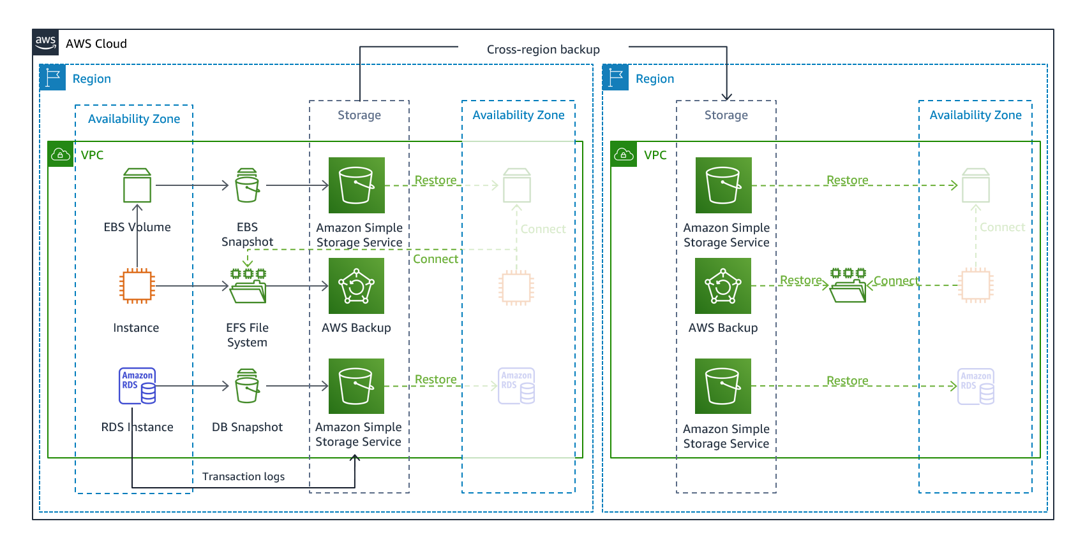

## Pilot light

With the pilot light approach, you replicate your data from one Region to another, and you provision a copy of your core workload infrastructure. Resources that are needed to support data replication and backup—such as databases and object storage—are always on. Other elements (such as application servers) are loaded with application code and configurations, but are turned off. They are only used during testing or when DR failover is invoked. In the cloud, you have the flexibility to deprovision resources when you don’t need them, and provision them when you do. A best practice for a resource that’s turned off is to not deploy the resource, and then create the configuration and capabilities to deploy it (turn on) when needed. Unlike the backup and restore approach, your core infrastructure is always available. Thus, you always have the option to quickly provision a full scale production environment by turning on and scaling out your application servers.

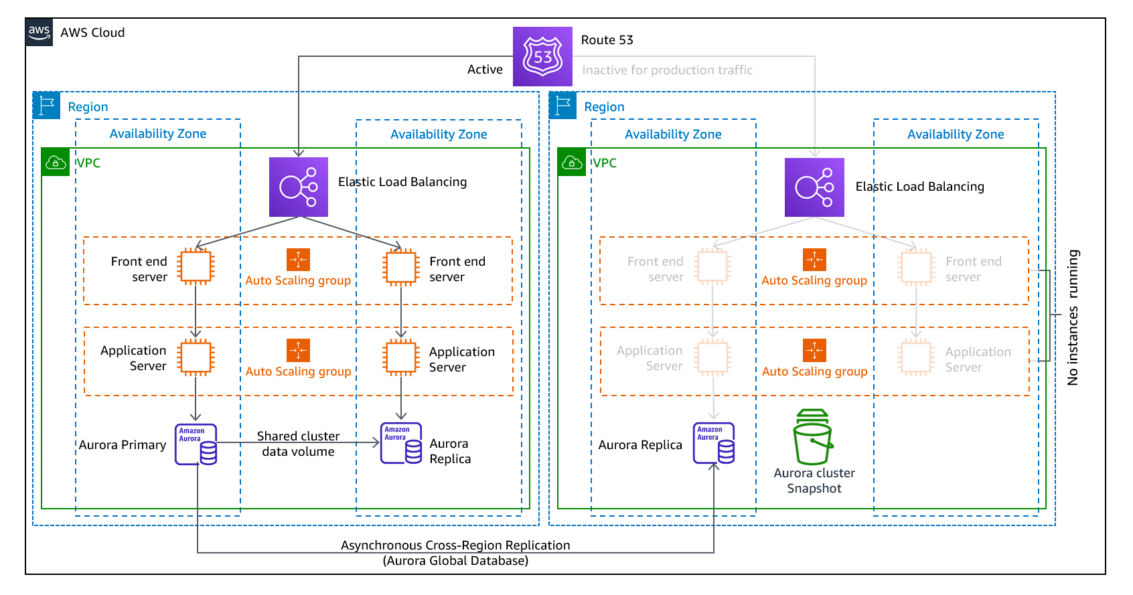

## Warm standby

The warm standby approach involves provisioning a scaled down—but fully functional—copy of your production environment in another Region. This approach extends the pilot-light concept and decreases the time to recovery because your workload is always-on in another Region. With this approach, you can perform testing or implement continuous testing more easily, which can increase your confidence in your ability to recover from a disaster.

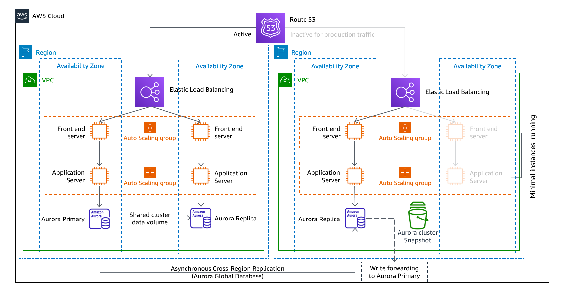

## Multi-site active/active

You can run your workload simultaneously in multiple Regions as part of either a multi-site active/active strategy or a hot standby active/passive strategy. A multi-site active/active approach serves traffic from all Regions where it’s deployed. In contrast, hot standby approach serves traffic from only a single Region, and the other Regions are used only for DR. With a multi-site active/active approach, users can access your workload in any Regions where it’s deployed. This approach to DR is the most complex and most costly. However, it can reduce your recovery time to near zero for most disasters, with the correct technology choices and implementation. (Note that data corruption might need to rely on backups, which usually results in a non-zero recovery point.) Hot standby uses an active/passive configuration, where users are directed to only a single region and DR Regions don’t take traffic. Most customers find that if they’re going to stand up a full environment in the second Region, it makes sense to use it in an active/active approach. Alternatively, if you don’t want to use both Regions to handle user traffic, then warm standby offers an approach that’s more economical and operationally less complex.

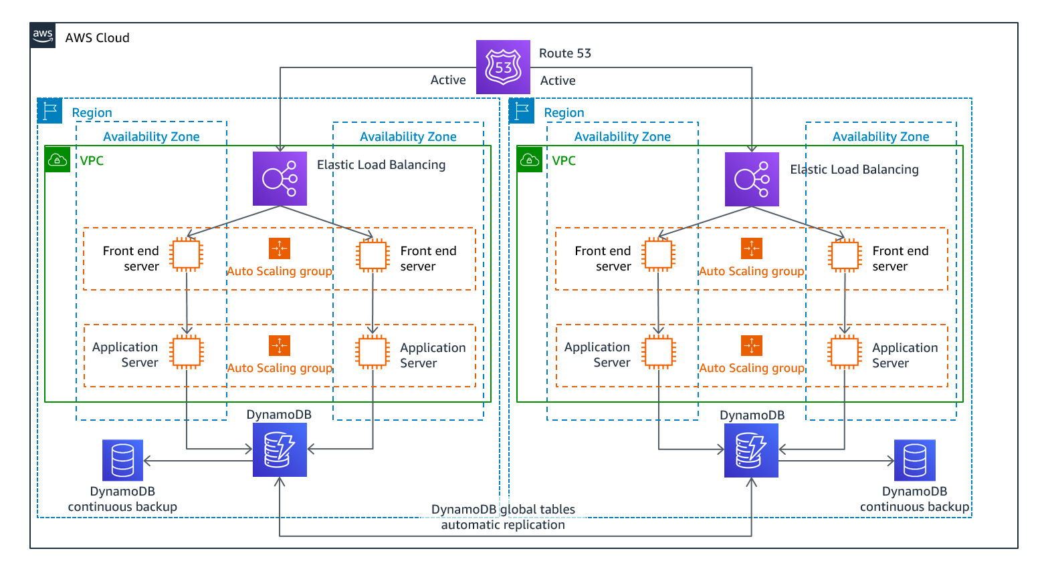

For more information about DR, see the [Disaster Recovery of Workloads on AWS: Recovery in the Cloud](https://docs.aws.amazon.com/whitepapers/latest/disaster-recovery-workloads-on-aws/disaster-recovery-workloads-on-aws.html) whitepaper.

## AWS Direct Connect with AWS VPN for failover

Raf commented that to make the connection to AWS more resilient, the customer can consider using Amazon Site-to-Site VPN as a failover for AWS Direct Connect so that the connection is redundant. This setup would protect the customer if the AWS Direct Connect connection became unavailable. With this setup, the customer would be able to fail over to the virtual private network (VPN) connection and remain connected to their AWS resources.

For more information about how to set up Site-to-Site VPN as a failover for Direct Connect, see [How do I configure Direct Connect and VPN failover with Transit Gateway?](https://aws.amazon.com/premiumsupport/knowledge-center/dx-configure-dx-and-vpn-failover-tgw/)

## Automatic scaling for containers

Morgan commented that this week’s customer needs to look into how they will scale their containers. When the customer uses Amazon Elastic Container Service (Amazon ECS), they will need to think about scaling both their underlying EC2 cluster and the containers themselves.

### Scaling the cluster

Amazon ECS can manage the scaling of EC2 instances that are registered to your cluster. This capability is referred to as Amazon ECS cluster auto scaling, and is performed by an Amazon ECS Auto Scaling group capacity provider that has managed scaling turned on.

When you use an Auto Scaling group capacity provider with managed scaling, Amazon ECS creates two custom Amazon CloudWatch metrics, and a target tracking scaling policy that attaches to your Auto Scaling group. Amazon ECS then manages the scale-in and scale-out actions of the Auto Scaling group based on the load that your tasks put on your cluster.

### Scaling the containers

Automatic scaling is the ability to increase or decrease the desired count of tasks in your Amazon ECS service automatically. Amazon ECS uses the Application Auto Scaling service to provide this functionality.

Your Amazon ECS service can be optionally configured automatically scale its desired count of tasks in your Amazon ECS service, either up or down, in response to CloudWatch alarms.Amazon ECS Service Auto Scaling supports the following types of scaling policies:

* Target tracking scaling policies (Recommended): Increase or decrease the number of tasks that your service runs, based on a target value for a specific metric. This scaling approach is similar to the way that your thermostat maintains the temperature of your home. You select the temperature, and the thermostat manages the temperature.
* Step scaling policies: Increase or decrease the number of tasks that your service runs, based on a set of scaling adjustments, which are also known as step adjustments. These adjustments vary based on the size of the alarm breach.

For more resources about automatic scaling and Amazon ECS, see the following:

* For more information about how to scale an ECS cluster, see [Amazon ECS cluster Auto Scaling](https://docs.aws.amazon.com/AmazonECS/latest/developerguide/cluster-auto-scaling.html).
* For a hands-on tutorial about how to scale an ECS cluster, see the [Amazon ECS Workshop: Deploy ECS Cluster Auto Scaling](https://ecsworkshop.com/capacity_providers/ec2/).
* For more information about service auto scaling, see [Service auto scaling](https://docs.aws.amazon.com/AmazonECS/latest/developerguide/service-auto-scaling.html) in the Amazon ECS Developer Guide.

## Automatic scaling for Amazon RDS

Morgan commented that this week’s customer should look into RDS storage autoscaling.

When you enable storage autoscaling, Amazon RDS automatically scales up your storage when it detects that you are running out of free database space.

If your workload is unpredictable, you can enable storage autoscaling for an RDS DB instance. To do so, you can use the Amazon RDS console, the Amazon RDS API, or the AWS Command Line Interface (AWS CLI).

For more information about Amazon RDS storage autoscaling, see [Managing capacity automatically with Amazon RDS storage autoscaling.](https://docs.aws.amazon.com/AmazonRDS/latest/UserGuide/USER_PIOPS.StorageTypes.html#USER_PIOPS.Autoscaling)

## Amazon S3 Intelligent-Tiering

Raf commented that this customer could also optimize for cost by using S3 Intelligent-Tiering on the S3 bucket where their data is being stored.

S3 Intelligent-Tiering is the only cloud storage class that delivers automatic storage cost savings when data access patterns change, thus reducing performance impact or operational overhead. The Amazon S3 Intelligent-Tiering storage class is designed to optimize storage costs by automatically moving data to the most cost-effective access tier when access patterns change. For a small monthly object monitoring and automation charge, S3 Intelligent-Tiering monitors access patterns and automatically moves objects that haven’t been accessed to lower-cost access tiers.

S3 Intelligent-Tiering is a good storage class for data with unknown, changing, or unpredictable access patterns—independent of object size or retention period. You can use S3 Intelligent-Tiering as the default storage class for virtually any workload, especially data lakes, data analytics, new applications, and user-generated content.

For more information about S3 Intelligent-Tiering, see [Amazon S3 Intelligent-Tiering storage class](https://aws.amazon.com/s3/storage-classes/intelligent-tiering/).

# Multi-Account Strategies

This week’s customer is currently operating everything for all the clients that they support out of one AWS account. This situation isn’t ideal for a company that wants to organize and scale their usage of AWS as their usage grows.

The practice of using multiple accounts has many advantages. To summarize, you can group workloads based on business purposes and ownership, centralize logging, and constrain access to sensitive data. You can also limit the scope of impact from adverse events, manage costs better, and distribute AWS service quotas and API request rate limits.

Businesses that are starting to adopt AWS, expanding their footprint on AWS, or planning to enhance an established AWS environment need to ensure they have a [foundation on AWS](https://docs.aws.amazon.com/whitepapers/latest/establishing-your-cloud-foundation-on-aws/welcome.html) for their cloud environment. One important aspect of their foundation is to organize their AWS environment by following a multi-account strategy.

By using multiple AWS accounts to help isolate and manage your business applications and data, you can optimize across most of the [AWS Well-Architected Framework](http://aws.amazon.com/architecture/well-architected/) pillars—including operational excellence, security, reliability, and cost optimization.

## Group workloads based on business purpose and ownership

You can group workloads with a common business purpose into distinct accounts. As a result, you can align the ownership and decision-making of those accounts. You can also avoid dependencies and conflicts with how workloads in other accounts are secured and managed.

Different business units or product teams might have different processes. Depending on your overall business model, you might choose to isolate distinct business units or subsidiaries in different accounts. By isolating business units, they can operate with greater decentralized control—while still retaining the ability to provide overarching guardrails. This approach might also ease divestment of those units over time.

Guardrails are governance rules for security, operations, and compliance that you can define and apply to align with your overall requirements.

If you acquire a business that already operates in AWS, you can move the associated accounts into your existing organization intact. This movement of accounts can be an initial step toward integrating acquired services into your standard account structure.

## Apply distinct security controls by environment

Workloads often have distinct security profiles that require separate control policies and mechanisms to support them. For example, it’s common to apply different policies for security and operations to the non-production and production environments of a given workload. If you use separate accounts for the non-production and production environments, the resources and data that make up a workload environment are separated from other environments and workloads by default.

## Constrain access to sensitive data

When you limit sensitive data stores to an account that is built to manage it, you can more easily constrain the number of people and processes that can access and manage the data store. This approach simplifies the process of achieving least-privilege access. Limiting access at the coarse-grained level of an account helps contain exposure to highly sensitive data.

For example, by designating a set of accounts to house publicly accessible Amazon Simple Storage Service (Amazon S3) buckets, you can implement policies that expressly forbid all other accounts from making S3 buckets publicly available.

## Promote innovation and agility

At AWS, we refer to your technologists as [builders](http://aws.amazon.com/campaigns/build-on-aws/) because they’re responsible for building value by using AWS products and services. Your builders might represent diverse roles, such as application developers, data engineers, data scientists, data analysts, security engineers, and infrastructure engineers.

In the early stages of a workload’s lifecycle, you can help promote innovation by providing your builders with separate accounts in support of experimentation, development, and early testing. These environments often provide greater freedom than more tightly controlled production-like test and production environments. They do so by providing broader access to AWS services while also using guardrails that help prohibit access to (and the use of) sensitive and internal data.

* Sandboxaccounts: Typically disconnected from your enterprise services and don’t provide access to your internal data. However, they offer the greatest freedom for experimentation.
* Developmentaccounts: Typically provide limited access to your enterprise services and development data. However, they can more readily support day-to-day experimentation with your enterprise-approved AWS services, formal development, and early testing work.

In both cases, we recommend security guardrails and cost budgets so that you limit risks and proactively manage costs.

You can support later stages of the workload lifecycle by using distinct test and production accounts for workloads or groups of related workloads. By having an environment for each set of workloads, owning teams can move faster by reducing dependencies on other teams and workloads, and by also minimizing the impact of changes.

## Limit scope of impact from adverse events

An AWS account applies boundaries for security, access, and billing boundaries to your AWS resources. These boundaries can help you achieve the independence and isolation of resources. By design, all resources that are provisioned within an account are logically isolated from resources that are provisioned in other accounts—even within your own AWS environment.

This isolation boundary provides a way to limit the risks of an application-related issue, misconfiguration, or malicious actions. If an issue occurs within one account, impacts to workloads contained in other accounts can be either reduced or eliminated.

## Support multiple IT operating models

Organizations often have multiple IT operating models, or ways that they divide responsibilities among parts of the organization to deliver their application workloads and platform capabilities. The following diagram shows three example operating models:

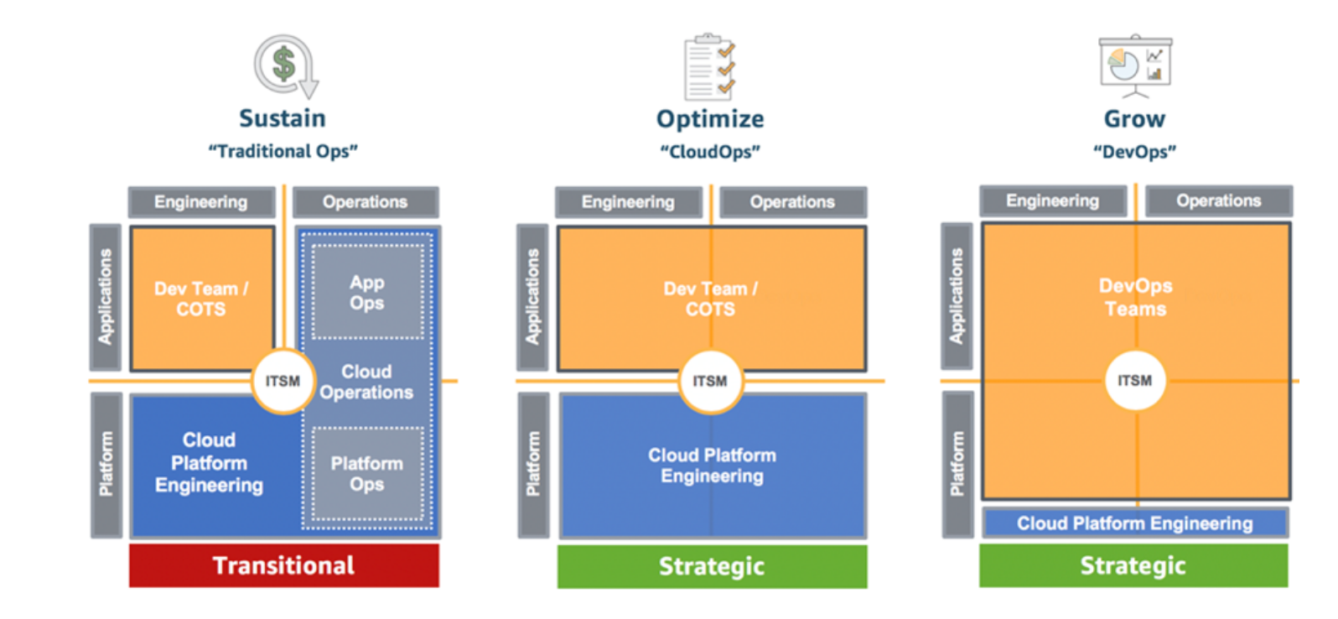

### **Example operating models**

In the Traditional Ops model, teams who own custom and commercial off-the-shelf (COTS) applications are responsible for engineering their applications, but not for their production operations. A cloud platform engineering team is responsible for engineering the underlying platform capabilities. A separate cloud operations team is responsible for the operations of both applications and platform.

In the CloudOps model, application teams are also responsible for production operations of their applications. In this model, a common cloud platform engineering team is responsible for both the engineering and operations of the underlying platform capabilities.

In the DevOps model, the application teams take on the additional responsibilities of engineering and operating platform capabilities that are specific to their applications. A cloud platform engineering team is responsible for the engineering and operations of shared platform capabilities that are used by multiple applications.

As a practice, IT Service Management (ITSM) is a common element across all of the models. Your overall goals and requirements for ITSM might not change across these models. However, the responsible individuals and solutions for meeting those goals and requirements can vary, depending on the model.

Given the implications of centralized operations versus more distributed operational responsibilities, you might benefit from establishing separate groups of accounts in support of different operating models. By using separate accounts, you can apply distinct governance and operational controls that are appropriate for each of your operating models.

## Manage costs

An account is the default way that AWS costs are allocated. By using different accounts for different business units and groups of workloads, you can more easily report, control, forecast, and budget your cloud expenditures.

In addition to cost reporting at the account level, AWS has built-in support to consolidate and report costs across your entire set of accounts. When you require fine-grained cost allocation, you can apply cost allocation tags to individual resources in each of your accounts.

## Distribute AWS service quotas and API request rate limits

AWS service quotas (also known as limits) are the maximum number of service resources or operations that apply to an account. For example, a service quota could be the number of S3 buckets that you can create for each account.

You can use the Service Quotas service to help protect you from unexpected or excessive provisioning of AWS resources, and from malicious actions that could dramatically impact your AWS costs.

AWS services can also throttle (or limit) the rate of requests that are made to their API operations.

Because service quotas and request rate limits are allocated for each account, use separate accounts for workloads to help distribute the potential impact of the quotas and limits.

For more information about multi-account strategies, see the following:

* For more information about building cloud foundations, see the [Establishing Your Cloud Foundation on AWS](https://docs.aws.amazon.com/whitepapers/latest/establishing-your-cloud-foundation-on-aws/welcome.html) whitepaper.
* For more information about organizing AWS accounts, see the [Organizing Your AWS Environment Using Multiple Accounts](https://docs.aws.amazon.com/whitepapers/latest/organizing-your-aws-environment/organizing-your-aws-environment.html) whitepaper.

# IAM Roles, Trust Relationships, and Permissions

This week, Raf suggested that the customer use AWS Identity and Access Management (IAM) roles to support the multi-account strategy. He suggested using IAM roles to facilitate cross-account access for the other accounts that are used in this solution. The roles provide cross-account access without needing to create static credentials for each account, such as IAM users.

## IAM roles

An IAM role is an identity that you can create in your account, and it has specific permissions. An IAM role has some similarities to an IAM user. Roles and users are both AWS identities with permissions policies that determine what the identity can or can’t do in AWS. However, instead of being uniquely associated with one person, a role can be assumed by anyone who needs it. Also, a role doesn’t have standard long-term credentials (such as a password or access keys) associated with it. Instead, when you assume a role, it provides you with temporary security credentials for your role session.Roles can be used by the following entities:

* An IAM user in the same AWS account as the role
* An IAM user in a different AWS account than the role
* An AWS service, such as Amazon Elastic Compute Cloud (Amazon EC2)
* An external user who was authenticated by an external identity provider (IdP) service that’s compatible with Security Assertion Markup Language (SAML) 2.0, OpenID Connect (OIDC), or a custom-built identity broker.

When you work with AWS, you should also be familiar with the following terms, which are related to IAM roles.

### **AWS service role**

An AWS service role is a role that a service assumes to perform actions in your account on your behalf. When you set up some AWS service environments, you must define a role for the service to assume. This service role must include all the permissions that the service needs to access the AWS resources that it must work with. Service roles vary from service to service, but many allow you to choose your permissions if you meet the documented requirements for that service. You can create, modify, and delete a service role from within IAM.

### **AWS service-linked role**

An AWS service-linked role is a unique type of service role that’s linked directly to an AWS service. Service-linked roles are predefined by the service, and they include all permissions that the service needs to call other AWS services on your behalf. The linked service also defines how you create, modify, and delete a service-linked role. A service might automatically create or delete the role. It might allow you to create, modify, or delete the role as part of a wizard or process in the service. Or it might require you to use IAM to create or delete the role. Regardless of the method, service-linked roles make setting up a service easier because you don't need to manually add the necessary permissions.

### **Delegation**

Delegation is the granting of permissions to someone to allow access to resources that you control. Delegation involves setting up a trust between two accounts. The first account is the account that owns the resource (the trusting account). The second account is the account that contains the users that need to access the resource (the trusted account). The trusted and trusting accounts can be any of the following:

* The same account
* Separate accounts that are both under your organization's control
* Two accounts owned by different organizations

To delegate permissions to access a resource, you create an IAM role in the trusting account that has two [policies](https://docs.aws.amazon.com/IAM/latest/UserGuide/id_roles_terms-and-concepts.html#term_policy) attached. The permissions policy grants the user of the role the needed permissions to carry out the intended tasks on the resource. The trust policy specifies which trusted account members are allowed to assume the role.

When you create a trust policy, you can’t specify a wildcard (*) as a principal.

The trust policy is attached to the role in the trusting account, and comprises half of the permissions. The other half is a permissions policy that’s attached to the user in the trusted account. The permissions policy allows that user to switch to (or assume) the role. A user who assumes a role temporarily gives up his or her own permissions, and instead takes on the role’s permissions. When the user exits (or stops using) the role, their original user permissions are restored. An additional parameter that’s called external ID can help ensure the secure use of roles between accounts that are not controlled by the same organization.

### **Federation**

Federation is the creation of a trust relationship between an external IdP and AWS. Users can sign in to a web identity provider, such as Login with Amazon, Facebook, Google, or any IdP that is compatible with OIDC. Users can also sign in to an enterprise identity system that’s compatible with SAML 2.0, such as Microsoft Active Directory Federation Services. When you use OIDC and SAML 2.0 to configure a trust relationship between these external IdPs and AWS, the user is assigned to an IAM role. The user also receives temporary credentials that allow the user to access your AWS resources.

### **Federated user**

Instead of creating an IAM user, you can use existing identities from AWS Directory Service, your enterprise user directory, or a web identity provider. These identities are known as federated users. AWS assigns a role to a federated user when access is requested through an identity provider.

### **Trust policy**

A trust policy is a JSON policy document where you define the principals that you trust to assume the role. A role trust policy is a required, resource-based policy that’s attached to a role in IAM. The principals that you can specify in the trust policy include users, roles, accounts, and services.

### **Permissions boundary**

A permissions boundary is an advanced feature where you use policies to limit the maximum permissions that an identity-based policy can grant to a role. You can’t apply a permissions boundary to a service-linked role.

### **Principal**

A principal is an entity in AWS that can perform actions and access resources. A principal can be an AWS account root user, an IAM user, or a role.

For more information, see [Roles terms and concepts.](https://docs.aws.amazon.com/IAM/latest/UserGuide/id_roles_terms-and-concepts.html)

# AWS IAM Identity Center

Raf suggested that this week’s customer use AWS IAM Identity Center (successor to AWS Single Sign-On) to manage single sign-on (SSO) for their AWS accounts. By doing so, the customer can use one place for workforce user and group access, and one place to manage AWS account access. AWS IAM Identity Center helps you securely create or connect your workforce identities and manage their access centrally across AWS accounts and applications. IAM Identity Center is the recommended approach for workforce authentication and authorization on AWS for organizations of any size and type.

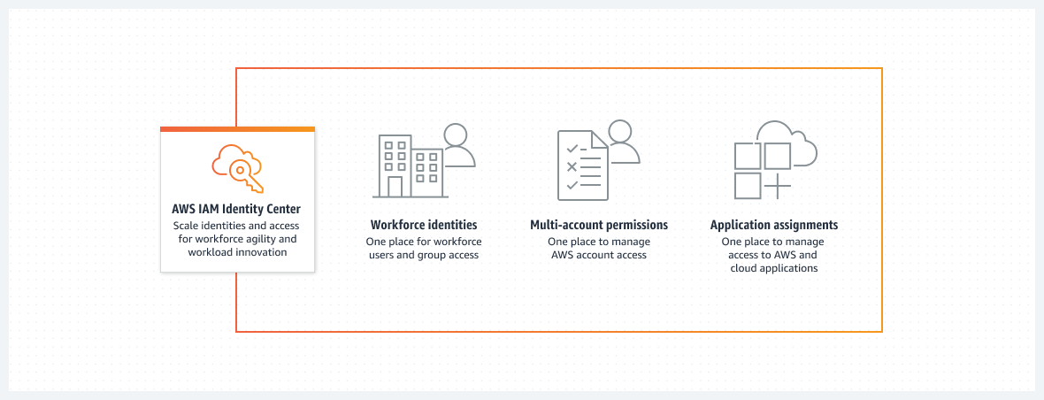

### IAM Identity Center features

IAM Identity Center includes the following core features: **Workforce identities** Human users who are members of your organization are also known as workforce identities or workforce users. You can create workforce users and groups in IAM Identity Center. You can also connect and synchronize to an existing set of users and groups in your own identity source for use across all your AWS accounts and applications. Supported identity sources include Microsoft Active Directory Domain Services, and external identity providers such as Okta Universal Directory or Microsoft Azure AD. **Application assignments for SAML applications** With application assignments, you can grant your workforce users in IAM Identity Center SSO access to Security Assertion Markup Language (SAML) 2.0 applications, such as Salesforce and Microsoft 365. Your users can access these applications in a single place, without the need for you to set up federation separately. **Identity Center enabled applications** AWS applications and services—such as Amazon Managed Grafana, Amazon Monitron, and Amazon SageMaker Studio Notebooks—discover and connect to IAM Identity Center automatically to receive sign-in and user directory services. This feature provides users with a consistent SSO experience for these applications, with no additional application configuration. Because the applications share a common view of users, groups, and group membership, users can also have a consistent experience when they share application resources with others. **Multi-account permissions** With multi-account permissions, you can plan for and centrally implement IAM permissions across multiple AWS accounts at one time, without the need for you to configure each of your accounts manually. You can create fine-grained permissions based on common job functions, or define custom permissions that meet your security needs. You can then assign those permissions to workforce users to control their access over specific accounts. **AWS access portal** The AWS access portal provides your workforce users with one-click access to all their assigned AWS accounts and cloud applications through a web portal. For more information, see [What is IAM Identity Center?](https://docs.aws.amazon.com/singlesignon/latest/userguide/what-is.html)

# Logging Services

Multiple AWS services do infrastructure logging, and you should be familiar with them: AWS CloudTrail, AWS Config, VPC Flow Logs, and Amazon GuardDuty. Raf recommended that the customer configure CloudTrail to concentrate data in the AWS Organizations management account, thus following best practices for account governance.

## AWS CloudTrail

CloudTrail monitors and records account activity across your AWS infrastructure, which gives you control over actions for storage, analysis, and remediation. Events include actions that are performed in the AWS Management Console, the AWS Command Line Interface (AWS CLI), and the AWS SDKs and APIs. The actions recorded by CloudTrail don’t include API calls that are made to a backend application that’s hosted on Amazon Elastic Compute Cloud (Amazon EC2). They also don’t include internal API calls that are made within an application, and don’t involve AWS API calls. CloudTrail captures AWS API call events and logs them.

CloudTrail typically delivers logs within an average of about 15 minutes after an API call. (This time is not guaranteed.)

By using CloudTrail, a user in an Organizations management account can create an organization trail that logs all events for all AWS accounts in that organization. Organization trails are automatically applied to all member accounts in the organization. Member accounts can see the organization trail, but they can't modify or delete the organization trail. By default, member accounts don't have access to the log files for the organization trail in the Amazon Simple Storage Service (Amazon S3) bucket. This feature helps you uniformly apply and enforce your event-logging strategy across the accounts in your organization.

For more information about CloudTrail, see [How CloudTrail works](https://docs.aws.amazon.com/awscloudtrail/latest/userguide/how-cloudtrail-works.html).

## AWS Config

It’s important to know the difference between AWS CloudTrail and AWS Config.

When you run your applications on AWS, you usually use AWS resources, which you must create and manage collectively. As the demand for your application grows, our need to keep track of your AWS resources also grows. AWS Config is designed to help you manage your application resources.

AWS Config provides a detailed view of how AWS resources are configured in your AWS account. This configuration includes how resources are related to one another, and how they were configured in the past—which means that you can see how the configurations and relationships change over time. You can use AWS Config to get an inventory of the resources that you have in your AWS account, and then you can apply rules for how those resources are configured.

An AWS resource is an entity that you can work with in AWS, such as an EC2 instance, an Amazon Elastic Block Store (EBS) volume, a security group, or a virtual private cloud (VPC).

### Resource administration

To exercise better governance over your resource configurations—and to detect resource misconfigurations—you need fine-grained visibility into what resources exist, and how these resources are configured at any time. You can use AWS Config to notify you when resources are created, modified, or deleted without needing to monitor these changes by polling the calls made to each resource.

You can use AWS Config rules to evaluate the configuration settings of your AWS resources. When AWS Config detects that a resource violates the conditions in one of your rules, AWS Config flags the resource as noncompliant and sends a notification. AWS Config is designed to continuously evaluate your resources as they are created, changed, or deleted.

### Auditing and compliance

You might work with data that requires frequent audits to ensure compliance with internal policies and best practices. To demonstrate compliance, you need access to the historical configurations of your resources. AWS Config can provide this information.

### Managing and troubleshooting configuration changes

When you use multiple AWS resources that depend on one another, a change in the configuration of one resource might have unintended consequences on related resources. With AWS Config, you can view how the resource that you want to modify is related to other resources, and thus assess the potential impact of your change.

You can also use the historical configurations of your resources that are provided by AWS Config to troubleshoot issues and to access the last-known good configuration of a problem resource.

### Security analysis

To analyze potential security weaknesses, you need detailed historical information about your AWS resource configurations. Examples include the AWS Identity and Access Management (IAM) permissions that are granted to your users, or the Amazon EC2 security group rules that control access to your resources.

You can use AWS Config to view the IAM policy that was assigned to an IAM user, group, or role at any time when AWS Config was recording. This information can help you determine the permissions that belonged to a user at a specific time: for example, you can view whether the user John Doe had the permissions to modify Amazon Virtual Private Cloud (Amazon VPC) settings on Jan 1, 2015.

You can also use AWS Config to view the configuration of your Amazon security groups, including the port rules that were open at a specific time. This information can help you determine whether a security group blocked incoming TCP traffic to a specific port.

For more information, see [What is AWS Config?](https://docs.aws.amazon.com/config/latest/developerguide/WhatIsConfig.html)

## VPC Flow Logs

VPC Flow Logs is a feature that you can use to capture information about the IP traffic that goes to and from network interfaces in your VPC. Flow log data can be published to Amazon CloudWatch Logs or Amazon S3. After you create a flow log, you can retrieve and view its data in the chosen destination.Flow logs can help you with various tasks, such as the following:

* Diagnosing overly restrictive security group rules
* Monitoring the traffic that reaches your instance
* Determining the direction of the traffic to and from the network interfaces

Flow log data is collected outside the path of your network traffic. Therefore, it doesn’t affect network throughput or latency. You can create or delete flow logs with a minimal risk of impact to network performance.

For more information, see [Logging IP traffic using VPC Flow Logs](https://docs.aws.amazon.com/vpc/latest/userguide/flow-logs.html).

## Amazon GuardDuty

Amazon GuardDuty is a near-continuous security monitoring service that analyzes and processes data sources, such as CloudTrail data events for Amazon S3 logs, CloudTrail management event logs, DNS logs, Amazon EBS volume data, Amazon Elastic Kubernetes Service (Amazon EKS) audit logs, and Amazon VPC flow logs.

It uses threat intelligence feeds (such as lists of malicious IP addresses and domains) and machine learning to identify unexpected, potentially unauthorized, and malicious activity within your AWS environment. This activity can include issues such as the escalation of privileges, use of exposed credentials, communication with malicious IP addresses or domains, or the presence of malware on your EC2 instances and container workloads.

For example, GuardDuty can detect compromised EC2 instances and container workloads that are serving malware or mining bitcoin. It also monitors AWS account access behavior for signs of compromise, such as unauthorized infrastructure deployments—for example, instances that are deployed in a Region that has never been used, or unusual API calls (such as a password policy change to reduce password strength).

For more information, see [What is Amazon GuardDuty?](https://docs.aws.amazon.com/guardduty/latest/ug/what-is-guardduty.html)

# Automatic Account Provisioning

This week, Raf suggested that the customer automate as much as possible when they provision new AWS accounts and configure them for use. By using the AWS service stack, they would have a solution that creates new accounts with AWS Organizations, applies security guardrails with service control policies (SCPs), authenticates users into accounts with AWS IAM Identity Center (successor to AWS Single Sign-On), and has centralized logging through AWS CloudTrail. To configure newly created accounts, Raf suggested that the customer use AWS Control Tower, and use AWS Service Catalog to determine which portfolio of solutions is available in each account when they are configured.

## AWS CloudFormation

The services that we covered in this course—such as AWS Control Tower and AWS Service Catalog—use AWS CloudFormation templates. CloudFormation is an infrastructure as code (IaC) service. It helps you model and set up your AWS resources so that you can spend less time managing those resources, and more time focusing on your applications that run in AWS.

With CloudFormation, you create a template that describes all the AWS resources that you want—such as Amazon Elastic Compute Cloud (Amazon EC2) instances or Amazon Relational Database Service (Amazon RDS) DB instances—and CloudFormation provisions and configures those resources for you. You don't need to individually create and configure AWS resources and determine what resource is dependent on what. Instead, CloudFormation handles provisioning and configuration.

When you work with AWS, you should be very familiar with CloudFormation and its features. It’s a best practice to deploy infrastructure in an automated way, instead of doing everything manually in the console.

For more resources about CloudFormation, see the following:

* For more information, see [What is AWS CloudFormation?](https://docs.aws.amazon.com/AWSCloudFormation/latest/UserGuide/Welcome.html)
* For a tutorial about how to use CloudFormation, see [Deploy a Reliable Multi-tier Infrastructure Using CloudFormation](https://www.wellarchitectedlabs.com/reliability/100_labs/100_deploy_cloudformation/).

## AWS Control Tower

AWS Control Tower offers a straightforward way to set up and govern an AWS multi-account environment that follows prescriptive best practices. AWS Control Tower orchestrates the capabilities of several other [AWS services](https://docs.aws.amazon.com/controltower/latest/userguide/integrated-services.html)—including AWS Organizations, AWS Service Catalog, and IAM Identity Center—to build a landing zone in typically less than an hour. Resources are set up and managed on your behalf.

AWS Control Tower orchestration extends the capabilities of Organizations. To help protect your organizations and accounts from being affected by drift (or divergence from best practices), AWS Control Tower applies preventive and detective controls (or guardrails). For example, you can use guardrails to help ensure that security logs and necessary cross-account access permissions are created, but not altered.

If you host more than a handful of accounts, it’s beneficial to have an orchestration layer that facilitates account deployment and account governance. You can adopt AWS Control Tower as your primary way to provision accounts and infrastructure. With AWS Control Tower, you can more easily adhere to corporate standards, meet regulatory requirements, and follow best practices.

AWS Control Tower uses CloudFormation StackSets to set up resources in your accounts. Each stack set has stack instances that correspond to accounts, and to AWS Regions per account. AWS Control Tower deploys one stack set instance per account and Region.

For more information, see [What is AWS Control Tower?](https://docs.aws.amazon.com/controltower/latest/userguide/what-is-control-tower.html)

## AWS Service Catalog

By using AWS Service Catalog, organizations can create and manage catalogs of IT services that are approved for AWS. These IT services can include virtual machine images, servers, software, databases, and more—they can even include complete, multi-tier application architectures.

Organizations can use AWS Service Catalog to centrally manage commonly deployed IT services. AWS Service Catalog is designed to help organizations achieve consistent governance and meet compliance requirements. End users can quickly deploy only the approved IT services that they need, and these deployments will follow the constraints that your organization sets.

AWS Service Catalog provides the following benefits:

* Standardization: Administer and manage approved assets by restricting where the product can be launched, the type of instance that can be used, and many other configuration options. The result is a standardized landscape for product provisioning for your entire organization.
* Self-service discovery and launch: Users browse listings of products (that is, services or applications) that they can access, locate the product that they want to use, and launch it on their own as a provisioned product.
* Fine-grained access control: Administrators assemble portfolios of products from their catalog, and add constraints and resource tags that will be used when the products are provisioned. Administrators then grant access to the portfolio through AWS Identity and Access Management (IAM) users and groups.
* Extensibility and version control: Administrators can add a product to different portfolios and restrict it without creating another copy. When the product is updated to a new version, the update is propagated to the product in every portfolio that references it.

For more information, see [What is AWS Service Catalog?](https://docs.aws.amazon.com/servicecatalog/latest/adminguide/introduction.html)

# Multi-Account Best Practices

Implementing multi-account best practices is an ongoing effort. The following links and references provide resources so that you can learn more about the subject. Remember that the goal of this course is not to dive deep into each approach. Instead, the goal of this course is to maintain knowledge at a Solutions Architect - Associate level by highlighting the services that are used for the most common approaches.

## Multi-account environments

The AWS for Industries Blog includes a blog post called [Best Practices for AWS Organizations Service Control Policies in a Multi-Account Environment](https://aws.amazon.com/blogs/industries/best-practices-for-aws-organizations-service-control-policies-in-a-multi-account-environment/). This blog post talks about core concepts of AWS Organizations and service control policies (SCPs). It also provides suggestions about using different organizational unit (OU) structures for different use cases (such as a corporate OU, a production public-facing OU, a production internal-facing OU, and a security OU). At the end, you might have a complex structure that looks like the following diagram:

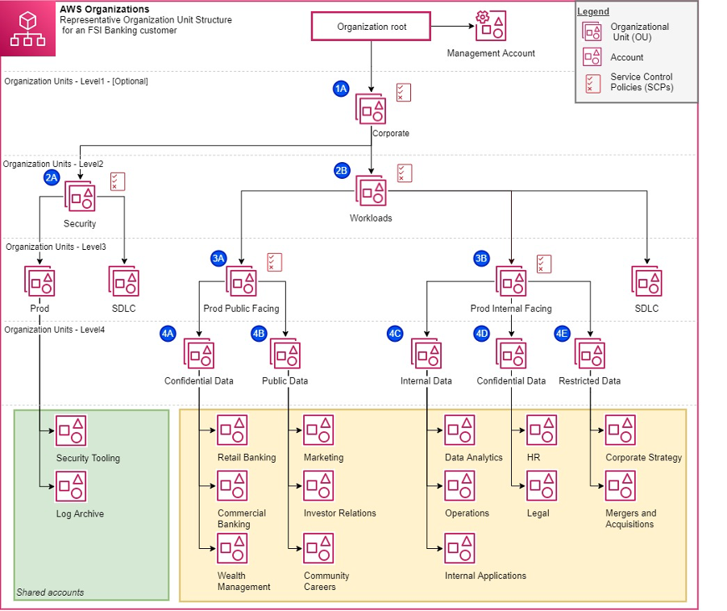

[Organizing Your AWS Environments Using Multiple Accounts](https://docs.aws.amazon.com/whitepapers/latest/organizing-your-aws-environment/organizing-your-aws-environment.html) is an AWS Whitepaper that was published on July 26, 2022. It talks about the AWS Well-Architected Framework and much of the content that you learned about in this course. It’s a good read! The AWS Organizations website also has another reference for further reading, called [Establishing your best practice AWS environment](https://aws.amazon.com/organizations/getting-started/best-practices/).

## Tag policies and SCPs

With Organizations, you can set tag policies, in addition to defining SCPs. You can use tag policies to maintain standardized tags for AWS resources that are used with Organizations accounts. For example, the following example tag policy defines a tag with a key of Environment and a value of Production, and this tag is enforced for Amazon Elastic Compute Cloud (Amazon EC2) instances. { "tags": { "Environment": { "tag_key": { "@@assign": "Environment" }, "tag_value": { "@@assign": [ "Production" ] }, "enforced_for": { "@@assign": [ "ec2:instance" ] } } } }

This tag policy prevents users from changing this tag on existing Amazon EC2 instances. However, it doesn't prevent a user from launching new instances with non-compliant tags, or no tags. This tag policy might be adequate if you use infrastructure as code (IaC) to provision environments. With IaC, environments will be created from a CloudFormation template, and you can thus embed the tags in the template. However, if you want to prevent the creation of new AWS resources that aren't tagged, you need to use SCPs. You could use the following example SCP to make sure that the AWS resources are created only if a certain tag is present. This SCP requires specific tags on specified created resources, and it uses explicit deny statements.

{ "Version": "2012-10-17", "Statement": [ { "Sid": "DenyCreateSecretWithNoProjectTag", "Effect": "Deny", "Action": "secretsmanager:CreateSecret", "Resource": "*", "Condition": { "Null": { "aws:RequestTag/Project": "true" } } }, { "Sid": "DenyRunInstanceWithNoProjectTag", "Effect": "Deny", "Action": "ec2:RunInstances", "Resource": [ "arn:aws:ec2:*:*:instance/*", "arn:aws:ec2:*:*:volume/*" ], "Condition": { "Null": { "aws:RequestTag/Project": "true" } } }, { "Sid": "DenyCreateSecretWithNoCostCenterTag", "Effect": "Deny", "Action": "secretsmanager:CreateSecret", "Resource": "*", "Condition": { "Null": { "aws:RequestTag/CostCenter": "true" } } }, { "Sid": "DenyRunInstanceWithNoCostCenterTag", "Effect": "Deny", "Action": "ec2:RunInstances", "Resource": [ "arn:aws:ec2:*:*:instance/*", "arn:aws:ec2:*:*:volume/*" ], "Condition": { "Null": { "aws:RequestTag/CostCenter": "true" } } } ] }

Do you see how SCPs and tag policies can—and should—be used together? For more information, see [Require a tag on specified created resources](https://docs.aws.amazon.com/organizations/latest/userguide/orgs_manage_policies_scps_examples_tagging.html#example-require-tag-on-create) in the AWS Organizations User Guide.